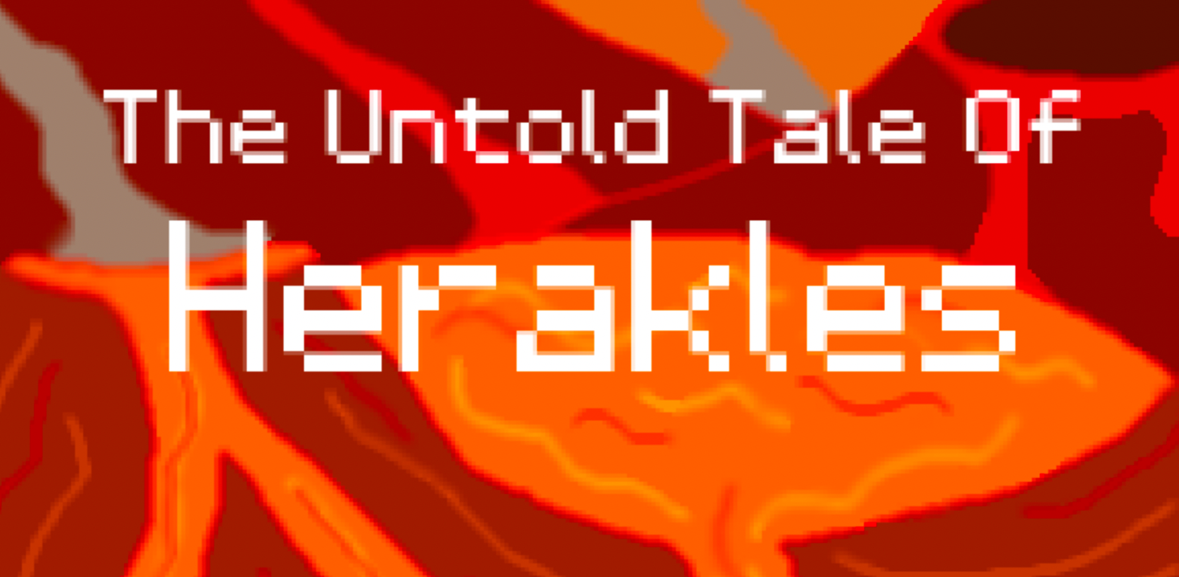**Bryan Vullo’s A-Level Computer Science Project Documentation.**

Table of Contents

Analysis 3

Problem Identification 3

Stakeholders 3

Research 4

Primary Research (my own) 4

Secondary Research (existing solutions) 7

Solution Description 8

Solution Details 8

Limitations 8

Success Criteria 9

Why is this a suitable project 11

Requirements 11

My requirements 11

Stakeholder Requirements 11

Design 13

The layout of my main menu 13

The layout of the game 13

Stakeholder Input 14

Output 14

Usability features 14

Algorithms 15

Code structure 15

Database Structure 16

Account Validation 17

Rooms 17

Music 18

Key Variables & Data Structures 18

Testing Methods 19

Checklist for all subroutines 19

Story board 20

Development & Testing 24

Stage 1 24

Testing 1 25

Review 1 26

Stage 2 27

Testing 2 28

Review 2 30

Stage 3 31

Testing 3 33

Review 3 34

Stage 4 35

Testing 4 35

Review 4 36

Stage 5 37

Testing 5 39

Review 5 40

Stage 6 41

Testing 6 45

Review 6 46

Stage 7 47

Testing 7 47

Review 7 47

Stage 8 48

Testing 8 50

Review 8 51

Stage 9 52

Testing 9 56

Review 9 57

Stage 10 58

Testing 10 62

Review 10 64

Stage 11 65

Testing 11 67

Review 11 68

Final Testing 69

Evaluation 71

Success Criteria 71

Limitation 71

Maintenance 71

Final scripts 72

Main.py 72

engine.py 84

database.py 101

credentials.py 107

title_screen.py 108

death_screen.py 109

login_class.py 110

display_savefiles.py 117

settings_menu.py 121

progress_menu.py 127

room_data.py 130

# Analysis

## Problem Identification

The video game market is overly saturated with not challenging, rewarding nor stimulating games, which can be easily completed and there is not much depth to them. In these games there is usually a guide and help given to the user which does not make the user think for themselves. I grew up with the Nintendo Gameboy Advance SP and Sony PlayStation 2 and 3; video games on these consoles were challenging and made the user think. They would show a problem and tell you to solve it; modern video games tell you *how* to solve it. The issue I have faced is the lack of retro-metroidvania, platformer games in the market which resemble the old games such as the Metroid series.

Although there is a gap in the market for challenging games and decreasing amount of people playing metroidvanias, the challenge is inherited from the game’s niche therefore players sometimes find it frustrating and stop playing a game completely if it is too hard. Therefore, I think a new feature to a metroidvania which would allow for more player interaction and for longer use of the game is different difficulty levels. This ensures players of all skill levels will enjoy the game whilst maintaining that level of challenge that makes a metroidvania a great game.

Another point to note is that as video games are all played on computers, this problem is intrinsically a computational problem which can be developed in a program using a simple GUI module. The problems that I address however are the features of the game and that’ll all be developed and amended in my code. And the obvious limitation is that I am a solo developer so I will take much longer to develop a game at a high quality.

## Stakeholders

My *target* stakeholders are males, from ages 10 to 24, that really enjoy metroidvania or problem-solving games. For example, a boy of age 12 who really enjoys playing Nintendo games such as Zelda and Super Mario franchises or any 2D games.

For my initial research on the market’s opinion on the matter, I will create a survey and try to make as many people as possible to answer it so that I have a variety of opinions to help me make a better representation of the market.

I will do this by making the survey an online survey using a platform called Google Forms; this way I can share the link to the survey on as many platforms as I can and reach out to more people than if I were to make the survey on sheets of paper and share it physically. Another positive of creating the survey online is that the stakeholders will be able to complete it in their own time at home or wherever they wish to without the pressure of me, the researcher, being there which could introduce bias in the research and data. Another source of bias could be in the opportunity/ convenience sampling like approach to this study, where most people answering and taking the survey will be of interest to the survey. Although this is could negatively affect the results, I will continue to use this method as it will enable me to reach out this research to as many people as possible.

After that I will choose a group of a smaller proportion to be the sample stakeholders, and these will be the people giving me feedback of the rest of the project, this group will be of highly accessible individuals such as friends, teachers and class-peers.

The stakeholders could include class-peers from both my computer science class, other classes or neither. My teachers of computer science, other subjects or neither as some may have experience or could help me and can give me impartial feedback. Friends and family as they are more easily available and can get a fast response. My last selection of people that I will be using will be clients, people that are genuinely interested in the final project and it being functional. These will be extremely helpful as they will know what they want, and they will be objective about it.

The use my that project will be to my stakeholders is to be a game that addresses all the issues that they face in the game genre and to be a game they really enjoy playing.

## Research

### Primary Research (my own)

I conducted some research about the metroidvania genre to find out how popular the genre is and what feedback I would receive. I conducted an online survey on Google Forms with 5 simple questions. These are my results:

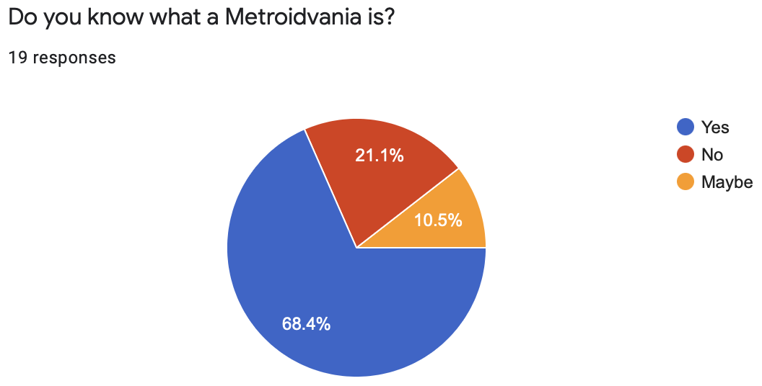

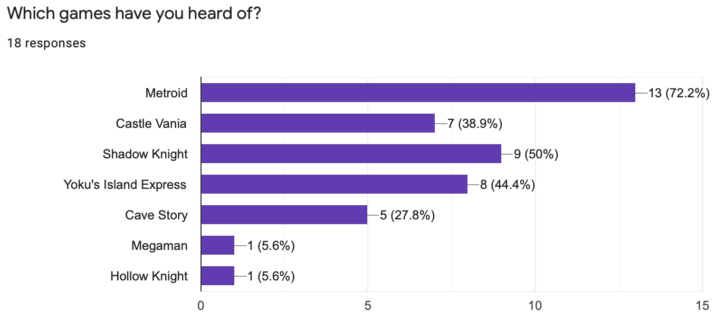

Hollow

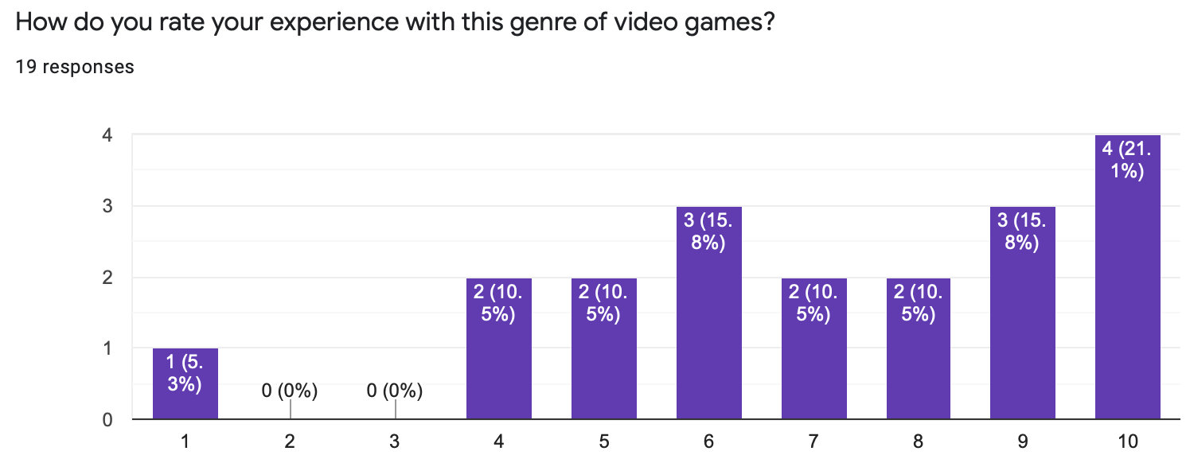

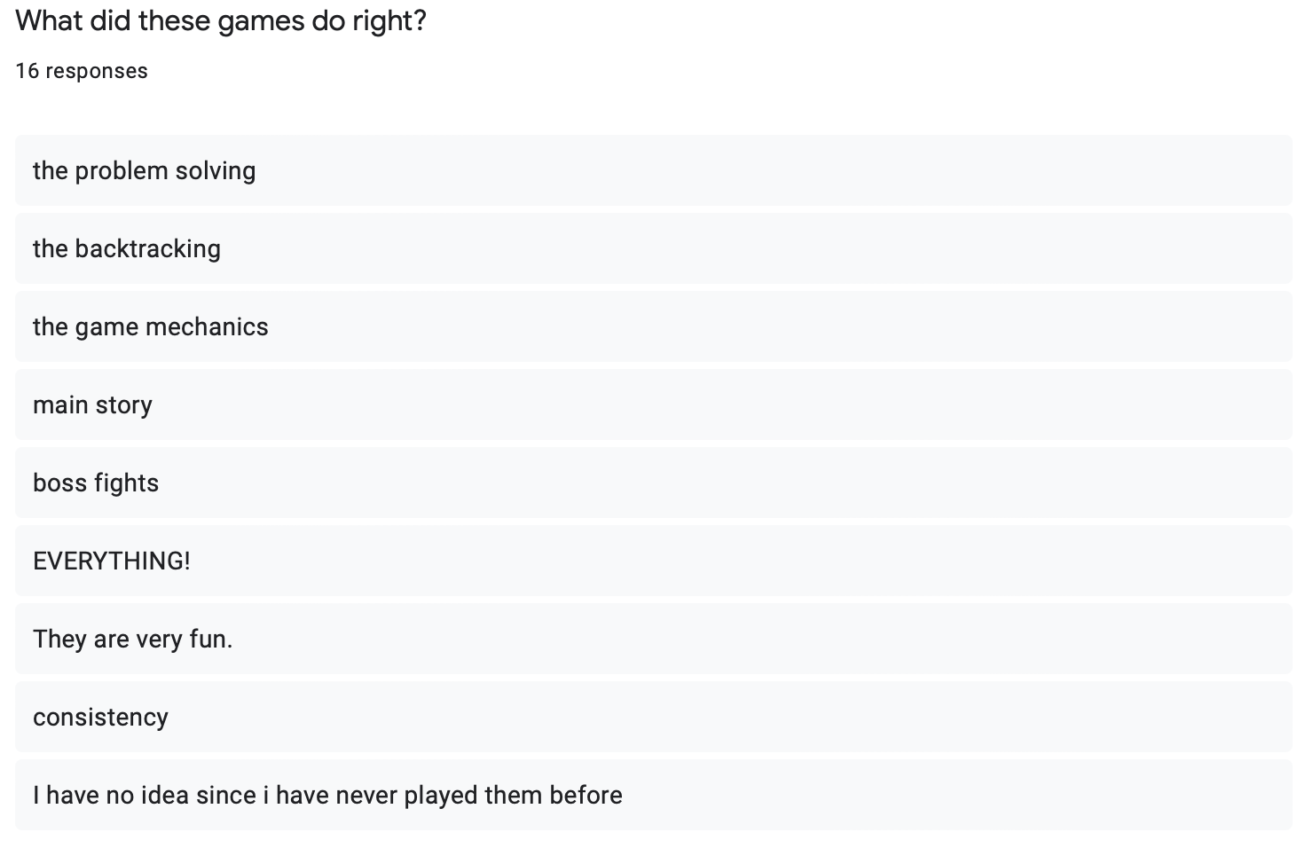

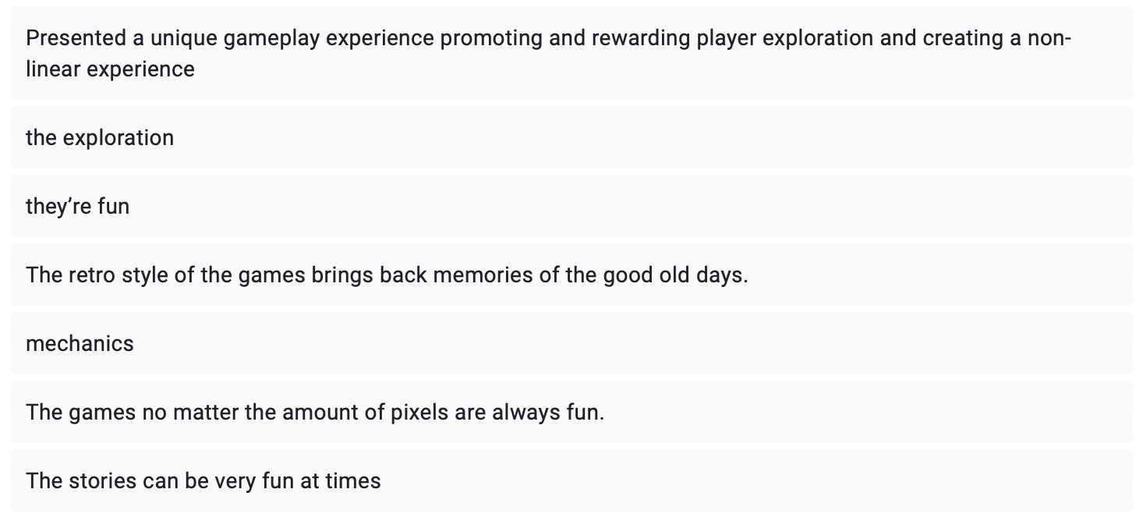

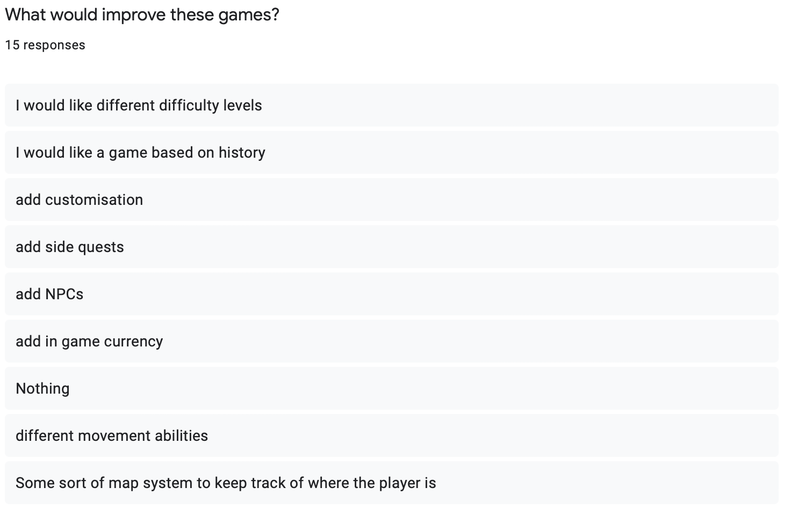

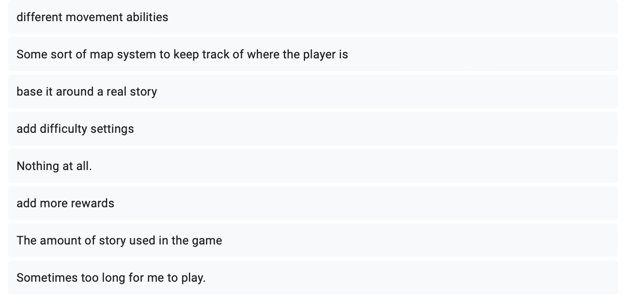

The research has shown me see that metroidvania games are more popular than I expected; it also helped me identify the qualities that are loved and what’s missing from the metroidvania games that would elevate the gameplay. These gaps in the genre are what I will be addressing and target to satisfy my stakeholders and create a good game that stands out from the others in the genre.

### Secondary Research (existing solutions)

I will take Metroid as my main case study as it’s my inspiration to the project in the first place. Metroid is a Nintendo game series that revolves around a main character, Samus, as she takes orders from a Space Federation to stop a widespread parasitic virus, called the X, which mimics its host’s abilities. Samus is the only person able to fight the X as she has Metroid DNA, which is the predator to the X.

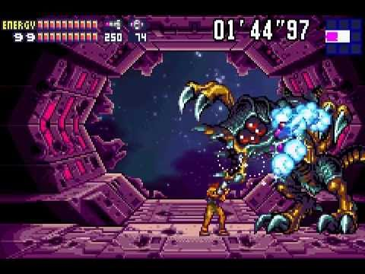

It's a 2D platformer game which involves acquiring new abilities to continue exploring and finish the mission set to you at the start of the game. These abilities allow you to backtrack to previously explored areas to use them to unlock new areas that you couldn’t explore previously. Due to these features, it takes problem solving to find your way through the game, but this is what the audience loves about these games.

From what my target audience addressed in my survey, what they’d like included in the game is all the fun features of games such as Metroid such as the movement and game mechanics and the boss fights. So, I will need to try my best to keep my game feeling how a typical Metroid game does. What I should also include which hasn’t been seen in a Metroid game before is interactions with Non-Playable Characters (NPCs), Customisation, a way of using an in-game currency, a different story and difficulty levels.

## Solution Description

My solution to the problem is to create my own game and include all the enhanced, modern features to create an interesting, enjoyable game.

## Solution Details

I will use the programming language Python as is allows for object-oriented programming which will make my code more complex, reusable and efficient; with the addition of public modules such as Pygame, Tkinter, Math, SQLite3, CSV. I will also create a library myself with common and useful modules to make the game script shorter, easier, and quicker for me to code. I can code in Python, and I am familiar with the public modules I will be using which makes me feel more confident in the success of the project. I will insert the use of multiple language such SQL when needed for specific tasks to make a more complex project.

I will use the Pygame and Tkinter Python modules to create my interface for my user; these modules will help me create a good-looking graphical interface which will appeal the user and make my game more fun and enjoyable.

I am going to use Integrated Development Environment (IDE) to code this project. I could use the basic IDLE IDE that comes with Python but a more sophisticated and helpful IDE I will use is Sublime Text as it has features such as better interface, colour coding and autocomplete which will make my time programming more efficient.

I will use the Agile Iterative programming style to create a first prototype then keep improving after. The benefits of this are that the project will be easier to understand from the documentation as there is a clear, set phases to follow in the project's timeline. Another benefit is that there will be less project creep due to there being fixed requirements and clear analysis completed beforehand which makes identifying potential bugs and problems much easier and saves a lot of time. This also allows me to leave the project once it is completed with no maintenance.

## Limitations

There are certain limitations of my game, one of main concerns being time as I have limited time to complete this project. The next being I’m doing this on my own which means development will be slow. The technical limitations to the project are that I will not be using game engines like most mainstream games do, so every feature must be created from scratch. Using a game engine would massively help during development but I’ve decided to create this project without one. This means I will probably not complete this project fully and make it as good as my inspiration Metroid but I will be able to make a basic game with features that have never been seen in a metroidvania.

I have a large scope with this project and making it will be difficult and take a long time, but I’ll try my best to hit my success criteria as much as possible in the time frame identified. I will work my way down the success criteria list when creating my game to ensure I don’t forget anything. It will be difficult, but I believe in my programming skills and my ability to learn as I make the project to keep up with my large scope of the project.

My main limitation to this project will be time; with a project like a game, I could keep adding and adding features, making my game larger. This creep will not stop as I will always be thinking of new features. But due to time I will need to stop myself during the development phase and move on in my project, I will make this stopping point clear in my development section of my documentation and then explain all the features that I missed out on including.

## Success Criteria

|  |  |
| --- | --- |
| **Features** | **Explanation** |
| Mobile Phone game | My first build will be for a PC, but one goal is to build it compatible for a mobile phone which will help me obtain one of the main goals of increasing accessibility and familiarity of the genre as mobile games are far more popular than PC games. |
| To create an interesting story line | To create an interactive story-oriented game which keeps the user always involved with the story. To also create an interesting Greek Mythology setting to the story by using famous icons to make the user feel more familiar with the characters from their previous knowledge |
| To make the game rewarding | To create a progressive aspect to the game to make the user feel rewarded for playing the game and keep them involved throughout the game. I will do this by making the user find better ‘gear’ in the game so that his character gets stronger. Another way of doing this is by adding a currency into the game, each enemy dead will drop coins and with the coins, they can purchase cosmetics for their character or new ‘gear’, consumables and skills. |
| Make the game relatively realistic and smooth | To make the in-game physics of the character and enemies realistic and understandable. To ensure that the game runs smoothly with no glitches or bugs, I will do this by making sure the time complexity is efficient and by making my code robust by using OOPs concepts. |
| Make a functional and understandable game map | To load and render separate ‘map chunks’ individually. Each map chuck is stored in a CSV file, each value referring to a specific tile. CSV files will be stored in a 2-D Array in the same way the map looks for easy tracing. |
| Have an interconnected map | Have a map of many rooms connected by doors. This allows for loading smaller chunks of the map at a time. |
| Make a functional and familiar pre-game home screen | The pre-game menu will include widgets, buttons, blimps and a background. Two different options: ‘create new account’ for new players and ‘log in’ for existing players. When a new account is created then a new record will be created in the database. When a user logs in a connection is made with a database and details are verified to make sure the account exists before the record will be searched for in the database and the data will be loaded into the program. |
| Have a pause menu | Have a button in the corner of the screen in the game for quick access to the pause menu; from here the user can access different menu screens, including map, progress, character, options menu screens.  Options menu: adjust audio volume, button layout, mute sounds, difficulty.  Character menu: view different gear and what upgrades are currently equipped. You can view the different items to find out more about them.  Map menu: view where the character is currently on the map and view identified items  Progress menu: view how much of the story has been completed (what gods have been identified and saved) |
| Have different types of quests in the game for the user to complete for more variance | To implement boss battles to progress in the main story of the game and save the gods and obtain new items, completing these quests will improve the character’s health and strength. Have side quests such as obtaining an item from somewhere else and bringing them back to the saved boss to get them ‘blessed’ and obtain a new skill which changes game mechanics such as “ability to run”. The game difficulty will increase as the user plays but completing these quests ensure that the character is always strong enough to continue, there is the option to not complete these side missions, but the game will be considerably more difficult for the user. |
| NPC Interaction | Have characters in set locations in the map that the character can interact. Each NPC would have their own side mission. |
| Customisation | Be able to change how the character looks in the game. |
| In-Game Currency | Have a currency that can be found in the world or acquired from dead enemies. Its total will be displayed in a counter at the top of the screen. |
| Difficulty Levels | Allow the user to change the difficulty level which will impact how much damage the character will receive from enemies and how hard enemies are to kill. |
| Be able to save | Allow the user to save their progress so that they can play at a later and continue from where they last left off. |
| Executable | Create an executable file which means that the game can be played by users without the need to download Python and the extra libraries that I use in the code. |

## Why is this a suitable project

This is a suitable project because it will show my skill with object-oriented programming. It will be suitable because it will also be an opportunity for me to highlight computational thinking within the processes of the project. My main objective for this project is to remaster and modernize a loved-by-many genres of games to make it more accessible and fun to people in today’s time. I will do this by adding more player customization and control over the settings of the game such as save files, difficulty settings, sound settings. I will also add an interesting storyline for the user to get involved in. Each one of these sections will need thorough planning and computational forethought for them to be successful. This is important because the gaming industry can be very judgmental and meticulous about games and their quality so for this game to be a success in the real world, I will need to make sure that everything is thought out; the less problems there are, the more recognition the game gets, the closer I get to my goal of reviving the almost-dead genre of metroidvania games. I will also create all the pixel art on my own using an application called Aseprite, from characters, enemies, allies, animations, special effects, items, background items, and backgrounds; every image and sprite will be created by me. This will ensure there is a unique experience and environment for the user to play in.

## Requirements

I will describe both mine and the stakeholders’ requirements

### My requirements

#### Software

I will require to have Python downloaded including extra libraries such as Pygame. Other libraries such as tkinter, sys, math and csv come with Python upon download.

#### Hardware

I will require a desktop or laptop with a display, keyboard and mouse (or touchpad). I will also require my computer’s specifications to have at least 8GB of RAM and an i3 processor. I will be using my M1 Macbook Air to develop on.

### Stakeholder Requirements

I have set my requirements for the user low to ensure access from as many users as possible as one of my main success criteria is to make metroidvanias more accessible and known; therefore, having a low entry level requirements will encourage more users to play my game.

#### Hardware

The user will need to have a computer with at least 8GB of RAM, a keyboard to play my game and mouse. Webcam and other peripherals are not needed.

#### Software

As stated in my success criteria, I am planning to make my finished game an executable therefore little software requirements are needed for the stakeholder to play my game. Having a functional operating system downloaded on their device is essential. If I cannot make the application into an executable, the user will need to have python, and all the packages I use installed on their device.

# Design

In this section I will break down the game into smaller problems and explain how each section will be implemented.

## The layout of my main menu

The main menu will be start with an image with the games title “Hercules - the untold story” where the user will need to press space to continue, this will be told to the user in text at the bottom of the screen.

Once out of the game screen, the user will be sent to the pre-game menu where the user will need to either “log in” or “sign up.” These will be the two button widgets where once pressed will open the respective screen. The two screens, once all the players details are inserted into the input field, will then allow the user to choose which one of the three game files they would like to play on, alongside the option to delete and rename the save file. Once these steps are completed by the user the game will load the user’s data from the games database and finally start the game.

## The layout of the game

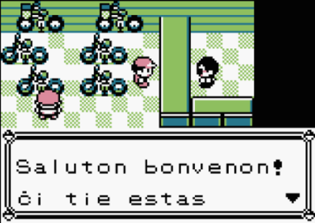Once in the game, the player can control the character “Hercules” and can continue completing the game story from where they last left off (if they previously played in the same game file). If it is the first time playing in the game file, non-playable characters (NPCs) will communicate with the user on what to do and provide story context through text boxes at the bottom of the screen as seen in other retro games such as Pokémon. In addition, I will provide NPC (non-playable characters) pictures to the left of the text box so that the user can easily identify which character is speaking. Once communicated and the player is in free-play and is out of the text animation, the user’s heads up display (HUD) will be visible.

In the Game Window the user can see the character’s health bar, ammunition, and currency count at the top left corner of the screen. In the top right corner, there will be a pause button, once interacted with, the pause menu will be displayed on screen and the game will be paused. From the pause menu the user can access the Map, Progress, Character and Option screens by a Row of buttons with the respective names displayed.

The Map screen will display the game map, including the greyed out undiscovered parts of the map, the game map discovered, character’s current location, identified collectible items.

The Progress screen will display the Gods to be saved, Bosses to be defeated, special powers to be unlocked. If the user wishes, these can be clicked on to find out more about the Greek mythology behind them.

The Character Screen will display the character, his cosmetics, and the gear available to equip onto him. These include different skins, swords, and bows. Some of these items may also be clicked onto for the user to find out more about the Greek mythology behind them.

The Options screen will display the different settings that the user may change around to customise his playing experience. Such as audio volume, mutable sounds such as music and sound effects, difficulty settings, button layout, and a button to go back to the main screen.

## Stakeholder Input

The user will use the keyboard and mice as input. The user will only need the mouse to navigate the menus with the pointer and to aim Hercules’ bow. The keyboard is the main input device for movement, abilities, and interactions.

i.e., W, A, S, and D keys for movement up, left, down, and right respectively, as these are widely used in the gaming community for movement inputs. Space bar to jump. Shift key will be the alternative option such as sprint instead of walk and special attack instead of the normal. E key is for melee attacks (sword) and the Left click for ranged attacks (bow and arrow). Q key is for interactions with NPCs and the map. C key will be used to toggle the character between crawling and standing.

## Output

The output for the inputs outlined above will be changes in the character. All the character’s data will be stored within the player object; so, for example when the D key is held down the attribute in the player object responsible for holding the x coordinate (player.x) will change so that when the character is displayed the character will be moving left. There will be any of these attributes responsible for dictating what the character is doing on screen. Vertical momentum for the jump input held in the player.momentum attribute; movement speed for the shift key; the players interactions on screen such as attacking and dealing damage to enemies and text boxes for when interacting with NPCs.

In general, the output will be a functional game where the inputs from the user will be represented accordingly in the game itself.

## Usability features

Usability features are features which make playing the game a smoother and more fun experience for the user. I will include many of these features such as having a count for the user so that they know how many arrows and coins they have; a health bar to indicate if they are on low health or not. Speech bars when NPCs speak. Damage numbers when you attack enemies to show much damage you dealt to the enemy and a large health bar when fighting the bosses to indicate how close you are to defeat them. A feature I will implement which is unique from other Metroidvanias is the ability to change game difficulty mid-game which makes the game more playable for users if they are finding it too hard at a certain point. Another unique feature will be the use of a cursor in the game to aim the bow, in traditional Metroidvanias the player can only fire their weapon horizontally, vertically and diagonally at a 45-degree angle; whereas in my game, the player is able to fire their bow in all 360 degrees.

## Algorithms

I will be using Dijkstra’s Algorithm to find the path that the arrow will be travelling when the user presses the Q key. The start point will be the centre of the character and the end point will be the position of the cursor when the Q key was pressed.

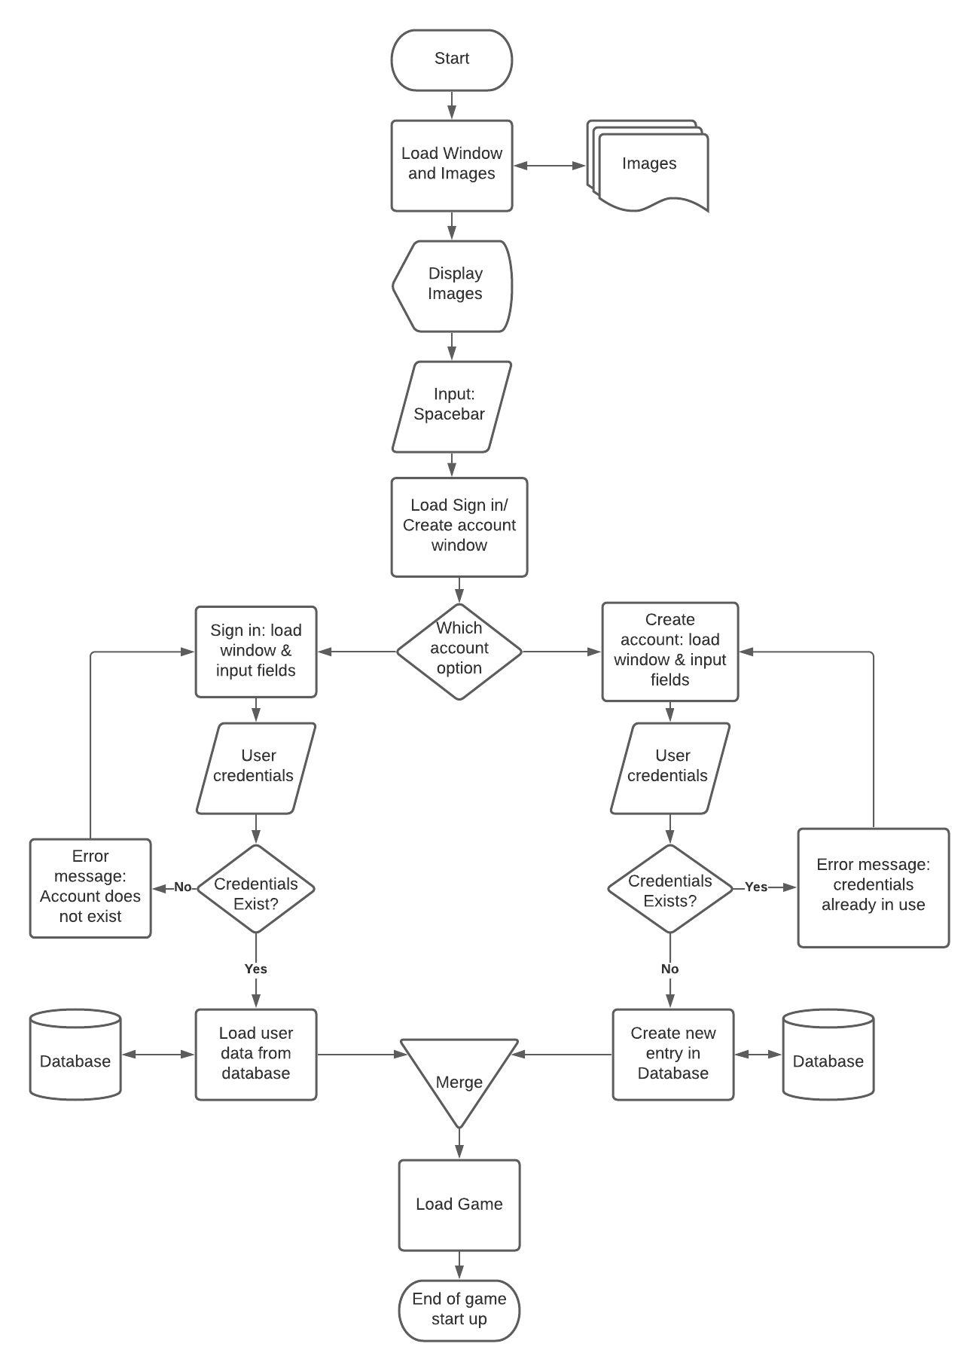This is a Flowchart of the start-up of the game. This can be implemented as a series of sub-routines as each shape can be executed in a single line or by calling to another function that I can create to make this sub-routine clearer. For example, another sub-routine I can create to make this simpler is a sub-routine called “isUser” that takes user credentials and returns True or False depending on if the user credentials exist or not, this would be useful as this can be used multiple times, as show in the flow chart. On the penultimate shape “Load Game”, the program should load the game files of the user that has signed in, including empty files. Each user is allowed three different save files. Alongside the option to start these save files, the user is given the option to “rename” and “delete” the given save file. Once the user has chosen a file to play on, the data is loaded from the database and the game is loaded from their most previous save location.

## Code structure

I will structure my code in multiple files, each file being a class. This makes my code very reusable and organised. From my main code, I will call out to these other scripts to create objects and so then I can manipulate them in the main code. The classes I will use in the game are:

* Tile class {dictionary of CSV values linked to each tile image}
* Map class
* Objects class
* Physics class
* Sound class
* Text class
* Animation class
* Enemy class
* Character class {movement, dealDamage, takeDamage}
  1. Player class {location, last save, items, coins, arrows}
  2. Enemy class {playerTrack, itemDrop}
     + The different types of enemies

As explained above, the code will be structured into different scripts, each script having its specific function. The scripts I will create are:

* Main script – where all the code is initiated, where the pre-game scripts are run and where the game loop exists. This script acts like the brain of the code, forming the path that the program will take and allows for branching to other scripts. This is also where the classes, created in other scripts, will be initiated.
* Title screen script – a simple GUI scripts that displays an image and prompts the user to press the space bar to continue the game.
* Login script – a GUI script where the user is prompted to login using their credentials and have the option to create a new account.
* Database script – a script which has a list of functions, e.g. isUser, that connects to the game database, this script does not display any GUI elements. These functions will be called from other scripts.
* Credentials script – a simple script that temporarily holds data which can be deposited by one script and can then be accessed by other scripts. This can be thought of as memory but for the program.
* Display save files script – a GUI script which will retrieve the user’s save files and prompt the user to select the save file which they would like to load.
* Engine script – a script that holds the main sub-procedures and classes of the game, this extracts the clutter from the main script so that it’s more readable and easier to write code in. These classes and sub-routines will be called from the main script.
* Setting menu script – a GUI script which displays the user’s settings and allows the user to change them to their liking.
* Character menu script – a GUI script which displays the user’s progress in the save file, allows for customization, and displays the game map.
* Death screen script – a simple GUI script which will be very similar to the title screen script but display a different image.

## Database Structure

I will structure my database with a main table followed by a series of small tables. The main table will contain all every user’s account information including their unique username and password all in one record followed by a key unique to each user.

Each user will have their own table, created using their unique username as the table name. Each player’s table will have only three records, each record being a save file. Each record will have data saved such as the last save point, the heart, arrow, and coin counts, and inventory.

### Account Validation

When creating a new user, firstly the program needs to check if the input fields are filled in and that the data is validated to the appropriate requirements, e.g. Having a special character in the password. Then the program needs to check if there is already a user with the same username, if there is another account cannot be created. Finally, the program can create the record in the main table with the user credentials. Then the user’s table of save files is created using the username.

When a user is signing in, the program needs to check if the account exists using the credentials from the input fields. Once an account is accessed, the key will be returned to then access the user’s table and then save files’ names will be displayed on the screen for the user to choose which one they would like to play. When the user selects an account, they whole record associated with the name will be accessed and used to load the game from the last time the user saved.

When saving, the data is collated by all the players attributed and then used to overwrite the current record.

## Rooms

The map will be created using a 2D array which will hold a value which will be a room, for example (0,0) for the top-left room in the layout. Each value will be held in a dictionary which will relate to a CSV file, each file being a room layout. Each value CSV file will relate to a different tile, again by another dictionary. Reusable rooms will not be given coordinate values, instead names. For example, “Save” for the save rooms and “Armory” for the armory rooms. Each one will look the same and having one reusable file for each is more efficient. 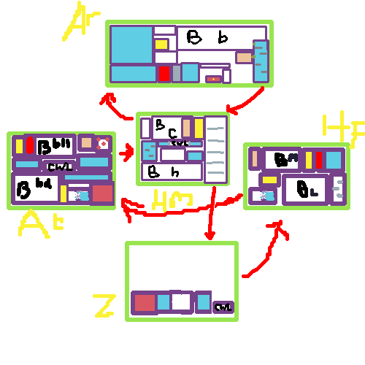

## Music

I will have music playing in the background throughout the game with sound effects (sfx) with every interaction on screen. I will have three soundtracks to play, with each one playing in different scenarios. Harmonic soundtrack for the Temple (save) rooms and God rooms, an action soundtrack for when there are enemies in the room, a calm soundtrack for when enemies are in the room and finally, an intense soundtrack for boss battles.

## Key Variables & Data Structures

These are a list of a few but the most important variables and data structures of the game.

|  |  |
| --- | --- |
| **Name** | **Functionality** |
| Player | The player object will contain all the player data. For example, the position coordinates, speed, momentum, health, arrow and coin counters, action variable such as attacking (true or false), dictionaries of all the animations and images, and the player rect and masks. |
| Map | Data structure that holds the rooms files and the relationship between one room and the other rooms. My two options to create this structure are either a 2D array of values being the coordinates of each room and create a different array for each map. Or create a dictionary of dictionaries where each key, in the key value pair, is a room ID and the value is a dictionary of all the different rooms it is connected. |
| Clicked | Variable that holds if the user has clicked the mouse, can be True or False. |
| Screen | The screen object is a pygame object, it is the canvas that is displayed in the window. Blitting images onto this canvas will display the image in the window. |
| Enemy list | A list of alive enemies in the room. This list will be used to access all the enemies in the room to move them, display them and check for interactions between enemies and other objects such as arrows and the player. |
| Arrow list | A list of currently displayed arrows. This list will be accessed to move the arrows, display the arrows and check for interactions with walls and enemies. |
| Tile list | A list of the room’s tiles. This room will be accessed to display the tiles and to check for collisions with the player, arrows and enemies. |
| Save file | This will be a record in the users database, this will be loaded and updated when the user opens and saves the game. This is vital for the game to store the users progress data so that he can close the game and continue from where they last saved. |

## Testing Methods

I will be using an iterative development to complete this program. This allows me to decompose the game into sub problems to solve independently. Each problem will be addressed and coded in its own prototype. This will allow me to build and quickly test each prototype to check if the new code works as it should be; it also allows me to be flexible and identify new requirements for my game.

Each sub procedure, class and section of logic will be tested as they are made to ensure that they work to a good standard for the current prototype. At the end of a prototype, I will conduct a larger test on my prototype to help identify any bugs, issues or improvements for the next prototype.

At the end of development (Post Development), a final test and play through of the game will be conducted by my stakeholders. The reason I will let my stakeholders test is so that they will replicate how an average user will play my game. And therefore, will be able to find and identify issues and bugs that I wouldn’t have tried to look for myself as some of my stakeholders do not come from a programming or gaming background.

I will be using both white-box and black-box testing for all my sub-routines to ensure that they function correctly when values are given in their operating range but also to ensure that they do not execute on malicious data outside of their input range. When testing, I will record the input, output, and if the output was expected. To help debug logical problems, I will print out values before, after and during a process to check how they are changing.

This is especially important in the subroutines that access and overwrite the database tables as I need to ensure the players data is saved properly because if false or wrong data is stored in them then the save file is no longer valid and cannot run properly and the user will need to restart the game from the start which will leave my stakeholders frustrated and make them not want to play again.

### Checklist for all subroutines

My testing checklist will be:

Test for: (Example: Health [capped at 100])

* A normal value - (65)
* Minimum value - (1)
* Maximum value - (100)
* Value outside of the range - (0 & 101 & -1)
* Value of the wrong data type - (“Helf")

This will ensure each subroutine is tested thoroughly for correct execution for all values and that no errors arise further down the line of my development that will need me to go back to and amend the subroutine.

My checklist of sub-routines to test:

* Log in verification
* Creating account verification
* Save file saving and retrieving
* Loading character in the last saved position with correct item counters
* Options menu
* Character menu
* Character movement
* Character animations
* Character collisions
* Particle collisions
* Tile collisions
* Enemy collisions
* Item collisions

## Story board

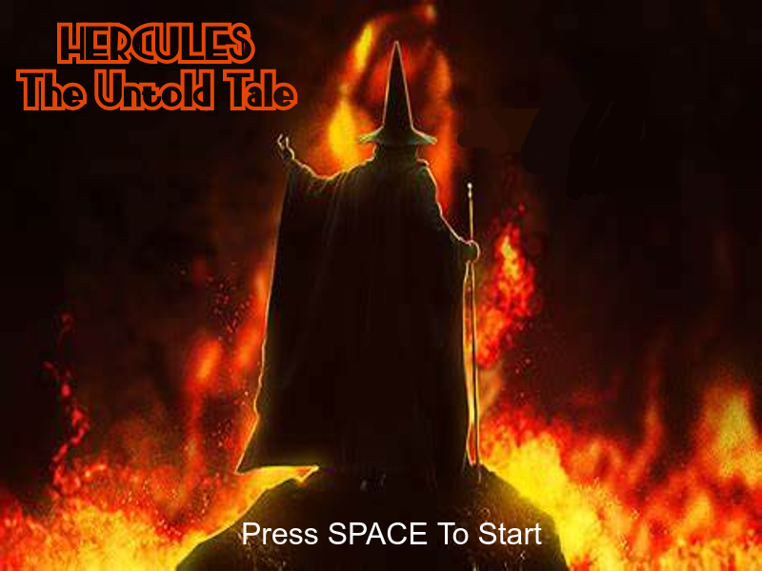

The starting image will be a front cover with the game title. Which will prompt the user to press the space key to start the game.

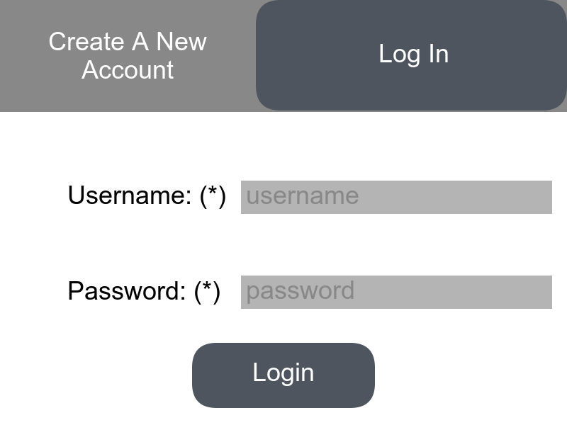

The user will now need to choose one of the options “login” or “create”. Login for existing players and create for new players. The users will need to input their credentials which will need to be validated against the database until they’re let through to the next window.

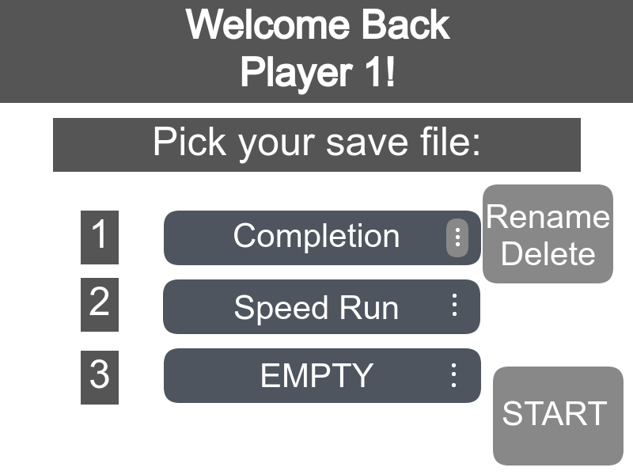

The user will need to select the save file they would like to play in and press the start button. They also have the option to rename and delete certain save files.

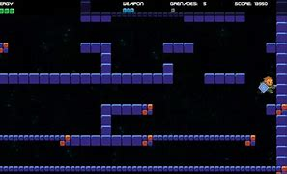

This is an image taken from google images. This is an example of how my game is going to look like, the 2D layout with tiles and character are similar components to my game.

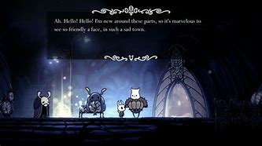

This is from a game called Hollowknight. This is how I want the NPC interactions to look like, with a text box of what the NPC is saying to create a story.

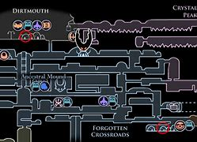

This is from a game called Hollowknight. This is how I would like my map to look like, an interactive image which changes as the player moves from room to room and located different landmarks of the map.

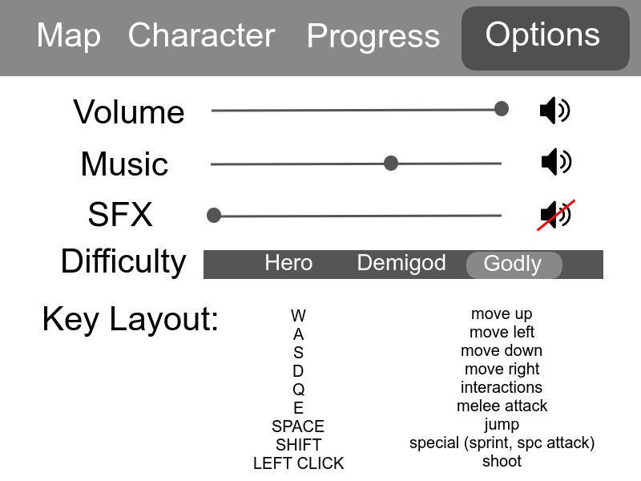

This is how the menu will look like with the different tabs of Map, Character, Progress and Options. This is the options tab whew the user will be able to customise their different settings to their liking. In the menu the user will be able to customise their character and check out different gear in the character tab. They can look at the map and see where they’re at and what they’ve discovered. The user will also be able to check how much progress they’ve made in the progress tab and look at everything they’ve discovered about Greek Mythology.

# Development & Testing

I decided to develop my game in a series of scripts (separate python files) which have different functions so that I can keep my ‘main’ code tidier.

## Stage 1

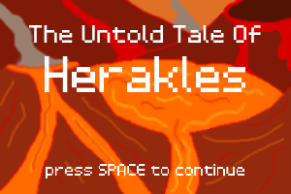The first draft was where I initially created my “title_screen”, “login_menu” and “main” scripts. The “title_screen” script would display my title image and make the user press space to continue; “login_menu” allows the user to enter his login details or create an account; “main” is the main script which determines when the other scripts are called and contains the game’s main loop. At this stage, I wanted to create a functioning start to my game so that I could fully focus on creating the game itself later in the development process. This consisted of displaying title screen, then when user presses the space bar the game will transition to a login menu. Once logged in, the game screen will be displayed, which so far was only a black screen.

Figure 1: Title Screen

Developing the “title_screen” script was straight forward; it successfully displays my title image and only allows for one input (the space bar) which stops the script’s loop and returns to the main script.

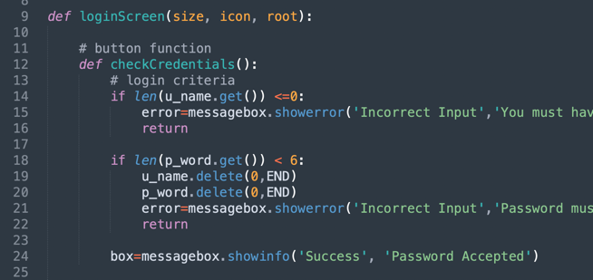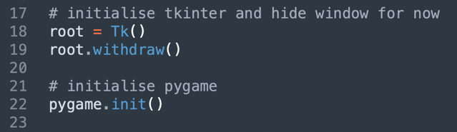Initialising both tkinter and pygame at the same time caused me some issues as this was my first time doing so. I initialised tkinter after pygame which caused errors. Once I figured out that I had to initialise tkinter first, my next problem was that a little black window (my root) would appear on screen which was unappealing. I then discovered the “withdraw” and “deiconify” functions that I would call upon my root to hide and display it.

Figure 2: Initialising Tkinter before Pygame

I initially tried to develop my login menu script using Pygame as my GUI library but when noticing that entering text into boxes was going to be more difficult than expected, I fell back on my original plan to use Tkinter.

Figure 3: The procedure inside the login function, to be refactored later

My “login_menu” script at this stage was a simple interface including two text boxes, two entries and a button. I initially found the structure of this script to be a bit tricky, as each button had its own procedure. If I wrote these button procedures outside my login function, then I would have had to pass the root variable each time which I wanted to avoid. Therefore, the procedure for the button was written inside of main function for the screen, I acknowledged that this was an incorrect and messy way to structure of the code, but it was the only way that I thought of at the time. At this stage it was enough to pass, and I would make a note to come back to it and refactor the code later to make it more efficient.

### Testing 1

Firstly, the title screen has been tested.

|  |  |  |
| --- | --- | --- |
| Test | Expected Outcome | Actual Outcome |
| Does is display the image? | Yes | Yes |
| Does it quit once the space bar is pressed? | Yes | Yes |
| Does it continue when other keys are pressed? | No | No |

The title screen works perfectly. So next we test the login menu.

|  |  |  |
| --- | --- | --- |
| Test | Expected Outcome | Actual Outcome |
| Displays the appropriate text and input fields | Yes | Yes |
| The login button validates the input data | Yes | Yes |
| Validation checks for a username | Yes | YesGraphical user interface, application  Description automatically generated  Pop up that appears to alert the user that a username must exist to log in. |
| Validation checks for a password more that 6 characters long | Yes | Yes A screenshot of a computer  Description automatically generated with medium confidence  Pop up that appears to alert the user that the password must be at least 6 characters long. |

The login menu is simple, and the validation is not complete.

### Review 1

In this stage, the program is very basic. A title screen displays which prompts to press the space bar to be pressed. The login menu is not fully functioning yet, it only checks for a username and a password longer than 6 characters long. The main purpose of this stage is to create a framework to expand on to fully create the log in system.

The next steps are to add more validation to the input data to make sure the data is correct and secure, to allow the user to create an account and to create a database connection to store accounts and verify credentials when logging in.

## Stage 2

The second draft is where I expanded my “login_menu” script and started writing the “database” script. The “database” script is the script which uses the SQLite3 library which allows python to execute SQL queries. I also decided to use SQLite3 instead of MySQL because SQLite3 creates a local database on the device (as a .db file in the same directory as the script it’s been created) which greatly simplifies connecting to the database.

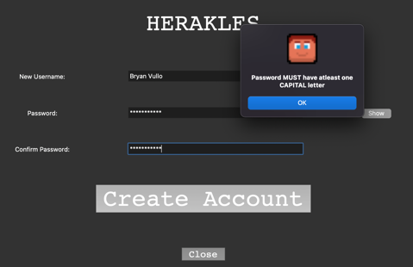My main priority at this stage was making the login menu user interface functional (front end) before connecting and making changes to the database; this started with allowing the option to create an account. I added a button which when pressed hides the ‘login’ menu and displays the ‘create an account’ menu which was slightly different such as the extra entry field which make the user confirm their password (Fig. 5). The next step was to hide the user’s password with asterisks (*) as they typed it in for security reasons; introducing another button which allows the user to toggle if they would like to show/hide their password (Fig. 4). Finally, I added checks to the entered details to make sure they fit certain requirements, these include must have a capital letter, number, special character in their password, it being at least 6 characters long and for a username to be entered. Extra checks made for the ‘create an account’ menu such as the two entered passwords to be exact for confirmation. These checks throw pop-up windows notifying the user if their credentials have been accepted and if not, for what reason they weren’t (Fig. 6).

Figure 5: Create an Account Menu

Figure 4: Login Menu with new features

Figure 6: Example of a pop-up window from credential checks

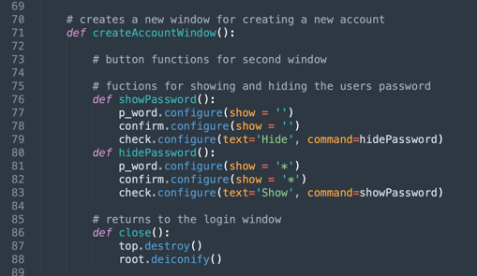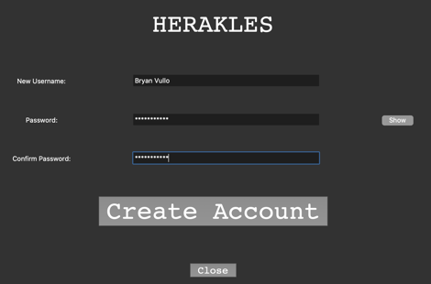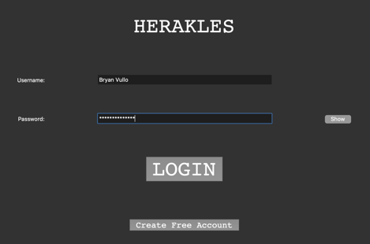The code at this stage with the procedures within the function started to get messy (Fig. 7) as I created more and more buttons which all needed their own procedures. I didn’t fix this issue just yet though.

The issue I noticed before it became a larger problem was the fact that if the user exited out of the login menu, skipping the login process entirely, the pygame window would appear as if the user successfully logged in. This would be a massive problem later in the project because to start the game, I would have to load data from their save file so if they never logged in then this would lead to the game crashing and throwing up errors. I fixed this by simply creating a procedure that is run when the user tries to exit out of the window which displays a pop-up message asking the user for confirmation if they would like to exit the game. If yes then the whole program is exited instead of just the one script, and if not then the tkinter window will continue being displayed.

Figure 7: A procedure within a procedure within a procedure... messy

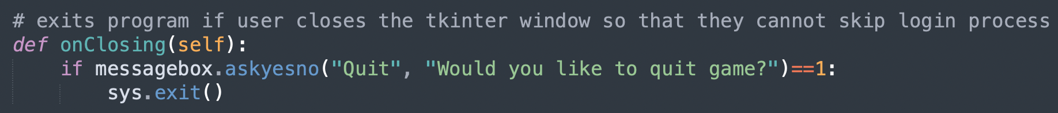

### Testing 2

|  |  |  |
| --- | --- | --- |
| Test | Expected Outcome | Actual Outcome |
| Do the rows and the columns evenly space out in the window? | Yes | Yes |
| Does the show button convert asterisks into the real text and change into the ‘Hide’ button | Yes |  |
| If user tries to close the window, a prompt will show telling them the application will close | Yes |  |
| Login in button validates data and validation is much more thorough | Yes | YesGraphical user interface, application, Teams  Description automatically generatedGraphical user interface, application, Teams  Description automatically generated  Graphical user interface, application  Description automatically generated |
| Create an account button displays a new window | Yes |  |
| Closing the create an account window will return to the login menu | Yes | Yes |
| Create account button verifies data with more validation such as do the passwords match | Yes |  |
| Swapping between windows, hides the other window | Yes | Yes |

### Review 2

In this stage, the login screen and validation of data has been improved and expanded so that passwords contain an array of characters to ensure that accounts are secure. The login menu is now fully functions.

The next step is for the program to connect to a database. This will allow the create an account menu to create an account and store that account in the database. This will also allow the user’s login credentials to be checked and verified by the database to then allow the user access to the account save files.

## Stage 3

With the user interface made, this stage was to create all the backend functionality to the login system. In this stage, I greatly expanded my ‘database’ script and created my ‘credentials’ script. The database script now creates the main ‘accounts’ table on the first run on the game as it doesn’t exist yet. 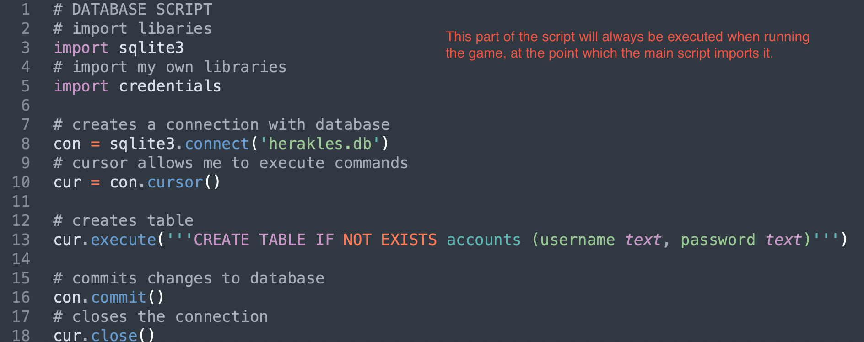

Here, I made three functions in my database script: ‘isAccount’, ‘createAccount’ and ‘loadCredentials’.

The function ‘isAccount’ takes the player’s username and password as the two parameters, from the two tkinter entry fields. It then connects to the database and searches the ‘accounts’ table for a record with the username and password given, if an account is found then the function returns ‘True’, if not it returns ‘False’. This function is used during the login process. 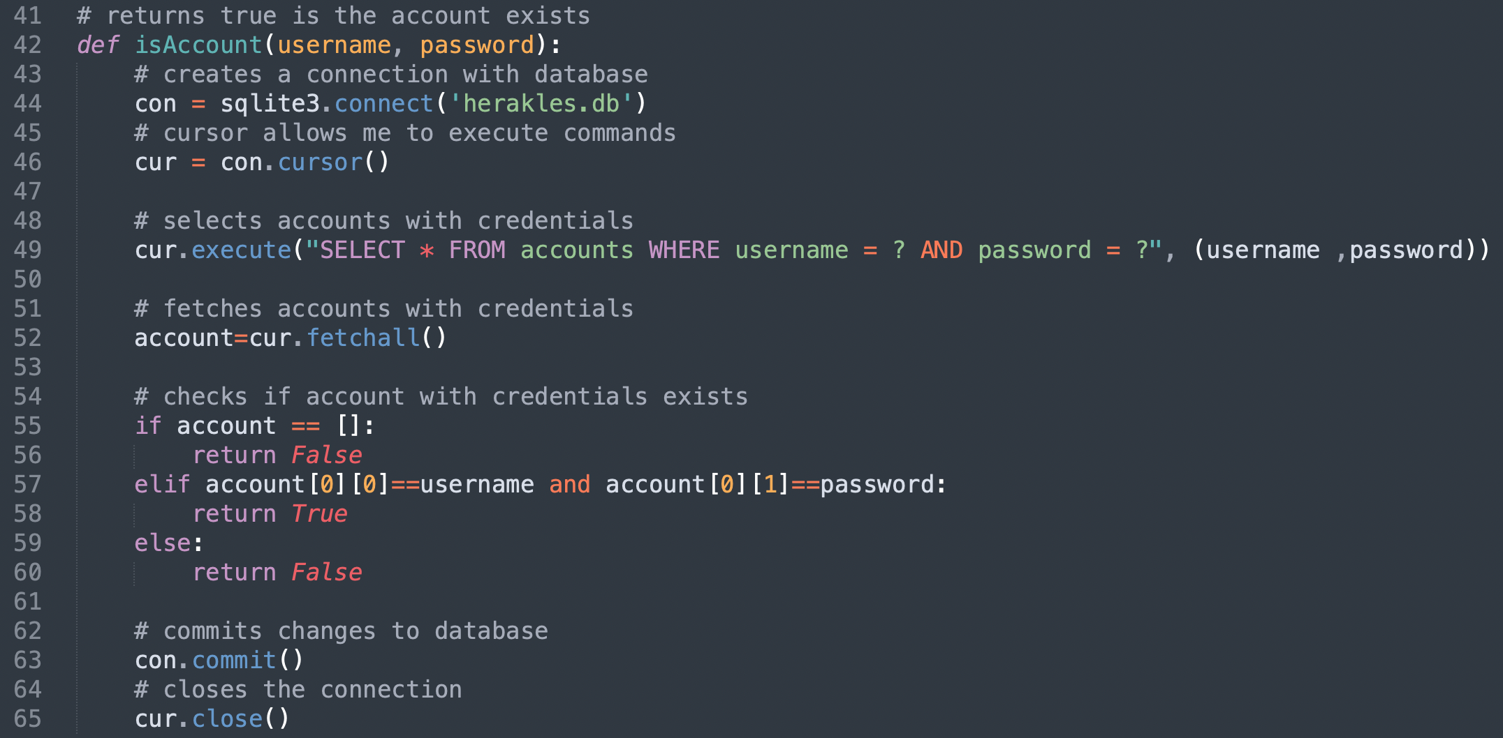

The ‘createAccount’ function takes the player’s username and password from the ‘create an account’ window’s entry fields as parameters, connects to the database and creates a new record in the ‘accounts’ table.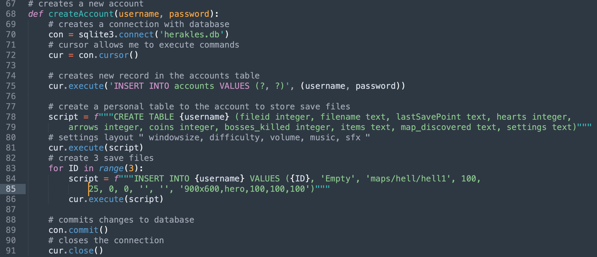

The third function, ‘loadCredentials’, again takes the player’s username and password as parameters, connects to the database and retrieves their record from the ‘accounts’ table and returns the whole record.

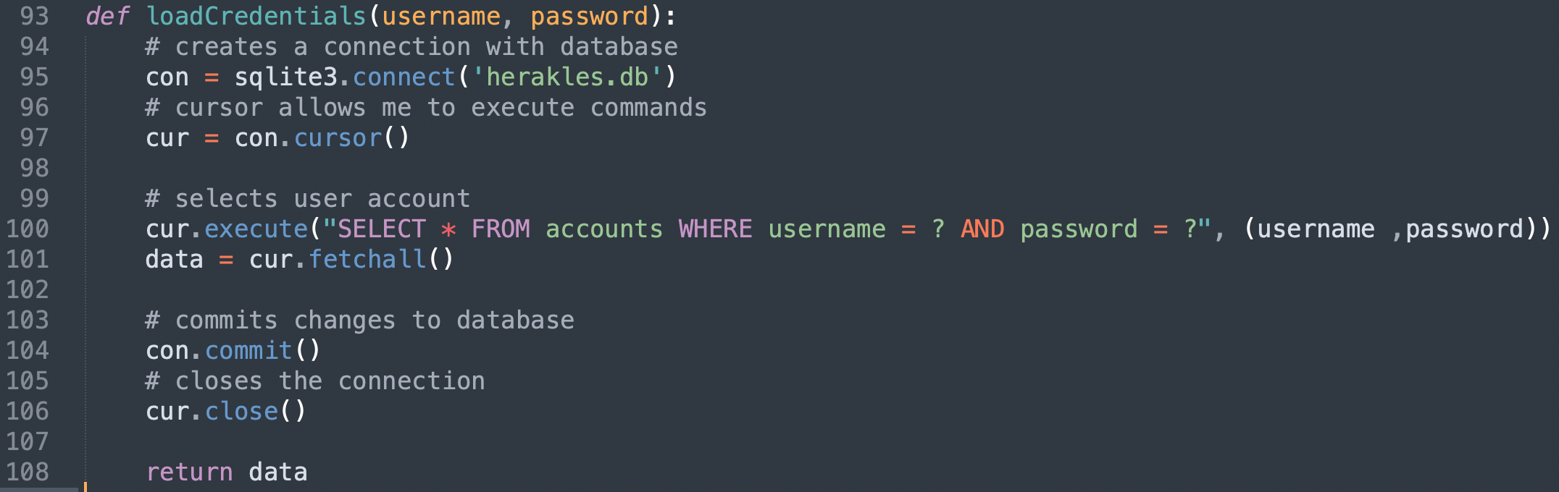

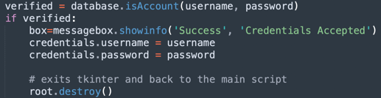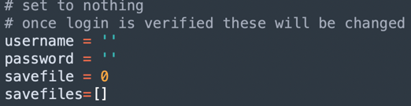The ‘credentials’ script isn’t much of a script as it’s implemented more like temporary storage for easy access from other script. This was my solution to the problem that tkinter cannot return data as it’s simply a GUI library and the only way to return from it to the main script is to destroy the root. Therefore, I’ve had to implement the ‘credentials’ script which is used to store the user’s credentials as two variables; once the user is logged in and confirmed from my database function but before the tkinter script terminates, the variables within the credentials are called to store the user’s credentials from the login script. Then, when the program returns to the main script, the credentials script is used to retrieve the user’s credentials to load their data straight into the main script to be used within the rest of the game.

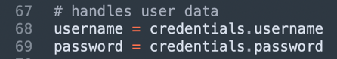The credentials variables are initialised in the script. Then used to store data in the login menu. Finally, the data is retrieved in the main script.

### Testing 3

When testing this stage, I wrote another function called printAll which selects and returns all the accounts in the database which allows me to view what is in the table at a specific time in the code and see how the functions change the table.

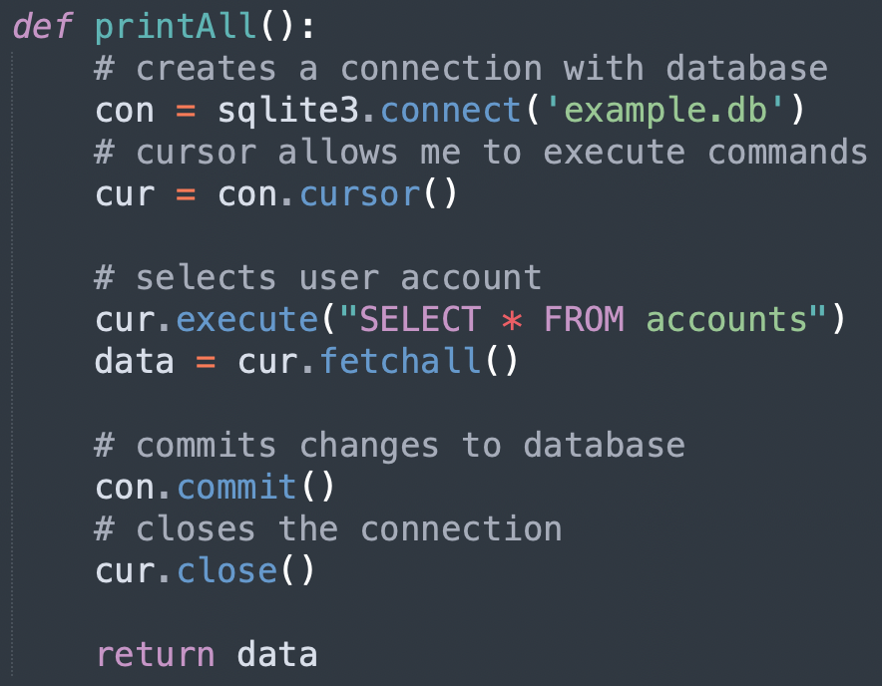

My testing script is:

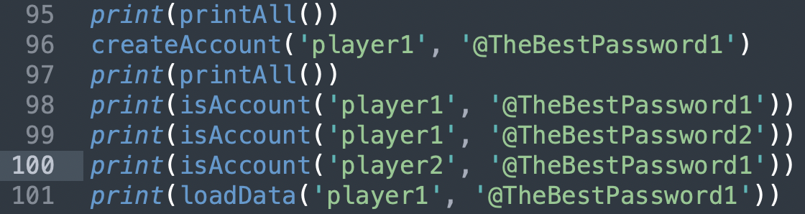

Line 95 checks what already exists in the table (which should be empty). The next line, 96, creates an account and 97 will allow me to check if the account was created and inserted in the database. Lines 98, 99 and 100 allow me to check if the isAccount function works properly and the last line will test if the loadCredentials (loadData) function works as it should.

The output:

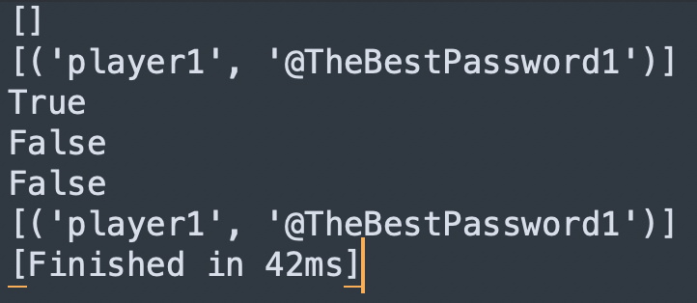

|  |  |  |
| --- | --- | --- |
| Test | Expected Outcome | Actual Outcome |
| Test for isAccount function | To return false is the account does not exist, and true if the account does exist and both the username and password match with the account in the database. | It works for correct values as inputs. It also works for both wrong username and password. |
| Test for createAccount function | For a new record to be added to the accounts table with the credentials given to the function. | The createAccount functions works perfectly as in the test is created the account’s new record in the database. |
| Test for loadCredentials function | To return the record of the account whose credentials are passed into the function. | This works as intended. |
| Do the accounts save to the database so that if the program is closed and reopened the account still exists? | Yes | Yes |

### Review 3

In this stage, I created some of the backend functionality for the game. This system with the database will allow the user to create an account and save their progress to the account. These functions, integrated with the login menu, will allow users to login and retrieve their data. This also makes the create an account menu fully functional too. Looking back now the loadCredentials functions is useless and there’s no point in using it but I learnt how to load data from a database which I will be using in my future functions.

The credentials script developed in this stage also allows me to have access to the user’s credentials and load their data from the main script.

The next step is to develop the save files for each account, create a selection screen/menu and then be able to load the selected safe file.

## Stage 4

In the fourth draft, I decided to develop loading the save files. To do this, firstly in the createAccount function I made it so that it creates a table called the username of the account and to then add three records with default data inside for the three records. I created a save file select menu where the user can select one of his three save files on his account. This process starts from the main script which now has the user’s credentials from the login process, which now loads the user’s table of save files, with the ‘loadSavefiles’ function in the database script and stores the save files in the credentials file temporarily as a list of three, from here the ‘display_savefiles’ script is called which extracts some data from each save file and displays them in a Tkinter window. Once the user chooses a save file, the index of the save file is stored in the credentials file under the variable ‘savefile’. The program returns to the main script, retrieves the save file index and loads the selected save file into the main script, using the ‘loadSavefile’ function in the database script. In the selection menu, the user also has the option to rename and delete the save files, these functions are both written in the database script called renameSaveFile and deleteSaveFile. Now with the save file loaded, the program is ready to start the game.

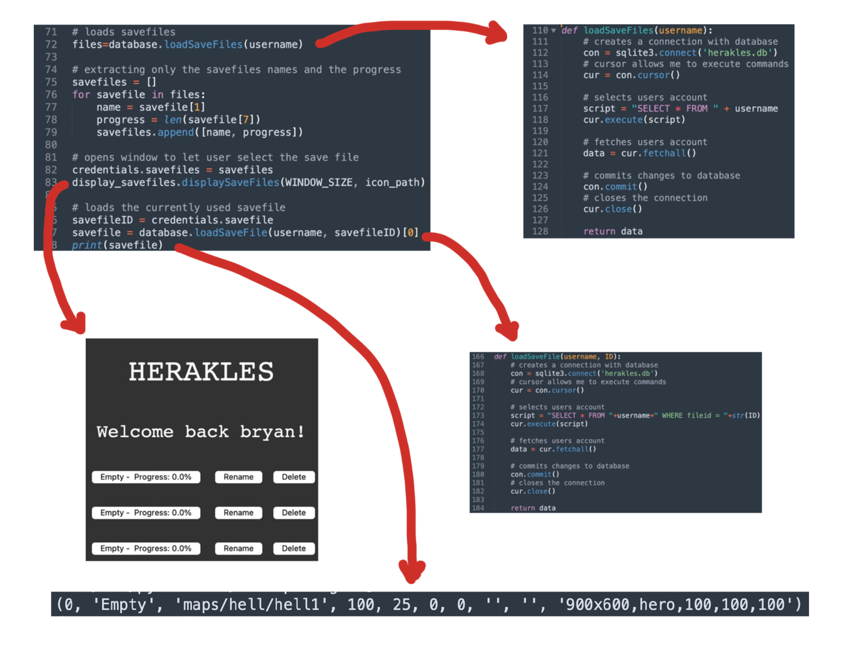

### Testing 4

|  |  |  |
| --- | --- | --- |
| Test | Expected Outcome | Actual Outcome |
| Are the username, password and save files loaded into the main script correctly? | Yes |  |
| Selection menu displays the save files correct | Yes |  |
| The correct save file is loaded in the main script | Yes | Yes |
| Renaming a save file changes the name | Yes |  |
| The save file is non-volatile, e.g., the name is saved in the database so next time opening the program the same names are shown | Yes | Yes |
| Deleting a save file resets the save file to the default settings and name. | Yes |  |

### Review 4

In this stage, I developed the save files for each account, the creation of them and the functionality too. This allows for users to have a place to save their data so that the next time they would like to play, they can start from where they last saved previously.

The next step for the program is to start developing the game. Firstly, to load the game and develop basic movement and mechanics. Then the stages after that to develop the main characteristics that’ll make my game stand out.

## Stage 5

In the fifth draft, I decided to develop on loading the game up. For the rest of the project, many of the improvements and changes will be made in the main script and the engine script. The engine script is the script where all the classes I’ll be using in the game are contained and where I hide most of the game logic to make my main script more organised.

Firstly, I created a dummy csv file which contains a 2D array of values, each value represents a 16x16 tile in my game, and imported that into my main script. From there, I created a dictionary in my main script which links each of those values to a path to the image file. Then in the game loop, I loop through the 2D array using two for loops, and create the rect for the tile, append it to a tiles list and then display the tile’s image.

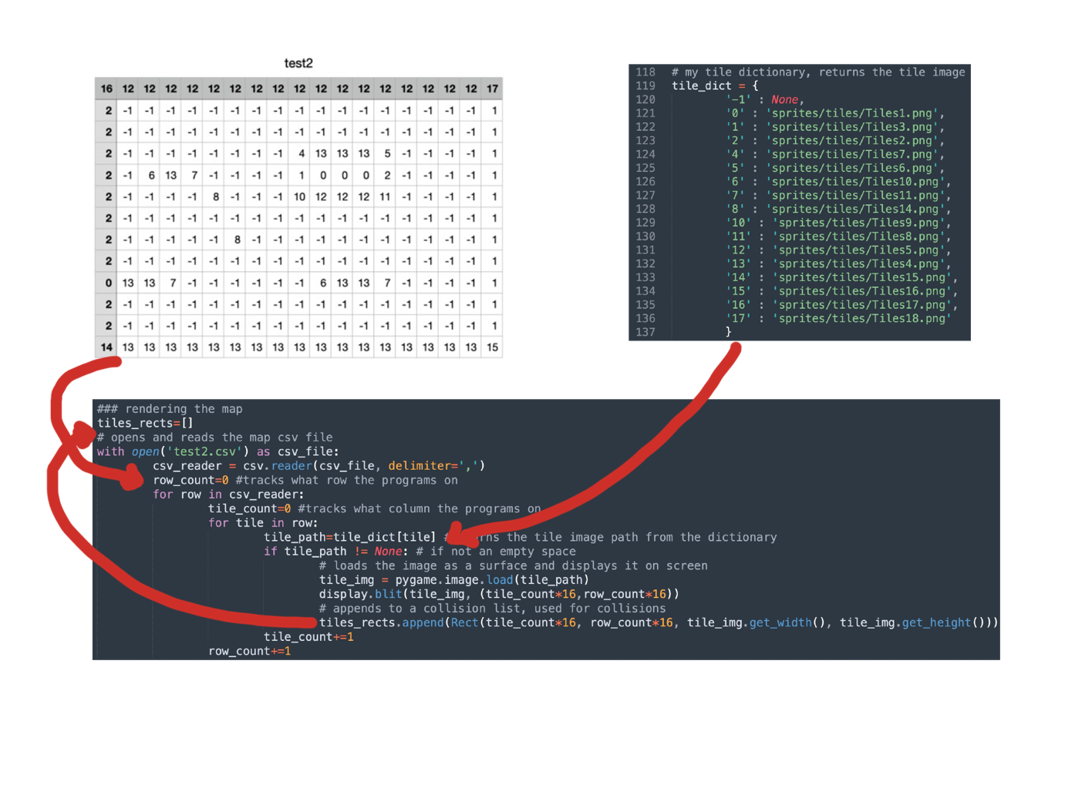

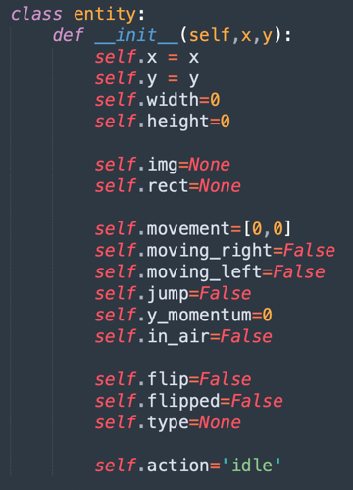

Secondly, in the engine script, I defined an entity class which will be used for my player, the player is defined with attributes at the start of the game, such as the player’s image object, rect object, dimensions, and action placeholders i.e., jump, in air, moving right, moving left and flip. This system is useful as I can now access everything I need about the player in one object. Depending on each keystroke, the players attributes are changed to true or false and the actions on the player are made on the next iteration of the game loop. Pygame use objects called ‘rects’ and ‘masks’ for collisions not the image object so I need to define both separately for each object I would like to display onto my screen.

Thirdly, I defined a class called ‘physics’ which will contain all the sub-routines needed for collisions, so they are easy to access under one class.

My first issue with collisions was when trying to rectify the two object’s positions. For example, in which direction do I move the player when he walks into a wall. For this I created two functions, the first takes an object and a list of objects and checks for collisions between them. The second function takes the player, the list of tiles and the player’s movement values for that frame. It separates the player movement into two vectors, horizontal and vertical movement. Moves the player in the horizontal vector first, checks for collisions using the first function, then moves the player in the horizontal vector and then checks for collision again. Then using the values for each vector, I can determine if the player was moving left, right, up or down and determine where to rectify the player’s position. The function also returns a dictionary which tells me in which direction the collisions occurred, this is used in my main script to calculate if the player is in the air or not.

Now when running the game, a map and player would be displayed and allows the user to move the player.

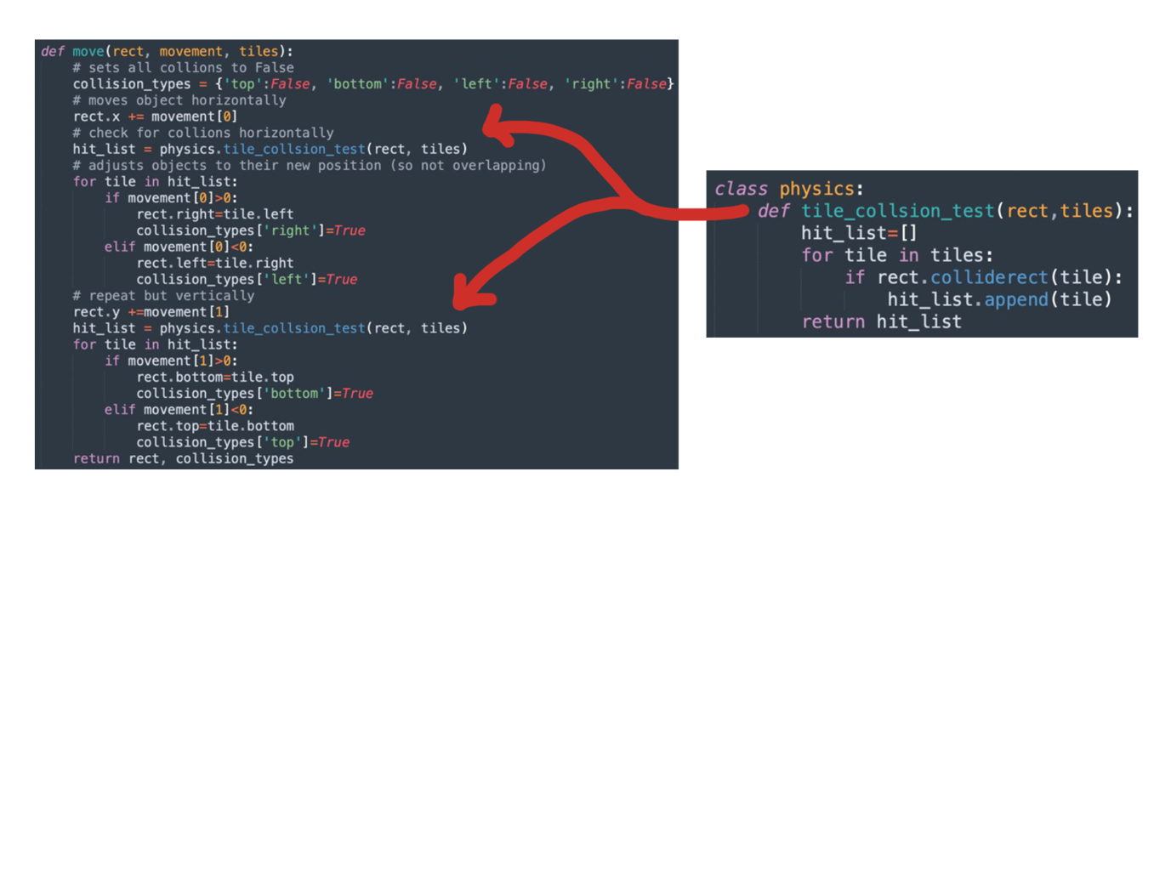

### Testing 5

|  |  |  |
| --- | --- | --- |
| Test | Expected Outcome | Actual Outcome |
| Do the maps get loaded properly? Each value representing the respective tiles. | Yes |  |
| Will the character move left if the ‘A’ or left arrow key is pressed? | Yes |  |
| Will the character move right if the ‘D’ or right arrow key is pressed? | Yes |  |
| Will the character jump if the space key is pressed? | Yes |  |
| Collisions | Collisions between player and tiles are handled and player cannot walk through the tiles nor fall through them. |  |
| Keystrokes trigger the correct event attributes in the player object | I.e. if the key ‘d’ is pressed, the attribute ‘moving_right’ true. | The keystrokes make the player move correctly as intended. |
| Events are handled properly i.e., flipped and in_air events | If the player is moving left, then the flipped attribute is changed to true. Then the image is flipped before displaying it. | The image is flipped (facing left) when moving left. |

### Review 5

In this stage, the basics of the game have been developed. Loading the map from an external CSV file. Movement such as moving left, moving right and jumping. Collisions between player and tiles. These basics features create a foundation for me to build on and create more complex features.

Next, I would like the Point of View (POV) to follow the character so that they’re always in the centre of the screen. I would also like to build a framework to do what I’ve done in this stage, such as reusable functions to load the map and a ‘tile’ object so that both the image and rect are encapsulated into one object. Then, I would also like to develop more complex features such as animations, running and to be able to use weapons such as a club and a bow and arrow.

## Stage 6

Now with the foundations of the game built, in this draft, I decided to build more features and make my code more efficient and simpler. This includes creating more modules in my engine script.

The first feature I wanted to develop was a simple one, I wanted the player to always be in the middle of the screen and for the background to move. To do this I created a scroll list of two values, an x and y value. The scroll value determines how far the player has moved from the top left corner of the screen and I would apply this value to all my coordinates when displaying my images so that every image is relative to my player’s image.

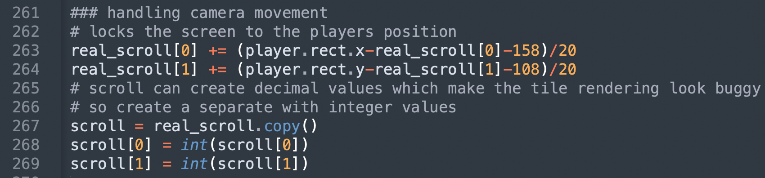

I also altered the math a little so that the player is slightly off centre in the direction he is moving in to create a more fluid motion rather than the player being fixed in the middle of the screen. This came with the problem that this scroll value would sometimes be decimal which would make rendering images look slightly out of sync with another. To fix this, I created a copy of the scroll variable and turned each of the values into integers and used that instead when displaying the images.

Next, I wanted to develop was an animation system in my engine script. I decided to structure this by using two different dictionaries. “Animations” which relates each frames’ animation ID with the image paths of each frame in order. “Animation_images” which relates an image path to a Pygame image object. This allows me to load each animation at the start once then call to these dictionaries to assign the image for that frame. In the game loop, all I need to do to change an animation is fetch the frame’s action ID from the Animation dictionary depending on the current action and the stage at which the animation is at. Then get the specific frame’s image path using the action ID as an index.

For clarity, this is the structure of the two dictionaries:

This image is the structure of the Animation dictionary. Each animation, e.g. ‘club/idle’ has a list of action IDs, each ID is a single frame in that animation, that’s why the IDs are repeated as I want to show these images for multiple frames.



This image shows the structure of the Animation_images dictionary. Each action ID relates to a Pygame Surface object, i.e. an image.

Finally, to display the image, fetch the Pygame image object using the “Animation_images” dictionary and the frame’s image path. To do this, I created a function under the entity class called “set_anim_image” which takes an animation ID and does the computation explained above.

In the main loop, the action frame is incremented, if the animation ended then it would repeat, except special cases described below in the code.

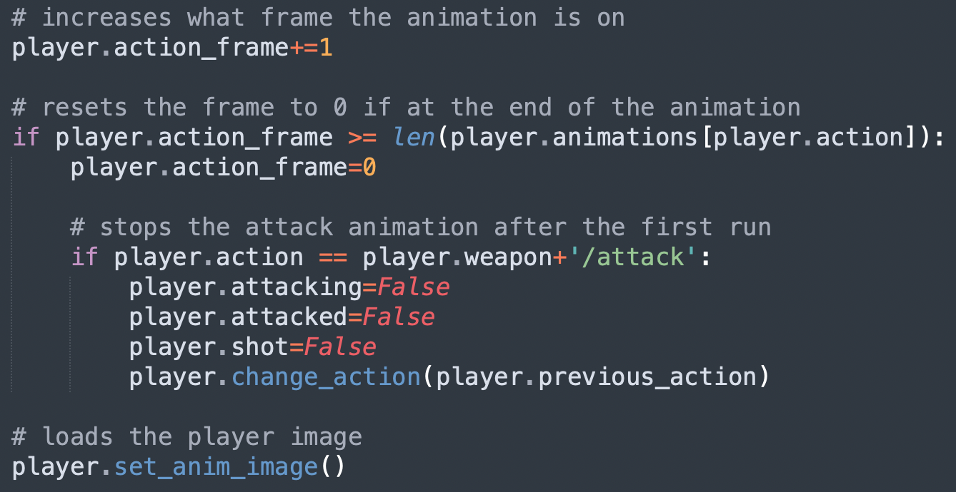

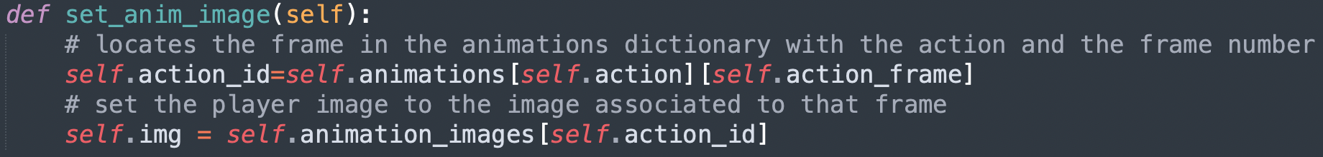

To change the animation, I created another function under the entity class called “change_action” which compares the new action to its current, if different it then sets the new action as its current and the current as the previous. I store the previous as I would like to switch back to the previous action once certain actions play once, for example attacking.

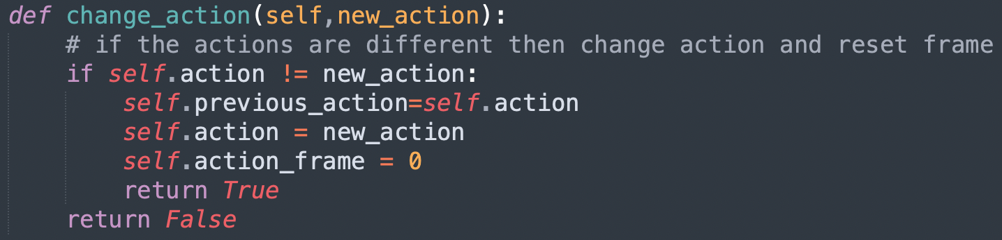

Secondly, I wanted to create a map loader system in my engine script, which takes a CSV file and returns a 2D array of values. This is like before but instead of fetching the data from the file each game loop, I could load it once before the room is loaded and have it until the room changes, this makes my code more efficient. 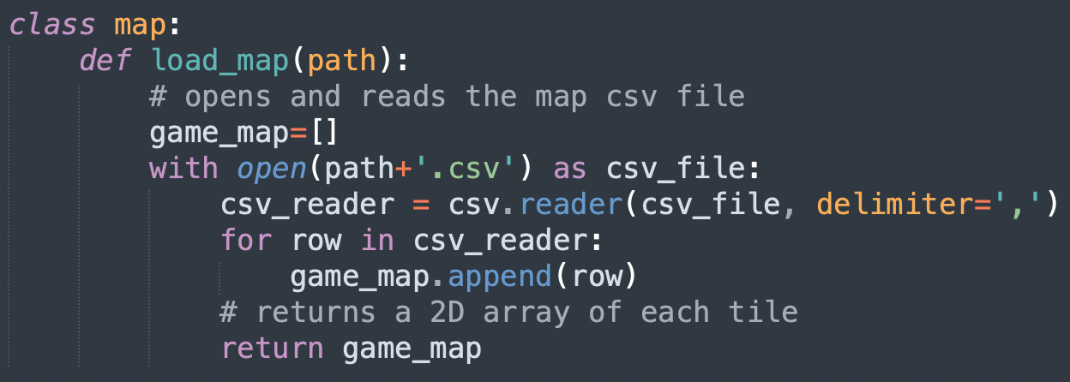

Thirdly, I didn’t like how I was creating each tile a rect and its image in the game loop separately. So, in my engine script, I created a “tile” class which encapsulates the tile image, rect and mask all in one object which is tidier.

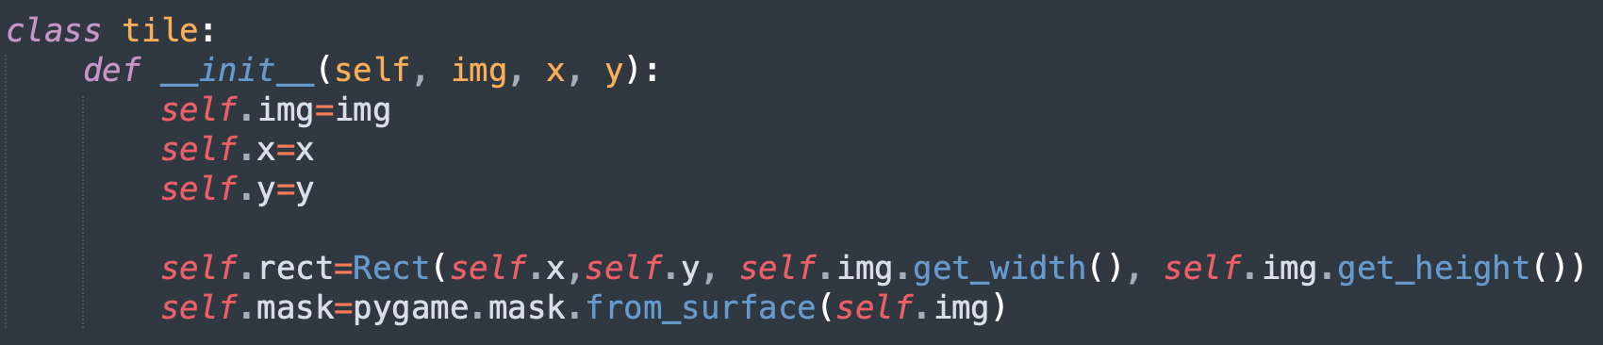

Fourthly, I wanted to implement my player having a bow and being able to shoot arrows as previously the player would only have a club. But firstly, I wanted to display a cursor on screen whenever the player has the bow equipped, wherever the mouse was. Which was as simple as fetching the mouse position each frame, taking into consideration the scale of the window as it gets scaled up. Then displaying the cursor image on screen at the mouse’s coordinates.

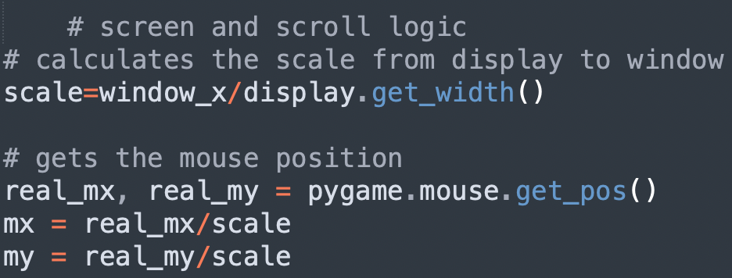

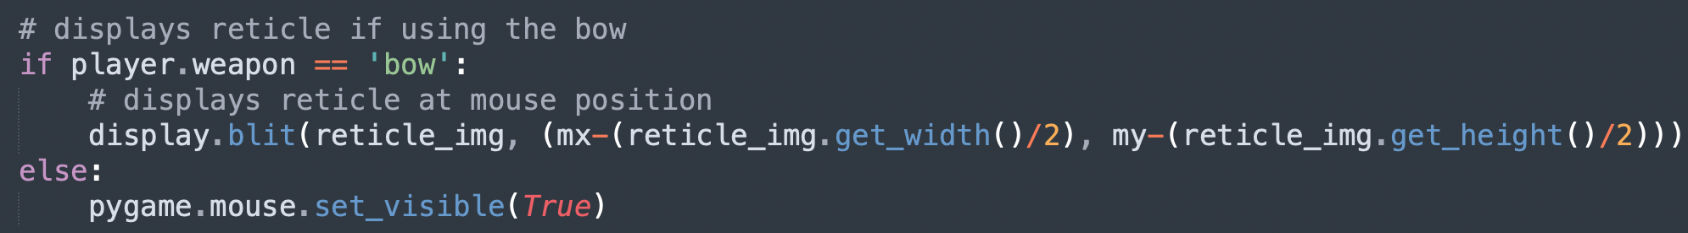

Implementing the bow was easy, I just needed to load new animations before the game loop started and assign new keystrokes to the actions attack and switch weapons.

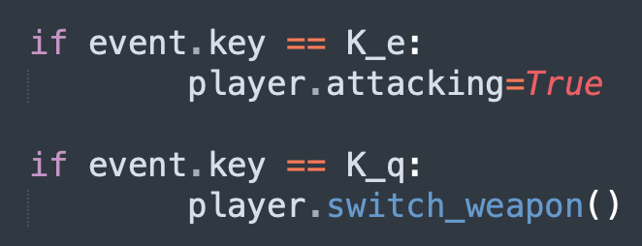

For the arrows, I created a new class in my engine script which creates a new arrow with its own rect and Pygame image. Then I needed to assign the arrow its position taking into consideration the scroll variable in that frame. This all happens when the player is attacking and is using the bow and has at least one arrow. 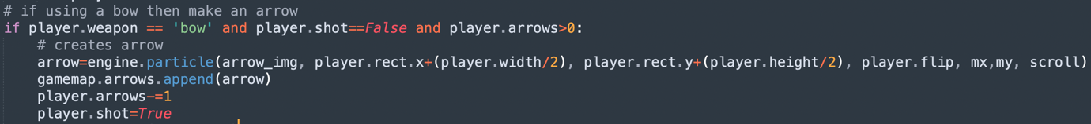

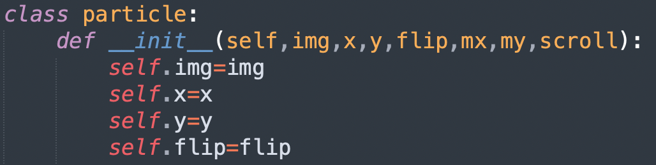

Then I wanted the arrow to move in the vector between the player and the cursor position and for the arrow image to rotate to that vector which took some math to calculate.

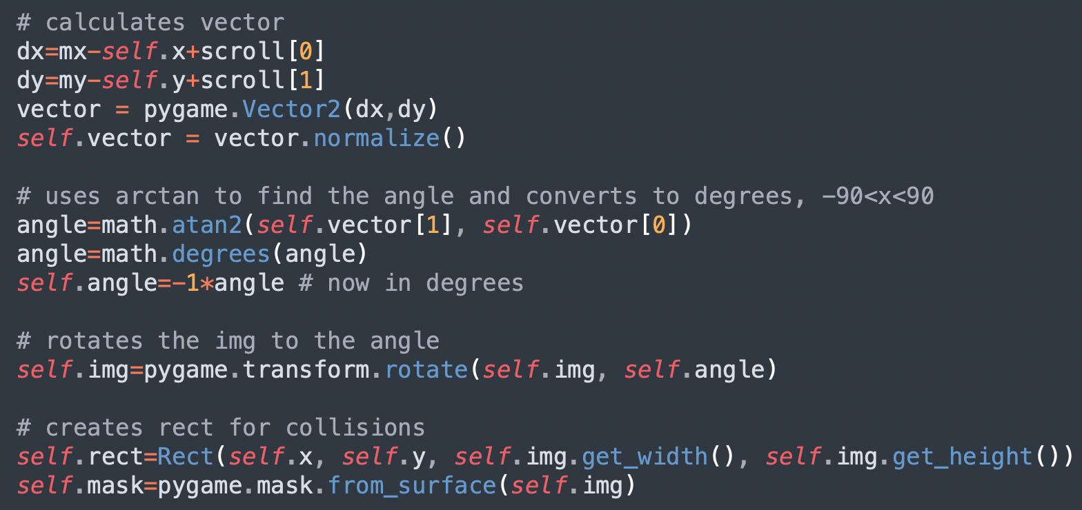

I then implemented collisions using rects between the arrow and the tiles, so that when an arrow collides with a tile it would be destroyed. This came with a problem that the arrow rect was made much larger due to the rotation and therefore collisions with the arrows and tiles were inaccurate. So, I then implemented collisions using masks instead of rects as they calculate collisions pixel by pixel instead of much larger rectangles to rectangles. As I read using masks for collisions was computationally more difficult than using rects in the Pygame documentation, I opted to check for collisions with rects first and if that was true then check for collisions using masks and if they were both true then destroy the arrow instead of solely using masks as this would be inefficient and could slow the program down if there was lots of arrows and other particles on screen.

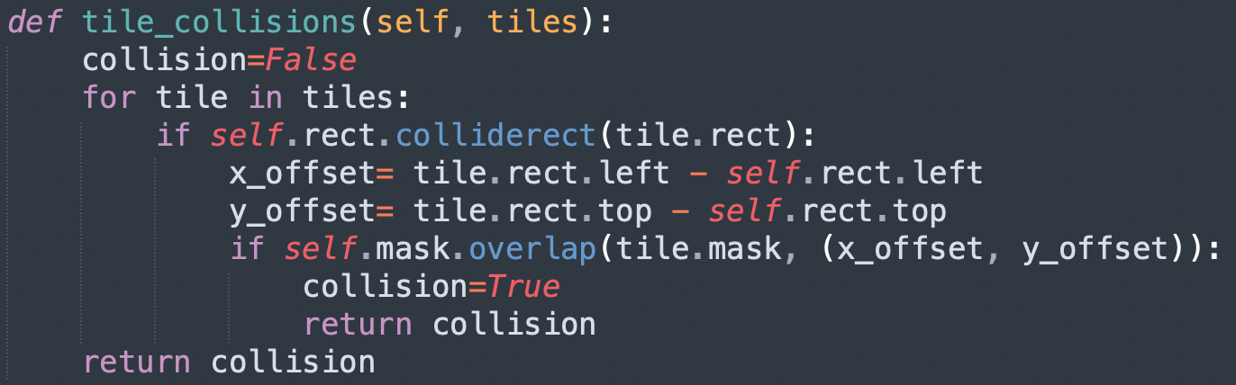

I also altered the main script from the last draft so that I display all my images at the end of each iteration of the game loop for tidiness, after all the calculations about what was happening in each frame.

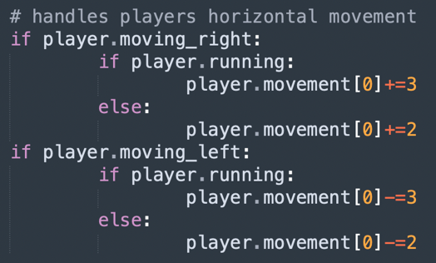

Finally, I wanted to implement the feature to make my player sprint, for this I created a new keystroke assignment and made it so when the user is holding down the shift key the player would move at a larger speed.

### Testing 6

|  |  |  |
| --- | --- | --- |
| Test | Expected Outcome | Actual Outcome |
| Does the player stay in the middle of the screen? (With some smooth lag) | Yes | Yes |
| Does the map loader work properly? With different files? | Yes | Yes |
| Do the tile objects work as they should? | Yes | Yes |
| Is the player animated? If there’s a change in action, does the new animation show? | Yes | Yes |
| Does the reticle/crosshair for the bow display when the bow is equipped? Is it in where the cursor was?  Does it follow the cursor movement? | Yes | A picture containing clipart  Description automatically generatedYes |
| Do the arrows travel from the centre of the player in the direction of the centre of the crosshair? | Yes |  |
| If an arrow collides with a tile, is it destroyed? | Yes | Yes |
| If holding down the ‘shift’ key, is the player moving at a higher velocity? | Yes | Yes |
| Does the ‘Q’ key switch between weapons? | Yes | Yes |
| Does the ‘E’ key show the attack animation? | Yes | Yes |

### Review 6

In this stage, I have developed a lot. The main game mechanics have been developed such as attacking and using different weapons. The frameworks for using a bow and arrow and for animations has been built which makes implementing new animations very easy. The visuals of the game have been enhanced as now the character stays in the middle of the screen. Creating the modules for the map loader and the tile creator class makes the code more efficient and reusable as I will expand the code.

Next, I will try to refactor some old code which I think needs to be reworked to improve efficiency. And then I will try to develop the in-game display of the menus and item counters.

## Stage 7

In my seventh draft, I decided to go back and refactor my code to make it more efficient and shorter. I started with the animation loading and created a loop instead of individually loading each animation. 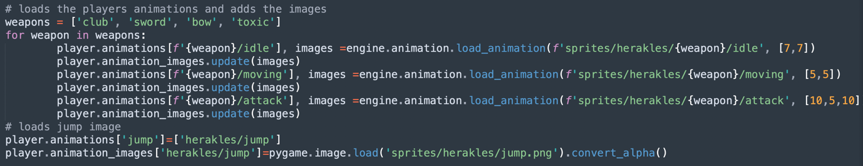

I also refactored my login menu using a class system to fix the issue of having functions within functions. This also helped reduce the number of parameters I was passing into functions as I could now save some values, such as window size and the icon, as attributes in the class and use them in all the other functions.

Below is a short sample of the new class system, compared to the previous script.

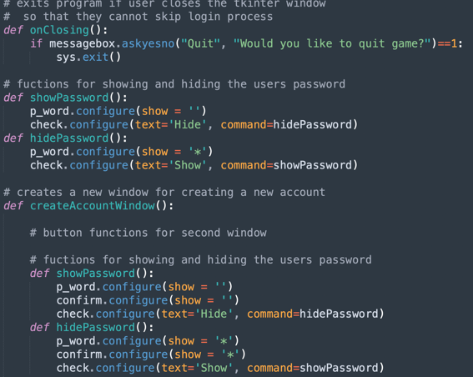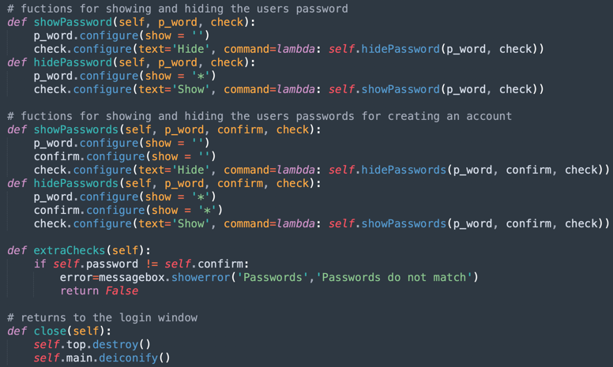

### Testing 7

There isn’t much to test in this stage as I only reworked on some old code, but I will test if the new code still works as intended.

|  |  |  |
| --- | --- | --- |
| Test | Expected Outcome | Actual Outcome |
| Does the login system work the same way as the old system did? | Yes | Yes |
| Do the animations load properly and work as they are meant to? | Yes | Yes |

### Review 7

In this stage, I only reworked some old code, but I can now go back and create some new features such as creating the in-game displays and menus.

## Stage 8

In my eighth draft, I decided to create the game HUD. Firstly, I needed to create the player’s heart, arrow and coin counters on screen. Secondly, I needed to implement menus in my game such as the settings menu and the progress menu. I also wanted to save the changes so that the next time the user opens the game, you find the settings the same way he left it.

To create the player’s counter, I firstly displayed the icons for each item in the top left corner of the screen. For the numbers, I decided to create my own font class which takes a sprite sheet of characters, individually splits the characters into Pygame image objects using the “clip” function I created and stores them in a dictionary with their string counterpart as the key. I then created a method which takes a string, surface and location as parameters and displays the Pygame images of each character of the string on the surface given starting from the location given. With this, I can then call this method at the end of the game loop where I display all my images to display the counters’ values.

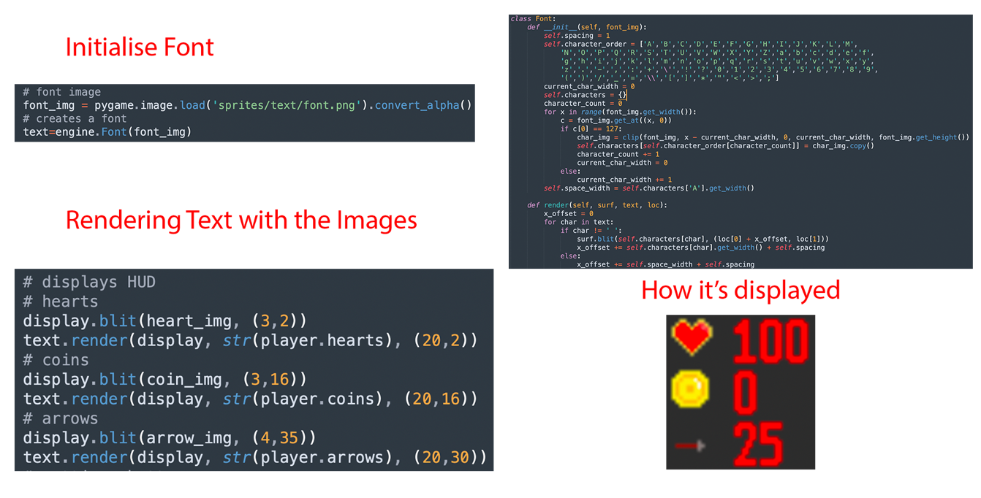

For the menus, I created separate scripts for each, “progress_menu” and “settings_menu”. They both use Tkinter as the GUI library to create the menu. I decided to create the settings menu first, which allows the user to change the window size of the game, difficulty, general volume, music volume, sound effects volume. There is also a button to save the changes and if the user tries to exit the menu a pop-up menu appears warning the user that unsaved changes will be lost. The save command calls to a new function from the database script which is called “save_settings” which saves the settings to the save file. Then the settings are also saved in the credentials file for the main scripts access.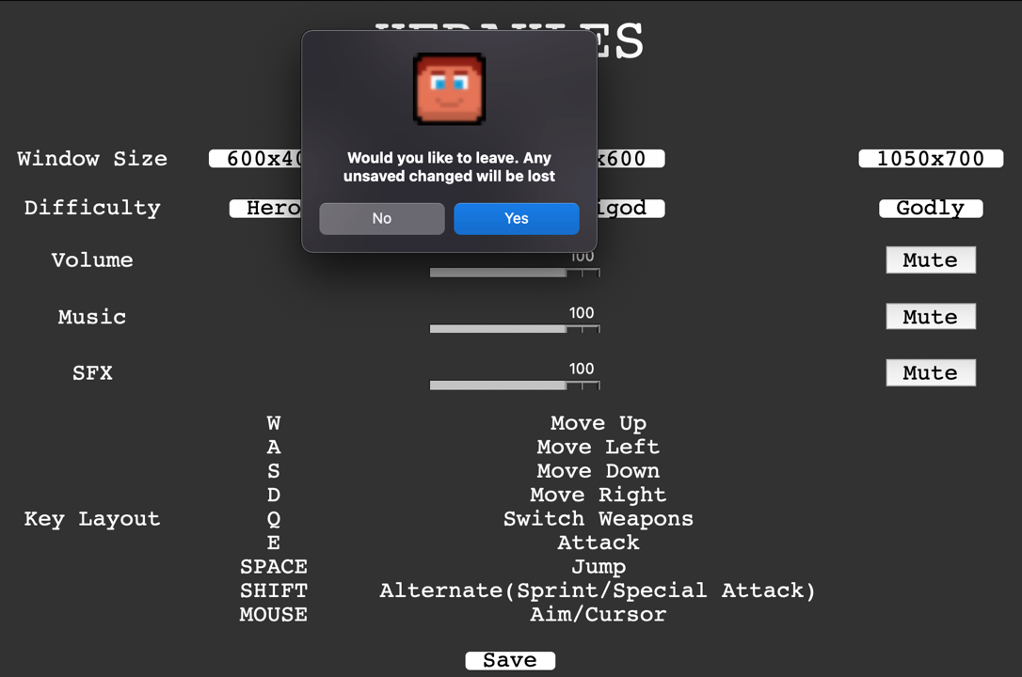

The progress menu script also displays a menu, which allows the player to switch between three menus: Map, Character, and Progress. But I left these menus empty as the game isn’t developed enough to display these menus yet. For example, I still don’t have a map to put in the map menu and I haven’t implemented the game’s story for the progress and character’s menu.

To integrate these menus into the game, I created a button class in my engine script which takes an image and coordinates as parameters and encapsulates the Pygame image, the coordinate values and the button rect in a single object. 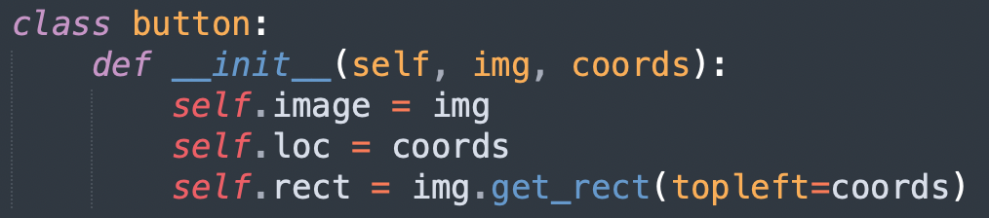

I then displayed the button images in the display section in the game loop. To make it interactable, I made a ‘if’ statement in the game loop which checks if the cursor is being clicked and if the cursor is colliding with the button rect, if so then the Pygame window is hidden, and the respective menu scripts are run. After the settings menu is run, the Pygame window is resized to the new window size and the new save file is loaded.

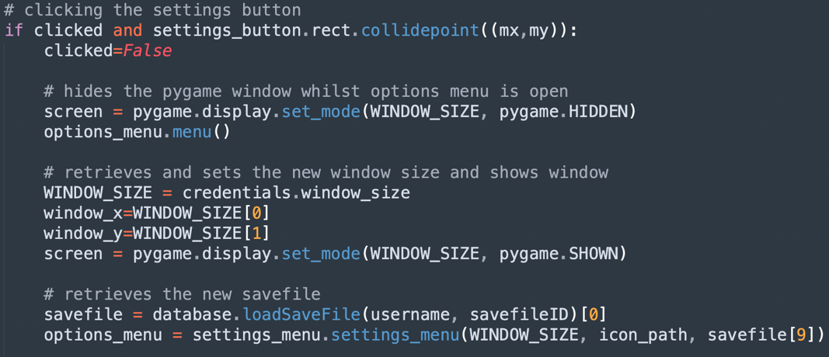

One problem, however, was with the Fullscreen functionality of the game. As the game wasn’t made to perfect scale with my monitor’s dimensions, there was an area on the right of my screen where it would appear pitch black with random colours which was not appealing.

To make it so the window size remains to what the user chooses it to be, I wrote some code before the game loop to retrieve the window size from the loaded save file and adjust the window size to it. 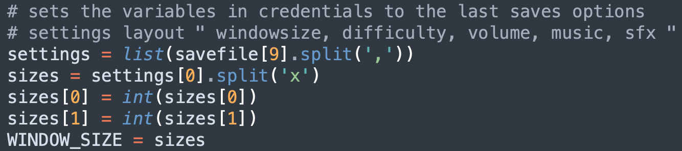

### Testing 8

|  |  |  |
| --- | --- | --- |
| Test | Expected Outcome | Actual Outcome |
| Are the icons and the counters displayed on screen? | Yes |  |
| Does the counter change when the items are used? | Yes | Yes |
| Are the menu icons displayed? | Yes |  |
| Does pressing the menu icons open the menu? | Yes |  |
| Does exiting the menu return to the game? | Yes | Yes |
| Does changing the window screen in the menu, change the game screen size? | Yes | Yes |

### Review 8

In this stage, I developed the display of my game; adding buttons which link to menus and counters which allow the user to see how much health, coins and arrows they have left. This gives the game a more traditional Metroid game feel as they are typical metroidvania characteristics. This helps in completing the success criteria of the game.

Next, I will change the map from the test map into the final map which involves multiple room loading. I will also create a sprite sheet loader as I would like to use multiple sprite sheets for different worlds and environments. I would like to add more images to the environment too, such as a temple which will be my save points in the map. Finally, I would like to add more movement mechanics in the next stage such as a crawl mechanic.

## Stage 9

In draft 9, I wanted to expand my map and stop using the one test CSV file, but instead create a connected map of CSV files, where leaving one will load the next. I also wanted to fix a couple issues I was having with my code and make my main script even simpler by exporting some of the calculations to the engine script.

I started by removing the Fullscreen functionality and opted out for another size. I decided to do this as I couldn’t find a way to fix this problem and I didn’t want to go back and change my screen dimensions for everything.

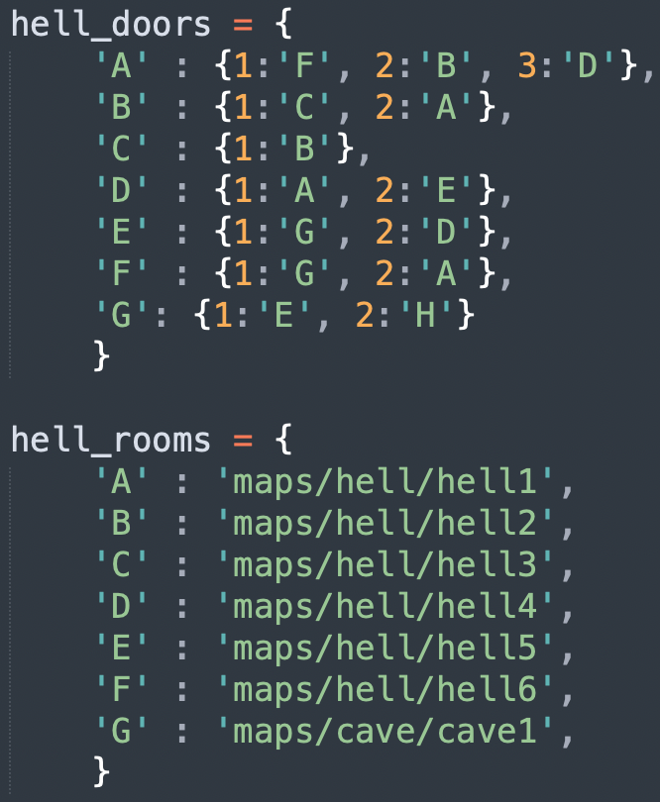I initially considered structuring my map in a 2D array of rooms, but upon further consideration, as I wanted some of my rooms to have two right exits, a 2D array wouldn’t have worked for this map structure without it becoming too complex. Therefore, after some thinking, I structured my map by using two dictionaries in a separate scripted called “room_data”. One determines how each room is related to the others, I structured it with a dictionary of dictionaries; a room ID is the key which returns a list of dictionaries. Each of those dictionaries related a door ID to the room ID it takes you to. I also decided to make my room IDs letters and door IDs numbers to make me less confused when trying to use this system. The other dictionary just simply related the room IDs to the CSV file path so that I can load them.

To expand my map, I developed the next part in my map class. This is so that everything would be encapsulated in the ‘gamemap’ object and make it easier to access the map’s data from the main code, including the different rooms, worlds, enemies and particles. Now the load function not only reads and loads the CSV file, but I made it create the tile objects; this was previously processed every frame in my game loop but now it’s only processed once when the room is loaded and therefore makes my game more efficient.

I started by creating a series of CSV files with empty tiles (doors) to the side. I then assigned a new value in my CSV files to represent doors, 13. Each door is handled separately in my load function, because it has no image, so it’s just a rect, I want to count each door and give it the respective door ID when loaded. 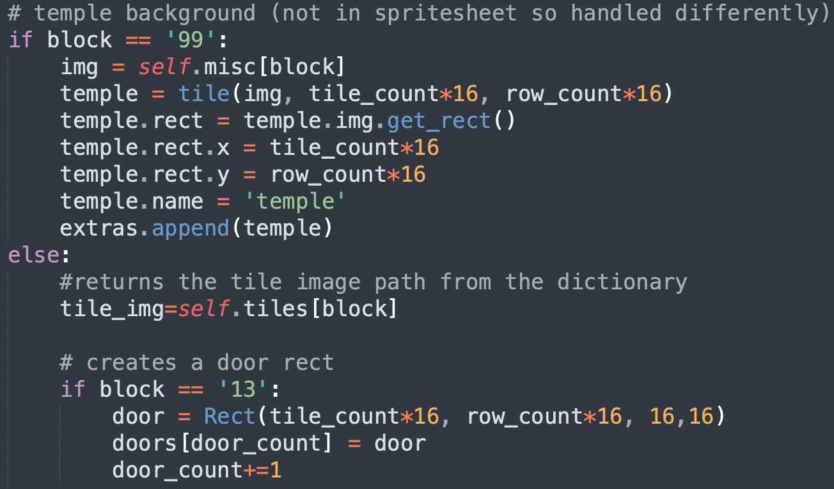

Doors aren’t the only thing I handle separately; I also handle miscellaneous objects, objects which their images are too big to be stored on a sprite sheet. For example, the temple is handled different but still has a value in the CSV file. When that value is found with separate ‘if’ statement, it’s image is found using the ‘misc’ dictionary instead of the ‘tiles’ dictionary and the image is appended to the ‘extras’ list instead of the ‘tiles’ list.

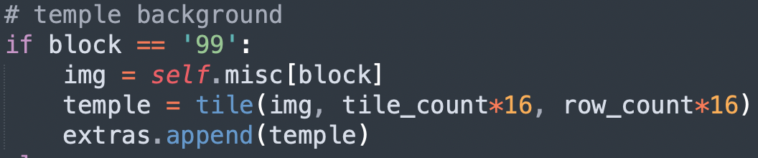

When the player collides with these door rects, the next room is loaded using the door ID and the two room data dictionaries. I also created ‘change’ and ‘get’ methods to retrieve and change the map’s data. The method ‘get door ID’ found the door ID from the dictionaries which was used when changing rooms. 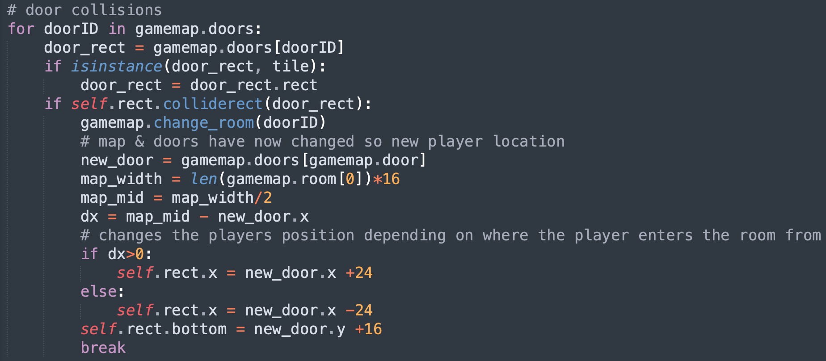

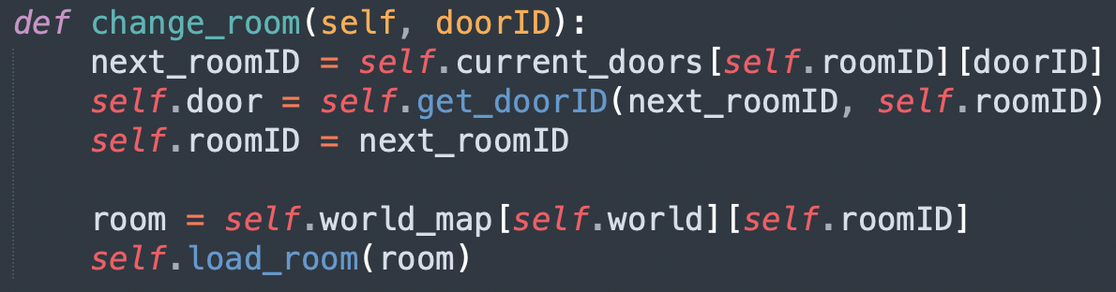

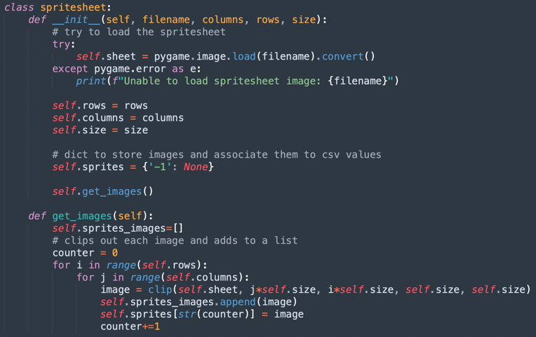Next, I wanted to load more images and different tile sets for different backgrounds and settings. So instead of having every image in a different dictionary in my main script, I decided to create a sprite sheet loader which takes a sprite sheet file and loads and cuts out each individual sprite out of the sheet using the “clip” function and stores it in its own dictionary all under the sheet object.

This came with a problem when cutting each sprite out though, I encountered some errors stating, “not enough memory”, so I decided to refactor my “clip” function in my engine script to make it simpler and more memory efficient.

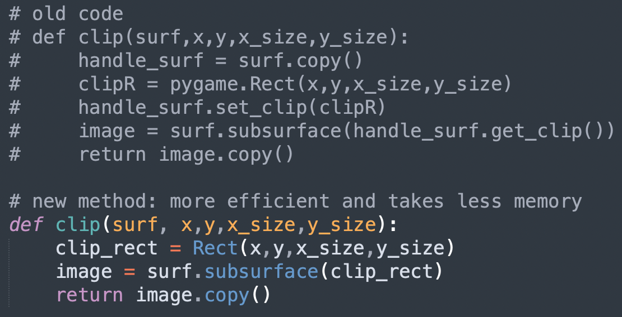

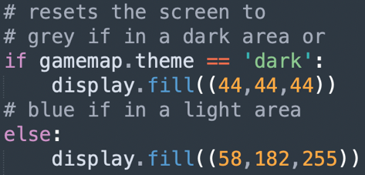As I created my sprite sheets all in the same orientation, the value for a type of tile (e.g., a corner tile) would be the same for each sprite sheet. So, all I need to do to switch between tile sets, is to call to a different sprite sheet. As the different tile sets have different themes (dark theme or light theme), I also created a theme attribute in my map class which is calculated whenever the change_world function is called. Then in my main code, I wrote a few lines of code which makes the background of the game grey if the tile set has a dark theme and sky blue if the tile set has a light theme.

Finally, I wanted to make some changes to the player. When created the maps, I created small tunnels in which the player cannot walk through, I made it so that the player needs to crawl through them. So next I implemented the crawling functionality. I started by creating the sprites for the crawling animation first and loaded it in my main script. Then I assigned a new keystroke, the ‘c’ key, to toggle the crawl action. The crawl animation will play if the player is crawling.

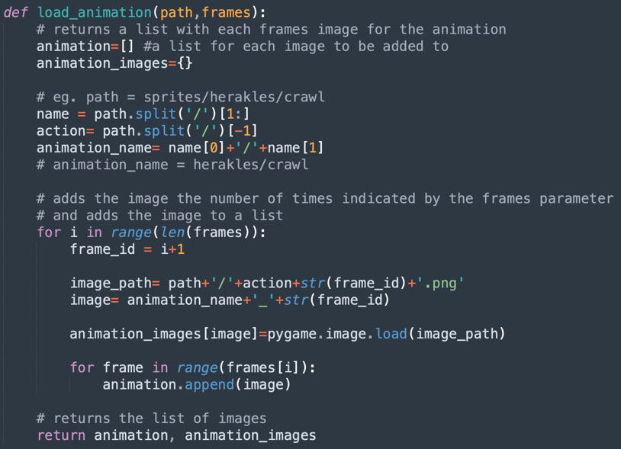

To load the animation, I created a new animation loader method in my animation class called “load_animation” and renamed my previous loader to “load_weapon_animation”. I had to do this as the previous loader only accepted file paths which had a weapon as a folder. As the crawl animation isn’t under a weapon folder, the animation wouldn’t load properly and caused errors in the program. So “load_animation” accepts animations without a weapon folder.

The first problem arose with the sprite size, as I made the crawl sprites much shorter than the standing sprites, when the user goes to crawl, the player starts in the air. This is because Pygame coordinates start from the top left and the coordinates do not get changed when the action changes, the game would detect the player is in the air and the jump animation would play instead; then as the jump sprite is taller than the crawl, the loop will restart. Making this system not work. I decided to make the crawl sprite taller by adding transparent pixels at the top of the image in my image editor.

This caused another error though. As the image is now larger, the rect would be of the same height as the rect of the normal standing sprite which wouldn’t fit in the tunnel. I then decided to use masks for collisions between the player and tiles as well. For this, I created a new method under the physics class called “tile_collisions” which uses the same process as the “tile_collisions_test” but uses masks after detecting a collision with the tile and player rects too.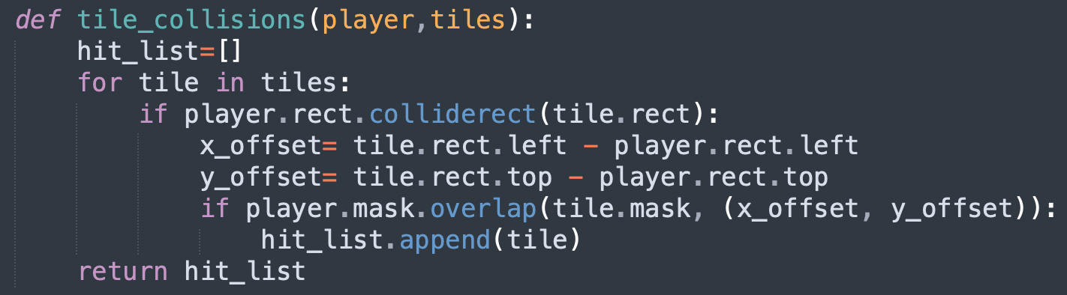

I also exported the game loop code from the main script which handles the player processes to the entity class under the method “move” to make my main loop code neater. I also created a new method called “get_input” in my entity class which would check for inputs what are being held down. Other inputs which check for key presses, I left in the main loop. 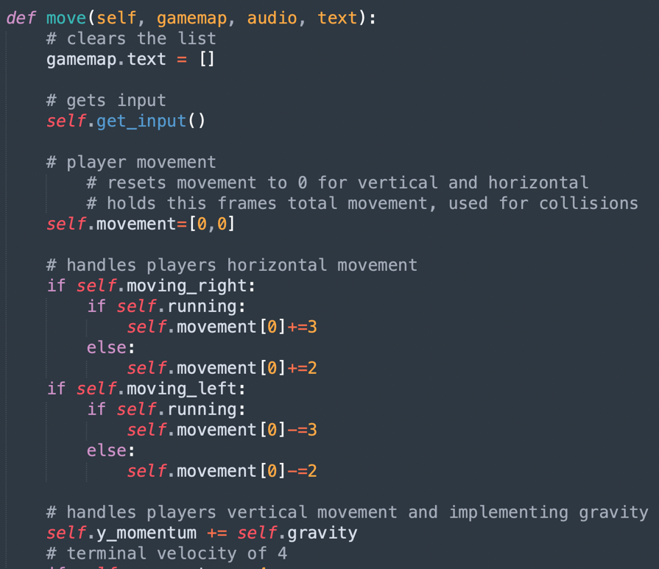

Also, although writing the method “set_anim_image” previously, I realised that I forgot to implement it in my main code, so I did at this stage.

### Testing 9

|  |  |  |
| --- | --- | --- |
| Test | Expected Outcome | Actual Outcome |
| Updated load function works? | Yes | Yes |
| Walking to the exit of one room, loads the correct next room | Yes |  |
| Can you backtrack rooms? | Yes | Yes |
| Is the temple displayed in the correct spot? | Yes | Yes |
| Can I easily change the sprite sheet (new tileset) because of the new loader? | Yes |  |
| Is the correct sky colour displayed for differing sprite sheets? | Yes |  |
| Can the player crawl? Through the tunnel? | Yes |  |
| Do the keystrokes of previous features still work properly with the updated move function? | Yes | Yes |

### Review 9

In this stage, I’ve worked on a lot. The main success of this stage was the development of loading the different rooms, the structure of them and creating a simple interface for it all. This feature, having different connected rooms and environments, is essential in creating a metroidvania and having developed it, is one main requirement fulfilled. Another major feature was the new crawl movement mechanic. Interesting movement mechanics are key characteristics of metroidvanias so developing the crawling functionality ensures that the game will be enjoyable to my stakeholders.

Next, is to implement some music and sound effects (sfx) to the game to create an atmosphere whilst playing the game and to make the game interesting. I will also try to develop multiple types of enemies and implement them into the game. Finally, I will introduce interactable and collectible items.

## Stage 10

For this stage, my goals were to introduce some music, sound effects, allow for changing worlds, introduce different enemies and interactable items.

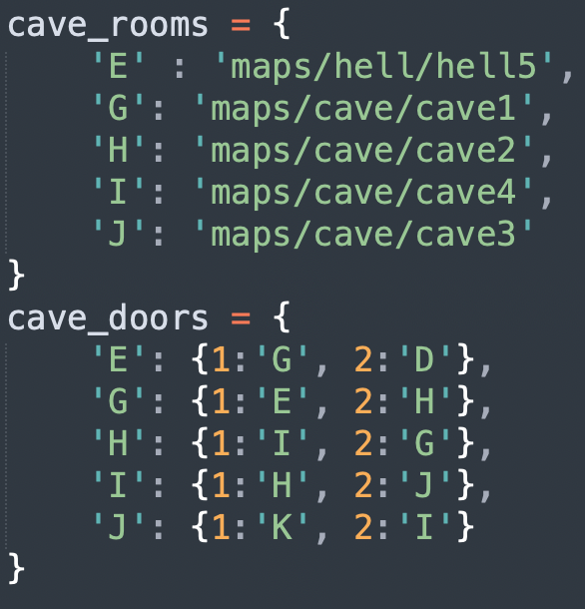

Firstly, as I previously developed for changing rooms, I wanted to develop changing the world. For this feature, instead of using invisible blocks, I decided to use a lightning bolt sprite as my ‘teleporter’ object. It took me a while to get my head around how to structure the new worlds, but I chose to create two new dictionaries for each world, one for the rooms file paths and the door connections (dictionary of dictionaries explain previously). With this new structure I can now link different world together. From now on, I will be creating two new dictionaries from each new world I create.

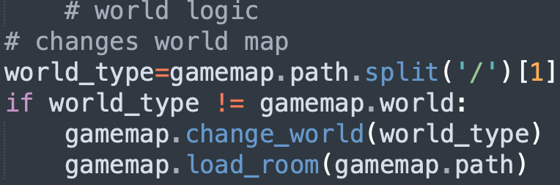

When the player collides with the lightning bolts, it’s handles slightly differently to normal doors, this is because in the main loop the map path is checked for check if the world is the same as the previous loop’s map, if not then the “change_world” method is called on my map object and the tile set is changed to the different world’s tile set.

My next step was to create the enemies. I started by adding them to the sprite sheet and load them as an image, then I assigned each type of enemy to a value. I created three different types of enemies: a standard type, a bull type enemy, and a flying type enemy. Then I added these values in some of my CSV files and added a section in my map loader which checks for these values and creates a new enemy object.

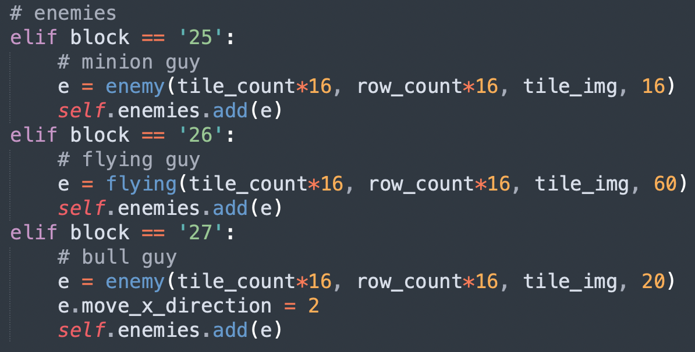

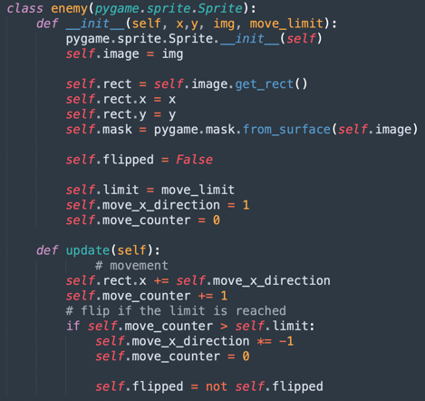The enemies above are created by enemy class which I made it so that it inherits from the Pygame Sprite class, the reason I made it inherit from the Sprite class is because you can group Sprite objects together which would be useful when trying to update and display all the enemies in the game loop as I can look through the one group.

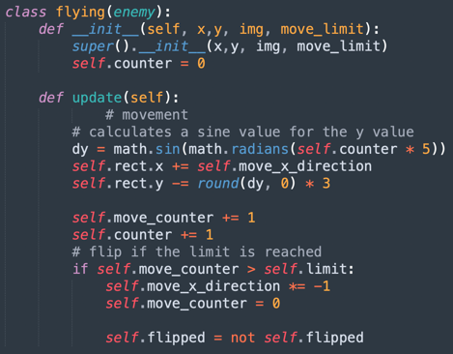I also created a child class of enemy called “flying_enemy”, it inherits the constructor but overwrites the update function because instead of moving side to side, flying type enemies would move in a figure eight. Creating the figure eight movement took some trigonometry to work out. As I made the enemy classes, I found it appropriate to rename the ‘entity’ class to ‘player’ because the class is only used for the player.

Next was allowing the player to kill the enemies and for the enemies to hurt the player. So first I check if the player is colliding with an enemy, if the player is attacking the enemy will die if not then the player will be damaged. The problem with this system is that because the game runs at 60 frames per second, the player would get damaged 60 times a second. My solution to this was to make the player invulnerable for a couple frames after he is damaged. To make it clear to the user that the player was damaged and that he is invulnerable, during this damaged period the player will glow red. 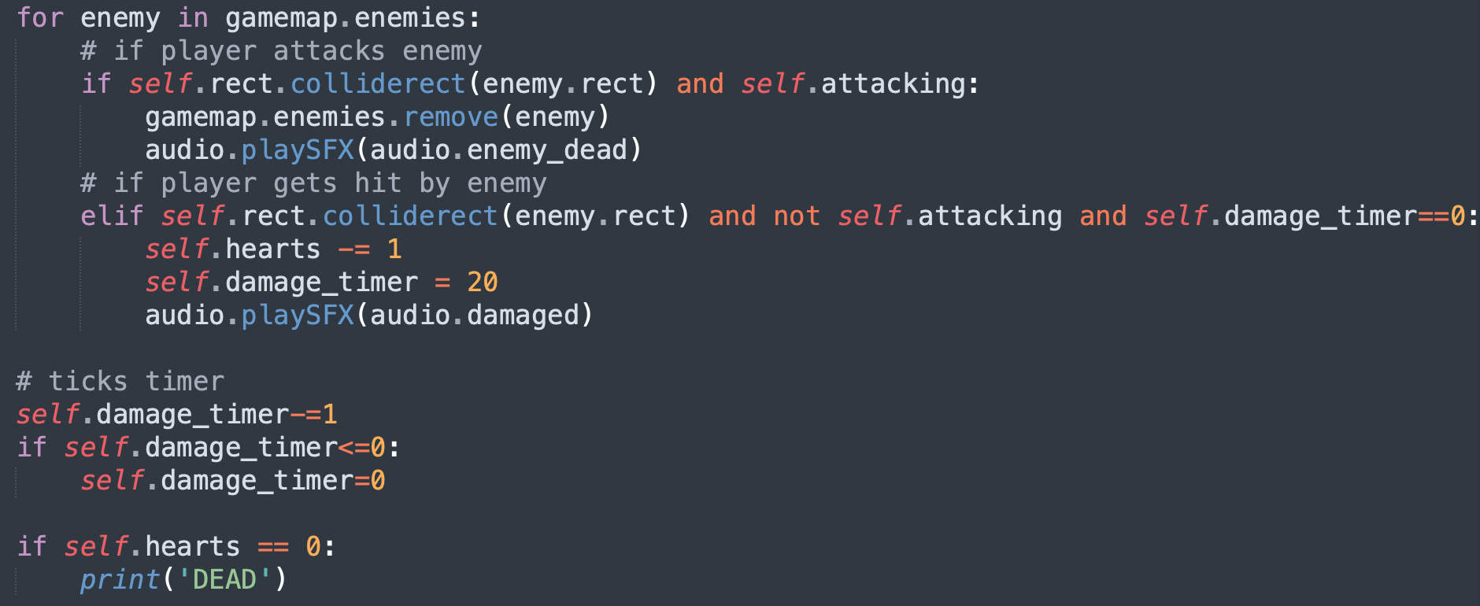

Next was to allow collisions between the arrows and enemies. To do this was relatively simple as I have already made a method under the particle class which checks for collisions called “tile_collisions”. As I will now be using this method for other objects instead of only tiles, I decided to rename the method to “collisions”. Then in the main loop, in the loop where I check for collisions between arrows and tiles, I added a new section which checks for collisions between arrows and enemies, if they collide then both arrow and enemy objects are destroyed.

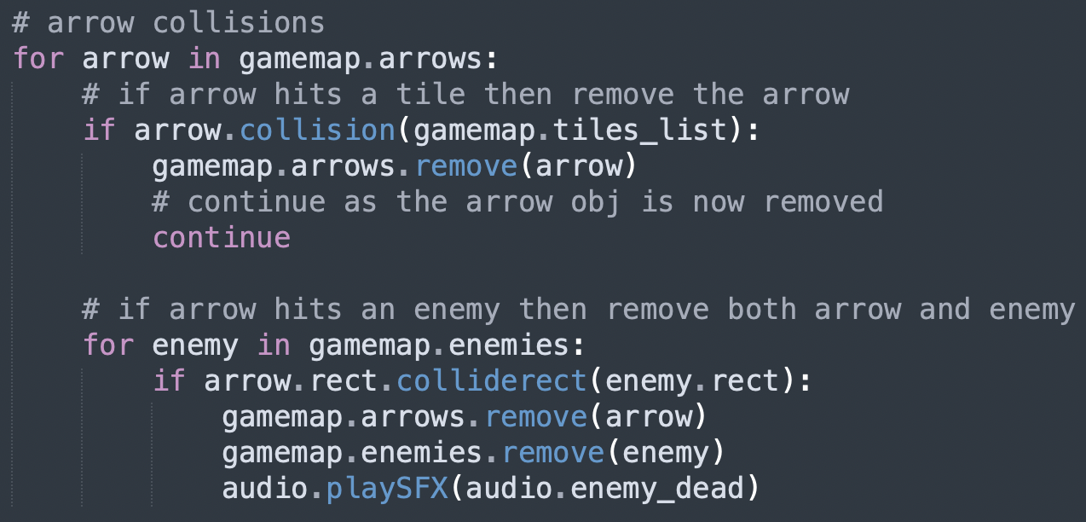

Having interactable objects in the game was the next step. These objects would be hearts, coins and arrows. When picking these objects up the player’s counters in the top left of the screen would increase. To do this, I first created the sprites and added them to the sprite sheet. I then assigned each interactable a number in the CSV files and added them to the rooms. Then in the map loader, I made it check for the interactables’ specific number and if there is one, it would create a tile object with the interactables’ sprite. Then as I would like to check for collisions with the player and these objects, I created a separate list called “items” and append each interactable alongside the item’s name within a tuple to this list, which is stored under the map object. Then in the player move function, I created a loop which checks for collision between the player and the items, then if true then the program looks at item’s name and increases the counter for that item type. For example, if the player collides with a heart, then the heart counter is increased.

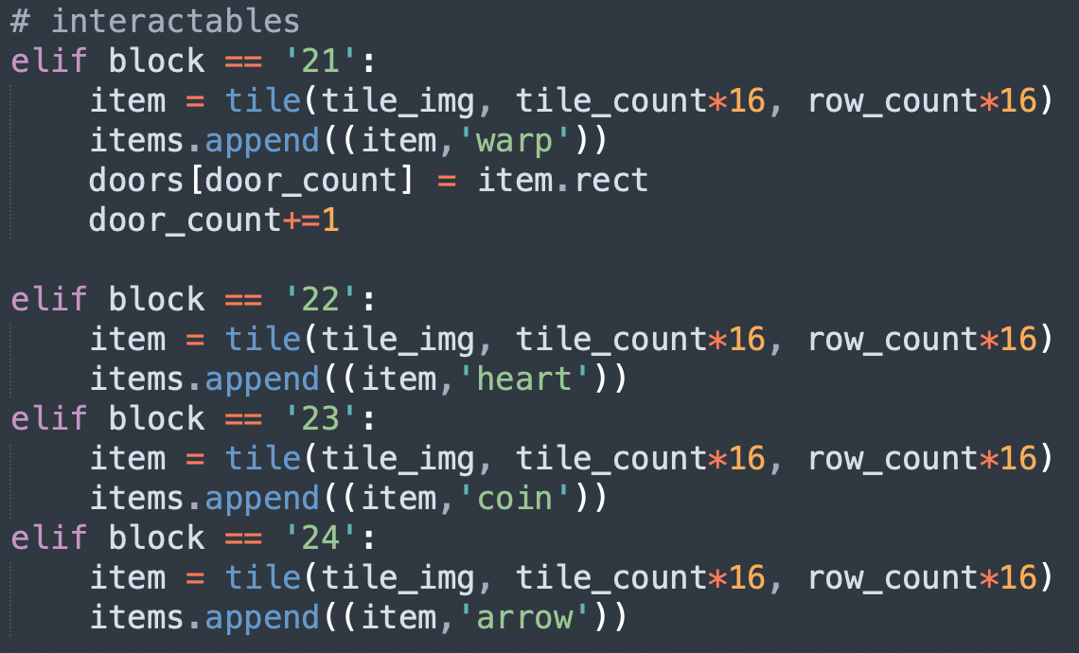

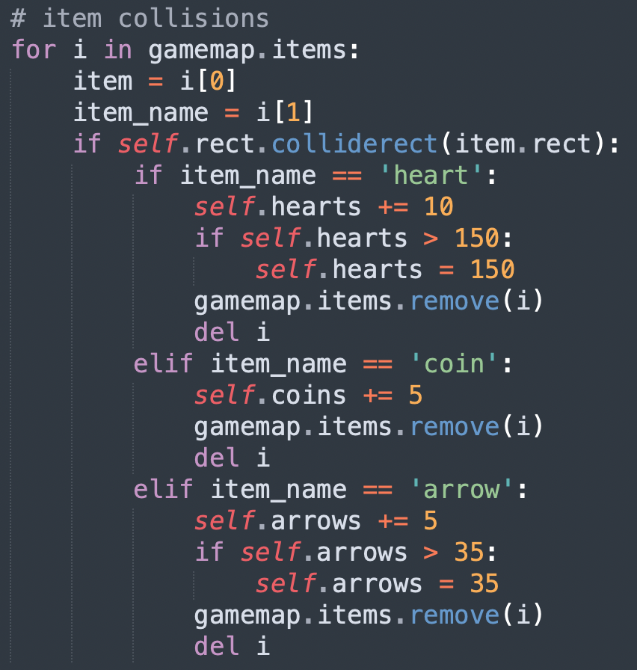

I made a few adjustments in the main script; I update the enemies after moving the player. Then display both the enemies and the interactable in the display section of my main loop. Another simple change is that arrows are not stored in a list in the main script, but now a list under the map object. This just further simplified the game as there now was only a few objects that make up the game: the player, the particles, the enemies, the interactables, the map. Of which the particles, enemies and interactables are stored within the map object itself.

Finally, the last step for this draft was to implement some music and sound effects, firstly I needed to initialise mixer at the start of my main script. I have two different soundtracks to play, one when there are enemies, my action soundtrack, and the other which plays when there are no enemies in the room, my calm soundtrack. To play the correct one, in the main loop the game checks if there are enemies in the room, using the “count_enemies” method of my map object. If the count is larger than one then the action soundtrack will play, else the calm soundtrack will play. 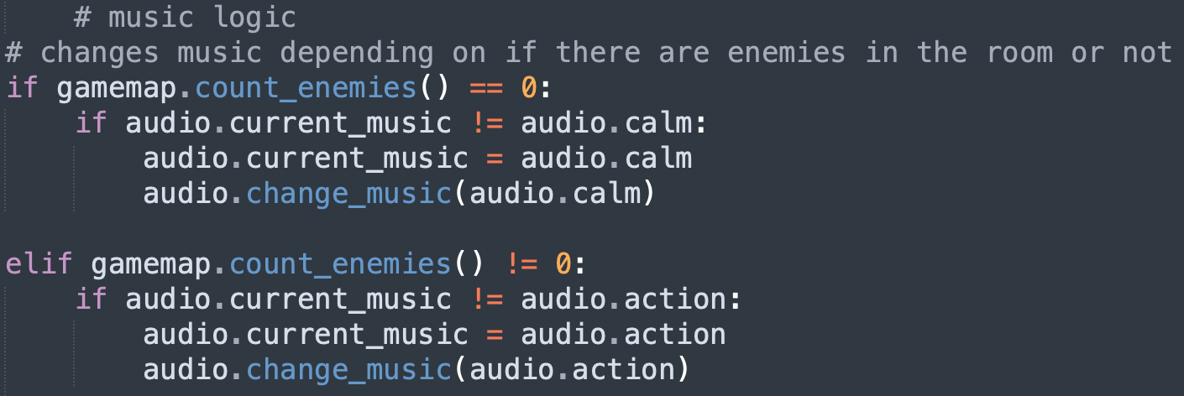

The sound effects I wanted to implement were bow shooting, club swinging, jumping, dying, enemies dying, walking. I play these sounds when these actions are done. But one effect I did remove was the walking sound effect as it is too loud and annoying for the user and when the walking sound effect is playing, the more important sounds can’t play at the same time which caused issues. Some of these have been shown in previous screenshots within this draft.

### Testing 10

|  |  |  |
| --- | --- | --- |
| Test | Expected Outcome | Actual Outcome |
| Is the correct sprite sheet used in different world? | Yes | Yes |
| Are the transitions from one world to another smooth? | Yes | Yes |
| Are enemies moving the correct way? | Yes |  |
| Are enemies facing in the direction they’re moving? | Yes |  |
| Does the player take damage from touching the enemies? | Yes | Yes |
| Does touching the enemy whilst attacking with the club/sword kill the enemy? | Yes | Yes |
| Does shooting the enemy with an arrow kill the enemy? | Yes | Yes |
| Does the character glow red when taking damage? | Yes |  |
| Is the character invulnerable when glowing red? (Can he take damage when glowing) | Yes | Yes, he cannot take damage. |
| Can I pick up a heart item? | Yes |  |
| Does it increase the heart counter? | Yes |  |
| Can I have more than 150 hearts? | No | No |
| Can I pick up coins? | Yes | Yes (picture above) |
| Does it increase the coin counter? | Yes | Yes (picture above) |
| Can I pick up arrows? | Yes | Yes (picture above) |
| Does it increase the arrow counter? | Yes | Yes (picture above) |
| Can I pick up more than 35 arrows? | No | No |
| Does the calm music play if there aren’t any enemies? | Yes | Yes |
| Does the action music play if there are enemies? | Yes | Yes |
| Does shooting the bow make a sound? | Yes | Yes |
| Does swinging the club/sword make a sound? | Yes | Yes |
| Does jumping make a sound? | Yes | Yes |
| Does taking damage make a sound? | Yes | Yes |
| does killing an enemy make a sound? | Yes | Yes |

### Review 10

In this stage, I developed many new features. Changing worlds, different enemy types, interactions with enemies using different weapon types, interactions between the player and different items, music and sound effects. These are important features to include into this project to ensure that I hit my success criteria.

## Stage 11

In the eleventh draft I wanted to develop the saving feature and making the player die when his health reaches zero. These are the final features that I will add to the game. At the end of draft, the game will be able to be played properly as all the functionalities and game mechanics would be developed. All I would have to do is add NPCs, expand the map and create the story with bosses.

I wanted to develop the saving mechanics. I have already put the temples in the game which are the save points. All I must do is allow for saving from these temples. Firstly, I had to adjust the temple rects from the small 16x16 tile sizes to the actual image size. I done this in the room loader module. 

Then, I wanted text prompting the user to save by pressing the interact button (the key v) when touching with the temple. I detected the collision in the player’s move function. Which if colliding with the temple, the text “Save – V” would be added to the gamemap’s text list along with the coordinates in which it would need to be displayed, above the temple image. This text list is emptied every game loop iteration before the detection, which makes it so that the text only displays when the player is colliding with the temple. The text is then rendered using the font object and displayed in the main game loop. 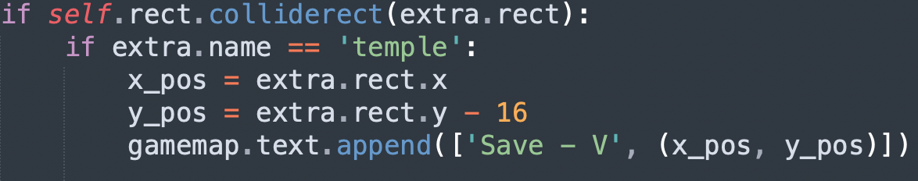

Next, was to check if the user is interacting with the temple, so in the same if statement from before, if the player is touching the temple and is interacting, then the “save” function of the database script is called to save the player’s numbers and position. Before saving, I wanted some confirmation from the user, so I implemented a Tkinter pop up window which asks the user if they wish to save. Only if so, will the data be saved. For the Tkinter pop up, I initialised and withdrew before the pop up then terminated Tkinter right after.

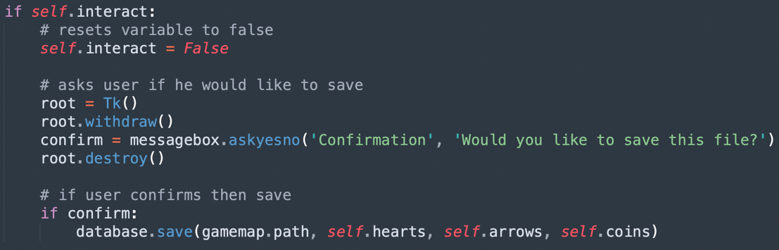

Finally, to see if this feature works, I altered my main loop to read the save file and assign the data from the save file to the player’s attributes before the main game loop starts. This only allowed me to see if the player’s numbers (hearts, arrows and coins) were saved though. So, to check if the save point location worked too, I created another room in the cave map section to also check if spawning into another world would work too and use the appropriate tile set.

The next mechanic to develop was the death of the player. For this, I check if the player’s hearts are equal to or less than zero in the main game loop, then if they are, load the death screen which is like the title screen and asks for the space bar input to continue. Then the latest save file is loaded into the main script which loads the game from the last point which the user saved from. Finally, I added a death sound effect which would play when the player dies. 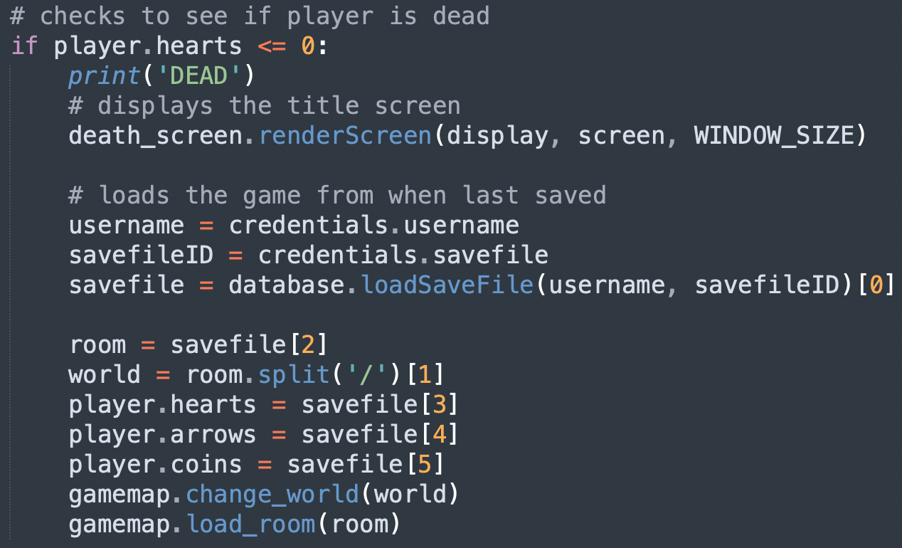

I also made some adjustments to the player’s action mechanics. One adjustment was to make the player unable to jump when crawling, I made this adjustment as I noticed that when I’d let stakeholders test the game, they would frequently try to jump in the tunnels which would bug the collision system and teleport the player out of the map.

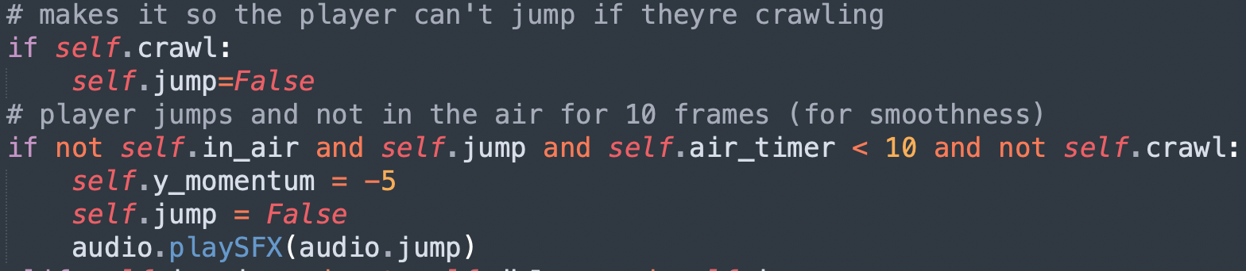

The next adjustment was with the player’s attacks. I adjusted attacking with the sword/club so that the player can only attack with these weapons when on the floor and not in the air.

The other adjustment with these weapons is that collisions between player and enemies would only kill enemies when using these weapons, this removed the fact that when using the bow, the user could shoot at one enemy and walk into another and kill both. So, when using the bow, the player will always get damaged if they touch an enemy. 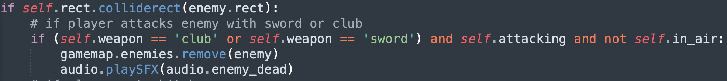

### Testing 11

|  |  |  |
| --- | --- | --- |
| Test | Expected Outcome | Actual Outcome |
| Is there the save text prompt when approaching a temple? | Yes |  |
| Does pressing the interact key (V), display the confirmation prompt? | Yes |  |
| Are the characters numbers (health, coins and arrows) and the last save point saved and loaded when reopening the game? | Yes | Yes |
| If hearts reach zero, does the death sound play? | Yes | Yes |
| If hearts reach zero, does the death screen display prompting the user to press space? | Yes |  |
| Does pressing space close the death screen? | Yes | Yes |
| Does the last save load after the death screen? | Yes | Yes |
| Can the character jump when crawling? | No | No |
| Can you attack with the club/sword if in the air? | No | No |
| Does the character take damage when using the bow and in the attack animation if they walk into an enemy? | Yes | Yes |

### Review 11

In this stage, I developed the saving feature. This feature is one which I outlined in the success criteria and is seen in other solutions such as Metroid. This allows the user to save and keep their progress and play later and continue from where they left off. This also makes sure that if the character dies, then all their progress isn’t lost.

# Final Testing

In this section, I will evidence all the testing that I conducted after the development stage.

I firstly conducted some testing and feedback from stakeholders. I let them have a play through of the game and the first stakeholder said:

“I believe the game has the potential to be an extremely enjoyable playing experience, as the variety of gameplay mechanics created a new experience for me and served as a good introduction to the genre. I believe that the game could match the level of games currently on the market soon. However, one issue I had noticed was that by leaning against a wall, the games camera would begin shaking. Additionally, the transition between screens was not made immediately obvious.”

The next stakeholder said:

“I really liked the game as it is old school, which I really enjoy. Graphics pay homage to the arcade style and the controls, characters etc. keep to the style. Movement is great and easy to pick up. The only irritation was the login. There is no advice on how to create the username and password and, I kept getting help messages. On the plus side, the messages worked and were clear. I felt the screen that I played had enough challenge however when I left through a door the game stopped so I couldn’t continue. Scoring and lives were clearly displayed and allowed me as a new player enough chances to play the game.”

I gave the next stakeholder a longer period to test out the game, allowing them to be more thorough than the previous two.

“This game is really good!! This feels like I’m playing Metroid on a laptop instead of a console! Honestly a fantastic game and the changing of rooms is very smooth. Small details like turning red when damaged really shows that care has been taken at every step of the way. I tried to break the game as much as I could, from the login to the game mechanics, very robust program. From what I understand, the game is mid-development which is a shame as the story and boss elements haven’t been implemented yet and the full map isn’t explorable. But from the sample I managed to play, I love it!”

From the responses from my stakeholders, I take that the game so far hits the requirements that they asked for at the start of the project, as they enjoy it a lot. Obviously, there are still lots to improve but it is good to know that from what I made so far; the features are getting good feedback. Although from this feedback I will be making some changes such as outlining the login requirements in both login and creating an account screen. Fixing the shaking bug from when leaning against certain walls and platforms. These are easy quick fixes that I can make to my final prototype. Other developments such as expanding the map, story and making the boss fights are going to take up too much time, which I do not have.

I also noticed that I never implemented the difficulty properly, although being able to change it in the menu, nothing changes in the game, therefore I changed the 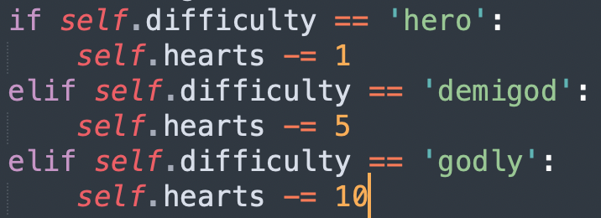code so that at higher difficulties the character takes more damage from enemies. 1 damage at ‘Hero’ difficulty, 5 at ‘Demigod’ and 10 at ‘Godly’ difficulty. This ensures that the game gets harder and more difficult at higher difficulties.

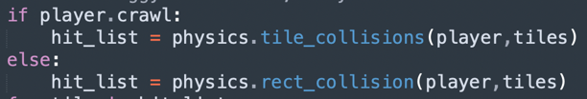Secondly, I changed the bug where the screen shakes when perching over some platforms, I noticed this issue was caused when I started using masks instead of rects for collisions, therefore I switched back the collisions to rects but only for when the character isn’t crawling, as that was the main reason I changed it to masks in the first place.

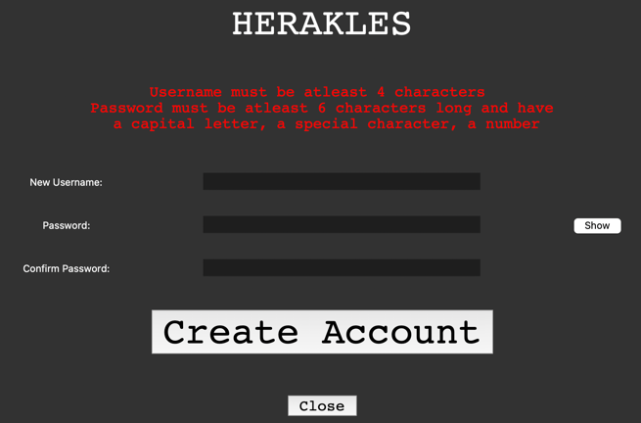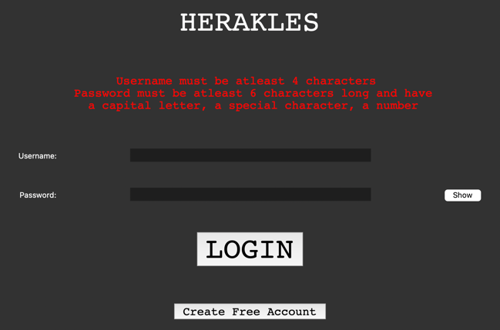Finally, I changed the login menu and create an account menu so that the requirements are clearly stated onto the screen.

After making these changes as requested by my stakeholders and remembering another, I will stop development here due to time and evaluate the whole project.

# Evaluation

## Success Criteria

Although I described the success criteria in the analysis section, I’ll briefly outline it here to make it easier to read.

|  |  |
| --- | --- |
| **Success Criteria** | **Met?** |
| Be able to create an account | Yes |
| Have a functional pre-game menu (login and save file menu) | Yes |
| Be able to save | Yes |
| Be able to access menus (setting/maps) | Yes |
| Be able to change difficulty/settings | Yes |
| Have an interconnected map | Yes |
| Executable file | Yes but does not open |
| Have NPCs and side quests | No |
| In-game currency to buy gear and customization | No |
| Create a storyline with boss fights | No |
| Have an interactive, updating map | No |
| Create it in a mobile version (if possible) | No |

I would say the most important and essential criteria has been met, that being the first six. Evidence showing that these criteria have been met has been evidenced beforehand. The last five criteria have not been met; however, this is purely due to time as I had restricted time in development. Although I know how I would go about developing each of these features, they will take too much time to do so, so I decided to stop there. I’ve also made the program into an executable file so that the user can use that instead of having all the code and libraries downloaded onto their machine, but the executable file does not open on my machine.

## Limitation

One main limitation of my game is the fact that it is only playable on a PC; it is not playable on any other device. Though the usability on a PC is very easy, everyone that uses a PC (either desktop or laptop) has a display, keyboard and mouse (or touchpad if on laptop), that is all you need to play my game which means the large majority of PC players will be able to play it making it as accessible as possible.

## Maintenance

Another piece of key information is that the project doesn’t need any maintenance, once a client has the program, they could play it as much as they would like without the need for it to be updated. Of course, the current project is not finished yet but when it is, there will be no maintenance required.

# Final scripts

## Main.py

# MAIN SCRIPT

# importing libraries

import pygame, sys, math, csv

# print(sys.path)

from pygame.locals import *

pygame.mixer.pre_init(44100, -16, 2, 512)

from tkinter import *

from tkinter import messagebox

# my own libraries

import title_screen

import death_screen

import login_class

import database

import credentials

import display_savefiles

import engine

import settings_menu

import progress_menu

# window size variables

window_x = 900

window_y = 600

WINDOW_SIZE = (window_x,window_y) #so that I can change it later

# initialise tkinter and hide window for now

root = Tk()

root.withdraw()

# initialise pygame

pygame.init()

# Window Title and Icon

icon_path = 'Sprites/Images/icon.png'

icon = pygame.image.load(icon_path)

pygame.display.set_icon(icon)

pygame.display.set_caption('Herakles')

# music

audio = engine.sound()

audio.play(audio.calm)

# screen is what my game is showing every frame

screen = pygame.display.set_mode(WINDOW_SIZE, 0,12)

clock = pygame.time.Clock()

# display, so that I can scale it to the window size later

display = pygame.Surface((300, 200))

# monitor size

monitor_sizes = pygame.display.get_desktop_sizes()[0]

##################################################################################

### Intro to the game

# titlescreen

title_screen.renderScreen(display, screen, WINDOW_SIZE) #displays title screen

# hides pygame window

screen = pygame.display.set_mode(WINDOW_SIZE, pygame.HIDDEN) #hides pygame window

# opens tkinter login menu

start_menu = login_class.start(WINDOW_SIZE, icon_path) #displays tkinter login menu

start_menu.loginScreen(root)

# handles user data

username = credentials.username

password = credentials.password

# loads savefiles

files=database.loadSaveFiles(username)

# extracting only the savefiles names and the progress

savefiles = []

for savefile in files:

name = savefile[1]

progress = len(savefile[7])

savefiles.append([name, progress])

# opens window to let user select the save file

credentials.savefiles = savefiles

display_savefiles.displaySaveFiles(WINDOW_SIZE, icon_path)

# loads the currently used savefile

savefileID = credentials.savefile

savefile = database.loadSaveFile(username, savefileID)[0]

print(savefile)

room = savefile[2]

world = room.split('/')[1]

hearts = savefile[3]

arrows = savefile[4]

coins = savefile[5]

# sets the variables in credentials to the last saves options

# settings layout " windowsize, difficulty, volume, music, sfx "

settings = list(savefile[9].split(','))

sizes = settings[0].split('x')

sizes[0] = int(sizes[0])

sizes[1] = int(sizes[1])

WINDOW_SIZE = sizes

window_x=WINDOW_SIZE[0]

window_y=WINDOW_SIZE[1]

credentials.window_size = sizes

credentials.difficulty = settings[1]

difficulty = settings[1]

credentials.volume = settings[2]

credentials.music = settings[3]

credentials.sfx = settings[4]

# reopens pygame window

screen = pygame.display.set_mode(WINDOW_SIZE, pygame.SHOWN)

#################################################################################

# used to move the player down the screen

gravity = 0.2

# creates an entity object

player = engine.player(30,30,hearts,arrows,coins,difficulty)

# loads the players animations and adds the images

weapons = ['club', 'sword', 'bow', 'toxic']

for weapon in weapons:

player.animations[f'{weapon}/idle'], images =engine.animation.load_weapon_animation(f'sprites/herakles/{weapon}/idle', [7,7])

player.animation_images.update(images)

player.animations[f'{weapon}/moving'], images =engine.animation.load_weapon_animation(f'sprites/herakles/{weapon}/moving', [7,7])

player.animation_images.update(images)

player.animations[f'{weapon}/attack'], images =engine.animation.load_weapon_animation(f'sprites/herakles/{weapon}/attack', [7,5,7])

player.animation_images.update(images)

# crawl animation

player.animations['crawl'], images = engine.animation.load_animation('sprites/herakles/crawl', [10,10])

player.animation_images.update(images)

# loads jump image

player.animations['jump']=['herakles/jump']

player.animation_images['herakles/jump']=pygame.image.load('sprites/herakles/jump2.png').convert_alpha()

print(player.animations)

print(player.animation_images)

# loads player image and stores in the object

player_img_path='sprites/herakles/club/idle/club_idle1.png'

player.img=pygame.image.load(player_img_path).convert_alpha()

player.width=player.img.get_width()

player.height=player.img.get_height()

player.rect=pygame.Rect(player.x, player.y, player.width, player.height)

player.mask=pygame.mask.from_surface(player.img)

# sets up enemy sprites

enemy_group = pygame.sprite.Group()

# items

heart_img =pygame.image.load('sprites/items/heart.png').convert_alpha()

coin_img =pygame.image.load('sprites/items/coin.png').convert_alpha()

# reticle and arrow image

reticle_img = pygame.image.load('sprites/items/reticle.png').convert_alpha()

arrow_img = pygame.image.load('sprites/items/arrow.png').convert_alpha()

# cog image for settings button

cog_img = pygame.image.load('sprites/items/cog.png').convert_alpha()

settings_button = engine.button(cog_img, (283, 2))

# progress button

progress_button = engine.button(icon, (263, 2))

# font image

font_img = pygame.image.load('sprites/text/font.png').convert_alpha()

# creates a font

text=engine.Font(font_img)

# creates menus

options_menu = settings_menu.settings_menu(WINDOW_SIZE, icon_path, savefile[9])

char_menu = progress_menu.progress(WINDOW_SIZE, icon_path)

# loads all my tile sets

# hell

hell_file = 'sprites/tiles/spritesheets/hell_spritesheet.png'

hell_sheet = engine.spritesheet(hell_file, 7, 4, 16)

hell_tiles = hell_sheet.sprites

# cave

cave_file = 'sprites/tiles/spritesheets/cave_spritesheet.png'

cave_sheet = engine.spritesheet(cave_file, 7, 4, 16)

cave_tiles = cave_sheet.sprites

# sand

sand_file = 'sprites/tiles/spritesheets/sand_spritesheet.png'

sand_sheet = engine.spritesheet(sand_file, 7, 4, 16)

sand_tiles = sand_sheet.sprites

# grass

grass_file = 'sprites/tiles/spritesheets/grass_spritesheet.png'

grass_sheet = engine.spritesheet(grass_file, 7, 4, 16)

grass_tiles = grass_sheet.sprites

# cloud

cloud_file = 'sprites/tiles/spritesheets/cloud_spritesheet.png'

cloud_sheet = engine.spritesheet(cloud_file, 7, 4, 16)

cloud_tiles = cloud_sheet.sprites

# loads game map

gamemap = engine.map(world, room)

# temple

temple_img =pygame.image.load('sprites/temple.png').convert_alpha()

gamemap.misc['99'] = temple_img

# saves tiles

gamemap.world_tiles['hell']=hell_tiles

gamemap.world_tiles['cave']=cave_tiles

gamemap.world_tiles['sand']=sand_tiles

gamemap.world_tiles['grass']=grass_tiles

gamemap.world_tiles['cloud']=cloud_tiles

gamemap.change_world(gamemap.world)

gamemap.load_room(gamemap.room)

for extra in gamemap.extras:

if extra.name == 'temple':

player.rect.x = extra.rect.x

player.rect.y = extra.rect.y

# initialises a scroll variable so that camera moves with player

scroll=[0,0]

real_scroll=[0,0]

# initialises the mouse click variable

clicked = False

# hides the mouse

pygame.mouse.set_visible(False)

# contains all arrows in the map

arrows=[]

### Game Loop, infinite loop

done = False

while not done:

### GAME LOGIC ###############################

# world logic

# changes world map

world_type=gamemap.path.split('/')[1]

if world_type != gamemap.world:

gamemap.change_world(world_type)

gamemap.load_room(gamemap.path)

# resets the screen to

# grey if in a dark area or

if gamemap.theme == 'dark':

display.fill((44,44,44))

# blue if in a light area

else:

display.fill((58,182,255))

# screen and scroll logic

# calculates the scale from display to window

scale=window_x/display.get_width()

# gets the mouse position

real_mx, real_my = pygame.mouse.get_pos()

mx = real_mx/scale

my = real_my/scale

### handling camera movement

# locks the screen to the players position

real_scroll[0] += (player.rect.x-real_scroll[0]-158)/20

real_scroll[1] += (player.rect.y-real_scroll[1]-108)/20

### basic camera (dont use this anymore)

# real_scroll[0] = player.rect.x - 158

# real_scroll[1] = player.rect.y - 108

# scroll can create decimal values which make the tile rendering look buggy

# so create a separate with integer values

scroll = real_scroll.copy()

scroll[0] = int(scroll[0])

scroll[1] = int(scroll[1])

# menu logic

# clicking the progress button

if clicked and progress_button.rect.collidepoint((mx,my)):

clicked = False

# hides the pygame window whilst menu is open

screen = pygame.display.set_mode(WINDOW_SIZE, pygame.HIDDEN)

char_menu.menu()

screen = pygame.display.set_mode(WINDOW_SIZE, pygame.SHOWN)

### make adjustments from menu here

# clicking the settings button

if clicked and settings_button.rect.collidepoint((mx,my)):

clicked=False

# hides the pygame window whilst options menu is open

screen = pygame.display.set_mode(WINDOW_SIZE, pygame.HIDDEN)

options_menu.menu()

# retrieves and sets the new window size and shows window

WINDOW_SIZE = credentials.window_size

window_x=WINDOW_SIZE[0]

window_y=WINDOW_SIZE[1]

screen = pygame.display.set_mode(WINDOW_SIZE, pygame.SHOWN)

# retrieves the new savefile

savefile = database.loadSaveFile(username, savefileID)[0]

options_menu = settings_menu.settings_menu(WINDOW_SIZE, icon_path, savefile[9])

# gets new difficulty

player.difficulty = credentials.difficulty

### HERE I WOULD SET THE NEW SOUND OPTIONS AND DIFFICULTY OPTIONS

# music logic

# changes music depending on if there are enemies in the room or not

if gamemap.count_enemies() == 0:

if audio.current_music != audio.calm:

audio.current_music = audio.calm

audio.change_music(audio.calm)

elif gamemap.count_enemies() != 0:

if audio.current_music != audio.action:

audio.current_music = audio.action

audio.change_music(audio.action)

# movement logic

# updates player movement and collisions

player.move(gamemap, audio, text)

gamemap.enemies.update()

# checks to see if player is dead

if player.hearts <= 0:

print('DEAD')

# displays the title screen

death_screen.renderScreen(display, screen, WINDOW_SIZE)

# loads the game from when last saved

username = credentials.username

savefileID = credentials.savefile

savefile = database.loadSaveFile(username, savefileID)[0]

room = savefile[2]

world = room.split('/')[1]

player.hearts = savefile[3]

player.arrows = savefile[4]

player.coins = savefile[5]

gamemap.change_world(world)

gamemap.load_room(room)

# arrow movement

for arrow in gamemap.arrows:

arrow.rect.x+=arrow.vector[0]*5

arrow.rect.y+=arrow.vector[1]*5

# arrow collisions

for arrow in gamemap.arrows:

# if arrow hits a tile then remove the arrow

if arrow.collision(gamemap.tiles_list):

gamemap.arrows.remove(arrow)

# continue as the arrow obj is now removed

continue

# if arrow hits an enemy then remove both arrow and enemy

for enemy in gamemap.enemies:

if arrow.rect.colliderect(enemy.rect):

gamemap.arrows.remove(arrow)

gamemap.enemies.remove(enemy)

audio.playSFX(audio.enemy_dead)

# handles player animations

if player.attacking:

if player.change_action(player.weapon+'/attack'):

if (player.weapon == 'club' or player.weapon == 'sword') and player.attacked==False and not player.in_air:

audio.playSFX(audio.sword)

player.attacked = True

# if using a bow then make an arrow

if player.weapon == 'bow' and player.shot==False and player.arrows>0:

# creates arrow

arrow=engine.particle(arrow_img, player.rect.x+(player.width/2), player.rect.y+(player.height/2), player.flip, mx,my, scroll)

gamemap.arrows.append(arrow)

player.arrows-=1

player.shot=True

audio.playSFX(audio.bow)

elif player.crawl:

player.change_action('crawl')

elif player.moving_right or player.moving_left:

player.change_action(player.weapon+'/moving')

# audio.playSFX(audio.walking)

else:

player.change_action(player.weapon+'/idle')

if player.in_air:

player.change_action('jump')

# increases what frame the animation is on

player.action_frame+=1

# resets the frame to 0 if at the end of the animation

if player.action_frame >= len(player.animations[player.action]):

player.action_frame=0

# stops the attack animation after the first run

if player.action == player.weapon+'/attack':

player.attacking=False

player.attacked=False

player.shot=False

player.change_action(player.previous_action)

# loads the player image

player.set_anim_image()

# flips player image if moving left

player.img = pygame.transform.flip(player.img, player.flip, False)

player.mask = pygame.mask.from_surface(player.img)

### DISPLAYING IMAGES ########################

# displays arrows and rotates the image

for arrow in gamemap.arrows:

arrow.display(display, scroll)

# displays tiles

for tile in gamemap.tiles_list:

display.blit(tile.img, (tile.x-scroll[0], tile.y-scroll[1]))

# displays extras

for extra in gamemap.extras:

display.blit(extra.img, (extra.x-scroll[0], extra.y-scroll[1]))

# displays text

for message in gamemap.text:

text.render(display, message[0], (message[1][0]-scroll[0], message[1][1]-scroll[1]))

# displays collectibles

for item in gamemap.items:

item=item[0]

display.blit(item.img, (item.x-scroll[0], item.y-scroll[1]))

# displays player image, tinted red if hurt

if player.damage_timer > 0:

player.img.fill((190, 0, 0, 100), special_flags=pygame.BLEND_ADD)

display.blit(player.img, (player.x-scroll[0],player.y-scroll[1]))

# displays enemies

for enemy in gamemap.enemies:

image = enemy.image

# flips image if moving left

if enemy.flipped:

image = pygame.transform.flip(image, enemy.flipped, False)

display.blit(image, (enemy.rect.x-scroll[0],enemy.rect.y-scroll[1]))

# displays reticle if using the bow

if player.weapon == 'bow':

# displays reticle at mouse position

display.blit(reticle_img, (mx-(reticle_img.get_width()/2), my-(reticle_img.get_height()/2)))

else:

pygame.mouse.set_visible(True)

# displays HUD

# hearts

display.blit(heart_img, (3,2))

text.render(display, str(player.hearts), (20,2))

# coins

display.blit(coin_img, (3,16))

text.render(display, str(player.coins), (20,16))

# arrows

display.blit(arrow_img, (4,35))

text.render(display, str(player.arrows), (20,30))

# settings button

display.blit(settings_button.image, settings_button.loc)

# progress button

display.blit(progress_button.image, progress_button.loc)

### INPUT LOOP ###################################

for event in pygame.event.get():

# exits loop if player clicks the close button

if event.type == pygame.QUIT:

done = True

# checks if any keys have been pressed down

if event.type == pygame.KEYDOWN:

if event.key == K_q:

player.switch_weapon()

if event.key == K_c:

# toggles between crawl and not crawl

player.crawl = not player.crawl

if event.key == K_SPACE:

player.jump=True

if event.key == K_v:

player.interact=True

if event.type == pygame.KEYUP:

if event.key == K_v:

player.interact=False

# checks if the mouse has been pressed

if event.type == MOUSEBUTTONDOWN:

if event.button == 1:

clicked=True

if event.type == MOUSEBUTTONUP:

if event.button == 1:

clicked=False

#scales display to window size and displays the screen

surf = pygame.transform.smoothscale(display, WINDOW_SIZE)

screen.blit(surf, (0,0))

pygame.display.update()

clock.tick(50)

pygame.quit()

sys.exit()

## engine.py

# Entity classes and Physics

import pygame, math

from pygame.locals import *

from tkinter import *

from tkinter import messagebox

pygame.mixer.pre_init(44100, -16, 2, 512)

import csv

import room_data

import database

class sound:

def __init__(self):

# music

self.calm = 'music/Hades.mp3'

self.action = 'music/Hades.mp3'

self.current_music = 'music/Hades.mp3'

# sfx

self.jump = pygame.mixer.Sound('music/jump.mp3')

self.damaged = pygame.mixer.Sound('music/ouch.mp3')

self.bow = pygame.mixer.Sound('music/whoosh.wav')

self.sword = pygame.mixer.Sound('music/swing.wav')

self.walking = pygame.mixer.Sound('music/walking2.wav')

self.enemy_dead = pygame.mixer.Sound('music/cartoon_ouch.mp3')

self.dead = pygame.mixer.Sound('music/death.wav')

def change_music(self, music):

pygame.mixer.music.fadeout(500)

pygame.mixer.music.load(music)

pygame.mixer.music.set_volume(0.1)

pygame.mixer.music.play(-1)

def play(self, music):

pygame.mixer.music.load(music)

pygame.mixer.music.set_volume(0.1)

pygame.mixer.music.play(-1)

def playSFX(self, sfx):

sfx.play()

class button:

def __init__(self, img, coords):

self.image = img

self.loc = coords

self.rect = img.get_rect(topleft=coords)

# old code

# def clip(surf,x,y,x_size,y_size):

# handle_surf = surf.copy()

# clipR = pygame.Rect(x,y,x_size,y_size)

# handle_surf.set_clip(clipR)

# image = surf.subsurface(handle_surf.get_clip())

# return image.copy()

# new method: more efficient and takes less memory

def clip(surf, x,y,x_size,y_size):

clip_rect = Rect(x,y,x_size,y_size)

image = surf.subsurface(clip_rect)

return image.copy()

class Font:

def __init__(self, font_img):

self.spacing = 1

self.character_order = ['A','B','C','D','E','F','G','H','I','J','K','L','M','N','O','P','Q','R','S','T','U','V','W','X','Y','Z','a','b','c','d','e','f','g','h','i','j','k','l','m','n','o','p','q','r','s','t','u','v','w','x','y','z','.','-',',',':','+','\'','!','?','0','1','2','3','4','5','6','7','8','9','(',')','/','_','=','\\','[',']','*','"','<','>',';']

current_char_width = 0

self.characters = {}

character_count = 0

for x in range(font_img.get_width()):

c = font_img.get_at((x, 0))

if c[0] == 127:

char_img = clip(font_img, x - current_char_width, 0, current_char_width, font_img.get_height())

self.characters[self.character_order[character_count]] = char_img.copy()

character_count += 1

current_char_width = 0

else:

current_char_width += 1

self.space_width = self.characters['A'].get_width()

def render(self, surf, text, loc):

x_offset = 0

for char in text:

if char != ' ':

surf.blit(self.characters[char], (loc[0] + x_offset, loc[1]))

x_offset += self.characters[char].get_width() + self.spacing

else:

x_offset += self.space_width + self.spacing

class animation:

def load_weapon_animation(path,frames):

# returns a list with each frames image for the animation

animation=[] #a list for each image to be added to

animation_images={}

# eg. path = sprites/herakles/club/idle

name = path.split('/')[1:]

action= path.split('/')[-1]

weapon= path.split('/')[-2]

animation_name= name[0]+'/'+name[1]+'/'+name[2]

# animation_name = herakles/club/idle

# adds the image the number of times indicated by the frames parameter

# and adds the image to a list

for i in range(len(frames)):

frame_id = i+1

image_path= path+'/'+weapon+'_'+action+str(frame_id)+'.png'

image= animation_name+'_'+str(frame_id)

animation_images[image]=pygame.image.load(image_path)

for frame in range(frames[i]):

animation.append(image)

# returns the list of images

return animation, animation_images

def load_animation(path,frames):

# returns a list with each frames image for the animation

animation=[] #a list for each image to be added to

animation_images={}

# eg. path = sprites/herakles/crawl

name = path.split('/')[1:]

action= path.split('/')[-1]

animation_name= name[0]+'/'+name[1]

# animation_name = herakles/crawl

# adds the image the number of times indicated by the frames parameter

# and adds the image to a list

for i in range(len(frames)):

frame_id = i+1

image_path= path+'/'+action+str(frame_id)+'.png'

image= animation_name+'_'+str(frame_id)

animation_images[image]=pygame.image.load(image_path)

for frame in range(frames[i]):

animation.append(image)

# returns the list of images

return animation, animation_images

class map:

def __init__(self, world, room):

self.tiles = []

self.tiles_list = []

self.world_tiles={}

self.misc = {}

self.enemies = pygame.sprite.Group()

self.arrows = []

self.text = []

# current room holders

self.world = world

self.path = room

# Storing room layouts for each world

self.hell_doors = room_data.hell_doors

self.hell_rooms = room_data.hell_rooms

self.cave_doors = room_data.cave_doors

self.cave_rooms = room_data.cave_rooms

self.world_map = {

'hell':self.hell_rooms,

'cave':self.cave_rooms

}

self.world_doors = {

'hell':self.hell_doors,

'cave':self.cave_doors

}

self.current_map = self.world_map[self.world]

self.current_doors = self.world_doors[self.world]

self.roomID = self.get_roomID()

self.room = self.world_map[self.world][self.roomID]

self.calc_theme()

def count_enemies(self):

return len(self.enemies)

def change_world(self, world):

self.world = world

self.tiles = self.world_tiles[self.world]

self.current_map = self.world_map[self.world]

self.current_doors = self.world_doors[self.world]

self.calc_theme()

def get_doorID(self, room, prev_room):

for i in range(len(self.current_doors[room])):

index = i+1

if self.current_doors[room][index] == prev_room:

return index

def get_roomID(self):

for key in self.current_map:

if self.current_map[key] == self.path:

return key

def change_room(self, doorID):

next_roomID = self.current_doors[self.roomID][doorID]

self.door = self.get_doorID(next_roomID, self.roomID)

self.roomID = next_roomID

room = self.world_map[self.world][self.roomID]

self.load_room(room)

def calc_theme(self):

if self.world == 'hell' or self.world == 'cave':

self.theme = 'dark'

else:

self.theme = 'light'

def load_room(self, path):

# opens and reads the map csv file

room_map=[]

# creates a 2D array of each tile

with open(path+'.csv') as csv_file:

csv_reader = csv.reader(csv_file, delimiter=',')

for row in csv_reader:

room_map.append(row)

self.room = room_map

self.path = path

# clears group to be loaded with new enemies

self.enemies.empty()

# creating the map

tiles=[]

doors={}

extras=[]

items=[]

row_count=0 #tracks what row the loop's on

door_count=1

for row in self.room:

tile_count=0 #tracks what column the programs on

for block in row:

# extras

# temple background (not in spritesheet so handled differently)

if block == '99':

img = self.misc[block]

temple = tile(img, tile_count*16, row_count*16)

temple.rect = temple.img.get_rect()

temple.rect.x = tile_count*16

temple.rect.y = row_count*16

temple.name = 'temple'

extras.append(temple)

else:

#returns the tile image path from the dictionary

tile_img=self.tiles[block]

# creates a door rect

if block == '13':

door = Rect(tile_count*16, row_count*16, 16,16)

doors[door_count] = door

door_count+=1

# interactables

elif block == '21':

item = tile(tile_img, tile_count*16, row_count*16)

items.append((item,'warp'))

doors[door_count] = item.rect

door_count+=1

elif block == '22':

item = tile(tile_img, tile_count*16, row_count*16)

items.append((item,'heart'))

elif block == '23':

item = tile(tile_img, tile_count*16, row_count*16)

items.append((item,'coin'))

elif block == '24':

item = tile(tile_img, tile_count*16, row_count*16)

items.append((item,'arrow'))

# enemies

elif block == '25':

# minion guy

e = enemy(tile_count*16, row_count*16, tile_img, 16)

self.enemies.add(e)

elif block == '26':

# flying guy

e = flying(tile_count*16, row_count*16, tile_img, 60)

self.enemies.add(e)

elif block == '27':

# bull guy

e = enemy(tile_count*16, row_count*16, tile_img, 20)

e.move_x_direction = 2

self.enemies.add(e)

# the rest are just tiles, so create tile rects

elif tile_img != None: # if not an empty space

block=tile(tile_img, tile_count*16, row_count*16)

# appends to a list, used for collisions

tiles.append(block)

tile_count+=1

row_count+=1

self.tiles_list = tiles

self.items = items

self.doors = doors

self.extras = extras

print(doors)

print(self.roomID)

class physics:

def rect_collision(player,tiles):

hit_list=[]

for tile in tiles:

if player.rect.colliderect(tile.rect):

hit_list.append(tile)

return hit_list

def tile_collisions(player,tiles):

hit_list=[]

for tile in tiles:

if player.rect.colliderect(tile.rect):

x_offset= tile.rect.left - player.rect.left

y_offset= tile.rect.top - player.rect.top

if player.mask.overlap(tile.mask, (x_offset, y_offset)):

hit_list.append(tile)

return hit_list

def move(player, tiles):

# sets all collions to False

collision_types = {'top':False, 'bottom':False, 'left':False, 'right':False}

movement=player.movement

# moves object vertically

player.rect.y += movement[1]

# due to buggy collisions, only use masks for crawling

if player.crawl:

hit_list = physics.tile_collisions(player,tiles)

else:

hit_list = physics.rect_collision(player,tiles)

for tile in hit_list:

if movement[1]>0:

player.rect.bottom=tile.rect.top

collision_types['bottom']=True

elif movement[1]<0:

player.rect.top=tile.rect.bottom

collision_types['top']=True

# moves object horizontally

player.rect.x += movement[0]

# check for collions horizontally

if player.crawl:

hit_list = physics.tile_collisions(player,tiles)

else:

hit_list = physics.rect_collision(player,tiles)

# adjusts objects to their new position (so not overlapping)

for tile in hit_list:

if movement[0]>0:

player.rect.right=tile.rect.left

collision_types['right']=True

elif movement[0]<0:

player.rect.left=tile.rect.right

collision_types['left']=True

return collision_types

class tile:

def __init__(self, img, x, y):

self.img=img

self.x=x

self.y=y

self.rect=Rect(self.x,self.y, self.img.get_width(), self.img.get_height())

self.mask=pygame.mask.from_surface(self.img)

class particle:

def __init__(self,img,x,y,flip,mx,my,scroll):

self.img=img

self.x=x

self.y=y

self.flip=flip

# calculates vector

dx=mx-self.x+scroll[0]

dy=my-self.y+scroll[1]

vector = pygame.Vector2(dx,dy)

self.vector = vector.normalize()

# uses arctan to find the angle and converts to degrees, -90<x<90

angle=math.atan2(self.vector[1], self.vector[0])

angle=math.degrees(angle)

self.angle=-1*angle # now in degrees

# rotates the img to the angle

self.img=pygame.transform.rotate(self.img, self.angle)

# creates rect for collisions

self.rect=Rect(self.x, self.y, self.img.get_width(), self.img.get_height())

self.mask=pygame.mask.from_surface(self.img)

def display(self, display, scroll):

display.blit(self.img, (self.rect.x-scroll[0], self.rect.y-scroll[1]))

def collision(self, tiles):

collision=False

for tile in tiles:

if self.rect.colliderect(tile.rect):

x_offset= tile.rect.left - self.rect.left

y_offset= tile.rect.top - self.rect.top

if self.mask.overlap(tile.mask, (x_offset, y_offset)):

collision=True

return collision

return collision

class spritesheet:

def __init__(self, filename, columns, rows, size):

# try to load the spritesheet

try:

self.sheet = pygame.image.load(filename).convert()

except pygame.error as e:

print(f"Unable to load spritesheet image: {filename}")

self.rows = rows

self.columns = columns

self.size = size

# dict to store images and associate them to csv values

self.sprites = {'-1': None}

self.get_images()

def get_images(self):

self.sprites_images=[]

# clips out each image and adds to a list

counter = 0

for i in range(self.rows):

for j in range(self.columns):

image = clip(self.sheet, j*self.size, i*self.size, self.size, self.size)

self.sprites_images.append(image)

self.sprites[str(counter)] = image

counter+=1

class enemy(pygame.sprite.Sprite):

def __init__(self, x,y, img, move_limit):

pygame.sprite.Sprite.__init__(self)

self.image = img

self.rect = self.image.get_rect()

self.rect.x = x

self.rect.y = y

self.mask = pygame.mask.from_surface(self.image)

self.flipped = False

self.limit = move_limit

self.move_x_direction = 1

self.move_counter = 0

def update(self):

# movement

self.rect.x += self.move_x_direction

self.move_counter += 1

# flip if the limit is reached

if self.move_counter > self.limit:

self.move_x_direction *= -1

self.move_counter = 0

self.flipped = not self.flipped

class flying(enemy):

def __init__(self, x,y, img, move_limit):

super().__init__(x,y, img, move_limit)

self.counter = 0

def update(self):

# movement

# calculates a sine value for the y value

dy = math.sin(math.radians(self.counter * 5))

self.rect.x += self.move_x_direction

self.rect.y -= round(dy, 0) * 3

self.move_counter += 1

self.counter += 1

# flip if the limit is reached

if self.move_counter > self.limit:

self.move_x_direction *= -1

self.move_counter = 0

self.flipped = not self.flipped

class player():

def __init__(self, x,y, hearts, arrows, coins, difficulty):

self.x = x

self.y = y

self.width=0

self.height=0

self.hearts=hearts

self.arrows=arrows

self.coins=coins

self.difficulty = difficulty

self.img=None

self.rect=None

self.mask=None

self.movement=[0,0]

self.moving_right=False

self.moving_left=False

self.running=False

self.jump=False

self.dbJump=False

self.y_momentum=0

self.in_air=False

self.air_timer=0

self.gravity = 0.2

self.damage_timer=0

self.flip=False

self.flipped=False

self.type=None

self.weapon='club'

self.default_weapon='club'

self.toxic=False

self.attacking=False

self.shot = False

self.attacked = False

self.crawl = False

self.interact = False

self.animations={}

self.animation_images={}

self.action='club/idle'

self.previous_action='jump'

self.action_id='herakles/club/idle_1'

self.action_frame=0

def switch_weapon(self):

# if player has unlocked toxic ability

if self.toxic:

if self.weapon != 'toxic':

self.weapon = 'toxic'

pygame.mouse.set_visible(False)

else:

self.weapon = self.default_weapon

# if not then switch weapons as normal

elif self.weapon != 'bow':

self.weapon = 'bow'

pygame.mouse.set_visible(False)

else:

self.weapon = self.default_weapon

def change_action(self,new_action):

# if the actions are different then change action and reset frame

if self.action != new_action:

self.previous_action=self.action

self.action = new_action

self.action_frame = 0

return True

return False

def set_anim_image(self):

# locates the frame in the animations dictionary with the action and the frame number

self.action_id=self.animations[self.action][self.action_frame]

# set the player image to the image associated to that frame

self.img = self.animation_images[self.action_id]

def get_input(self):

key = pygame.key.get_pressed()

# checks for pressed keys

if key[pygame.K_RIGHT] or key[pygame.K_d]:

self.moving_right=True

self.moving_left=False

self.flip=False

if key[pygame.K_LEFT] or key[pygame.K_a]:

self.moving_left=True

self.moving_right=False

self.flip=True

if key[pygame.K_LSHIFT]:

self.running=True

if key[pygame.K_e]:

self.attacking=True

# checks for keys that have been released

if key[pygame.K_RIGHT]==False and key[pygame.K_d]==False:

self.moving_right=False

if key[pygame.K_LEFT]==False and key[pygame.K_a]==False:

self.moving_left=False

if key[pygame.K_LSHIFT]==False:

self.running=False

def move(self, gamemap, audio, text):

# clears the list

gamemap.text = []

# gets input

self.get_input()

# player movement

# resets movement to 0 for vertical and horizontal

# holds this frames total movement, used for collisions

self.movement=[0,0]

# handles players horizontal movement

if self.moving_right:

if self.running:

self.movement[0]+=3

else:

self.movement[0]+=2

if self.moving_left:

if self.running:

self.movement[0]-=3

else:

self.movement[0]-=2

# handles players vertical movement and implementing gravity

self.y_momentum += self.gravity

# terminal velocity of 4

if self.y_momentum > 4:

self.y_momentum = 4

# makes it so the player can't jump if theyre crawling

if self.crawl:

self.jump=False

# player jumps and not in the air for 10 frames (for smoothness)

if not self.in_air and self.jump and self.air_timer < 10 and not self.crawl:

self.y_momentum = -5

self.jump = False

audio.playSFX(audio.jump)

elif self.in_air and not self.dbJump and self.jump:

self.y_momentum = -5

self.jump = False

self.dbJump = True

audio.playSFX(audio.jump)

# applys momentum to movement

self.movement[1] = self.y_momentum

# door collisions

for doorID in gamemap.doors:

door_rect = gamemap.doors[doorID]

if isinstance(door_rect, tile):

door_rect = door_rect.rect

if self.rect.colliderect(door_rect):

gamemap.change_room(doorID)

# map & doors have now changed so new player location

new_door = gamemap.doors[gamemap.door]

map_width = len(gamemap.room[0])*16

map_mid = map_width/2

dx = map_mid - new_door.x

mid_height = len(gamemap.room)*16/2

# changes the players position depending on where the player enters the room from

if dx>0:

self.rect.x = new_door.x +24

else:

self.rect.x = new_door.x -24

self.rect.bottom = new_door.y +16

break

# item collisions

for i in gamemap.items:

item = i[0]

item_name = i[1]

if self.rect.colliderect(item.rect):

if item_name == 'heart':

self.hearts += 10

if self.hearts > 150:

self.hearts = 150

gamemap.items.remove(i)

del i

elif item_name == 'coin':

self.coins += 5

gamemap.items.remove(i)

del i

elif item_name == 'arrow':

self.arrows += 5

if self.arrows > 35:

self.arrows = 35

gamemap.items.remove(i)

del i

# checks for collision with each enemy

for enemy in gamemap.enemies:

if self.rect.colliderect(enemy.rect):

# if player attacks enemy with sword or club

if (self.weapon == 'club' or self.weapon == 'sword') and self.attacking and not self.in_air:

gamemap.enemies.remove(enemy)

audio.playSFX(audio.enemy_dead)

# if player gets hit by enemy

elif self.damage_timer == 0:

if self.difficulty == 'hero':

self.hearts -= 1

elif self.difficulty == 'demigod':

self.hearts -= 5

elif self.difficulty == 'godly':

self.hearts -= 10

self.damage_timer = 20

if self.hearts <= 0:

audio.playSFX(audio.dead)

else:

audio.playSFX(audio.damaged)

# collisions with extras ie. backgrounds and NPCs

for extra in gamemap.extras:

if self.rect.colliderect(extra.rect):

if extra.name == 'temple':

x_pos = extra.rect.x

y_pos = extra.rect.y - 16

gamemap.text.append(['Save - V', (x_pos, y_pos)])

if self.interact:

# resets variable to false

self.interact = False

# asks user if he would like to save

root = Tk()

root.withdraw()

confirm = messagebox.askyesno('Confirmation', 'Would you like to save this file?')

root.destroy()

# if user confirms then save

if confirm:

database.save(gamemap.path, self.hearts, self.arrows, self.coins)

# ticks timer

self.damage_timer-=1

if self.damage_timer<=0:

self.damage_timer=0

# updates the players position and returns the collisions for that frame

collisons = physics.move(self, gamemap.tiles_list)

# checks if player is in the air or not

if collisons['bottom']:

self.in_air=False

self.air_timer = 0

self.y_momentum = 1

self.dbJump = False

else:

self.in_air=True

self.air_timer += 1

# moves the player once collision tested

self.x=self.rect.x

self.y=self.rect.y

## database.py

# DATABASE SCRIPT

# import libaries

import sqlite3

# import my own libraries

import credentials

# creates a connection with database

con = sqlite3.connect('herakles.db')

# cursor allows me to execute commands

cur = con.cursor()

# creates table

cur.execute('''CREATE TABLE IF NOT EXISTS accounts (username text, password text)''')

# commits changes to database

con.commit()

# closes the connection

cur.close()

# returns true is the username is already taken

def isUsername(username):

# creates a connection with database

con = sqlite3.connect('herakles.db')

# cursor allows me to execute commands

cur = con.cursor()

# selects accounts with credentials

cur.execute("SELECT * FROM accounts WHERE username = ? ", (username,))

# fetches accounts with credentials

account=cur.fetchall()

# checks if account with credentials exists

if account == []:

return False

elif account[0][0]==username:

return True

else:

return False

# returns true is the account exists

def isAccount(username, password):

# creates a connection with database

con = sqlite3.connect('herakles.db')

# cursor allows me to execute commands

cur = con.cursor()

# selects accounts with credentials

cur.execute("SELECT * FROM accounts WHERE username = ? AND password = ?", (username ,password))

# fetches accounts with credentials

account=cur.fetchall()

# checks if account with credentials exists

if account == []:

return False

elif account[0][0]==username and account[0][1]==password:

return True

else:

return False

# commits changes to database

con.commit()

# closes the connection

cur.close()

# creates a new account

def createAccount(username, password):

# creates a connection with database

con = sqlite3.connect('herakles.db')

# cursor allows me to execute commands

cur = con.cursor()

# creates new record in the accounts table

cur.execute('INSERT INTO accounts VALUES (?, ?)', (username, password))

# create a personal table to the account to store save files

script = f"""CREATE TABLE {username} (fileid integer, filename text, lastSavePoint text, hearts integer,

arrows integer, coins integer, bosses_killed integer, items text, map_discovered text, settings text)"""

# settings layout " windowsize, difficulty, volume, music, sfx "

cur.execute(script)

# create 3 save files

for ID in range(3):

script = f"""INSERT INTO {username} VALUES ({ID}, 'Empty', 'maps/hell/hell1', 100,

25, 0, 0, '', '', '900x600,hero,100,100,100')"""

cur.execute(script)

# commits changes to database

con.commit()

# closes the connection

cur.close()

def loadCredentials(username, password):

# creates a connection with database

con = sqlite3.connect('herakles.db')

# cursor allows me to execute commands

cur = con.cursor()

# selects user account

cur.execute("SELECT * FROM accounts WHERE username = ? AND password = ?", (username ,password))

data = cur.fetchall()

# commits changes to database

con.commit()

# closes the connection

cur.close()

return data

def loadSaveFiles(username):

# creates a connection with database

con = sqlite3.connect('herakles.db')

# cursor allows me to execute commands

cur = con.cursor()

# selects users account

script = "SELECT * FROM " + username

cur.execute(script)

# fetches users account

data = cur.fetchall()

# commits changes to database

con.commit()

# closes the connection

cur.close()

return data

def renameSaveFile(fileID, newfilename):

# creates a connection with database

con = sqlite3.connect('herakles.db')

# cursor allows me to execute commands

cur = con.cursor()

# fetches users username

username = credentials.username

# updates the filename

script = "UPDATE "+ username+" SET filename = '"+newfilename+"' WHERE fileid = "+str(fileID)

cur.execute(script)

# commits changes to database

con.commit()

# closes the connection

cur.close()

def deleteSaveFile(fileID):

# creates a connection with database

con = sqlite3.connect('herakles.db')

# cursor allows me to execute commands

cur = con.cursor()

# fetches users username

username = credentials.username

# updates the savefile with default settings

script = f"UPDATE {username} SET filename='Empty', lastSavePoint='X,Y', hearts=100, arrows=25, coins=0, bosses_killed=0, items='', map_discovered='', settings='900x600,hero,100,100,100' WHERE fileid = "+str(fileID)

cur.execute(script)

# commits changes to database

con.commit()

# closes the connection

cur.close()

def loadSaveFile(username, ID):

# creates a connection with database

con = sqlite3.connect('herakles.db')

# cursor allows me to execute commands

cur = con.cursor()

# selects users account

script = "SELECT * FROM "+username+" WHERE fileid = "+str(ID)

cur.execute(script)

# fetches users account

data = cur.fetchall()

# commits changes to database

con.commit()

# closes the connection

cur.close()

return data

def save_settings(settings):

# retrieves user data from credentials file

username = credentials.username

savefile = int(credentials.savefile)

# creates a connection with database

con = sqlite3.connect('herakles.db')

# cursor allows me to execute commands

cur = con.cursor()

# updates the savefile to it's new settings

script = f"UPDATE {username} SET settings = '{settings}' WHERE fileid = {savefile}"

cur.execute(script)

# commits changes to database

con.commit()

# closes the connection

cur.close()

# used for debugging and view all created accounts

def printall():

# creates a connection with database

con = sqlite3.connect('herakles.db')

# cursor allows me to execute commands

cur = con.cursor()

cur.execute('SELECT * FROM accounts')

print(cur.fetchall())

# commits changes to database

con.commit()

# closes the connection

cur.close()

def save(savePoint, hearts, arrows, coins):

# fileid, filename, lastSavePoint, hearts, arrows, coins, bosses_killed, items, map_discovered, settings

# retrieves user data from credentials file

username = credentials.username

savefile = int(credentials.savefile)

# creates a connection with database

con = sqlite3.connect('herakles.db')

# cursor allows me to execute commands

cur = con.cursor()

# updates the savefile to it's new settings

script = f"UPDATE {username} SET lastSavePoint = '{savePoint}', hearts = {hearts}, arrows = {arrows}, coins = {coins} WHERE fileid = {savefile}"

cur.execute(script)

# commits changes to database

con.commit()

# closes the connection

cur.close()

## credentials.py

# this script is so that I can access the user's credentials

# from my main script. I cannot directly return the username

# and password to my main script from tkinter so I temporarily

# store them in here.

# set to nothing

# once login is verified these will be changed

username = ''

password = ''

savefile = 0

savefiles=[]

# for settings changes

window_size=''

difficulty=''

volume=''

music=''

sfx=''

# progress

bosses = ''

items = ''

map_discovered = ''

## title_screen.py

# TITLE SCREEN

import pygame, sys

from pygame.locals import *

def renderScreen(display, screen, size):

# loads image and displays it on screen

image = pygame.image.load('Sprites/Images/title_screen.png')

display.blit(image,(0,0))

surf = pygame.transform.scale(display, size)

screen.blit(surf, (0,0))

pygame.display.update()

running = True

while running:

for event in pygame.event.get():

if event.type == pygame.QUIT:

pygame.quit()

sys.exit()

if event.type == pygame.KEYDOWN:

if event.key == K_SPACE:

running = False

## death_screen.py

# DEATH SCREEN

import pygame, sys

from pygame.locals import *

def renderScreen(display, screen, size):

# loads image and displays it on screen

image = pygame.image.load('Sprites/Images/death_screen.png')

display.blit(image,(0,0))

surf = pygame.transform.scale(display, size)

screen.blit(surf, (0,0))

pygame.display.update()

running = True

while running:

for event in pygame.event.get():

if event.type == pygame.QUIT:

pygame.quit()

sys.exit()

if event.type == pygame.KEYDOWN:

if event.key == K_SPACE:

running = False

## login_class.py

# LOGIN MENU

# importing libraries

import sys

import tkinter as tk

from tkinter import *

from tkinter import messagebox

# importing my own libraries

import database

import credentials

class start:

def __init__(self, size, icon):

self.size = size

self.icon = icon

# exits program if user closes the tkinter window so that they cannot skip login process

def onClosing(self):

if messagebox.askyesno("Quit", "Would you like to quit game?")==1:

sys.exit()

# login function for button checks and verifies user credentials

def login(self, uname, pword, root):

self.username = uname

self.password = pword

if self.checkCredentials():

if self.verify():

# exits tkinter and back to the main script

root.destroy()

def verify(self):

verified = database.isAccount(self.username, self.password)

if verified:

box=messagebox.showinfo('Success', 'Credentials Accepted')

# stores the login details in a seperate file called 'credentials'

credentials.username = self.username

credentials.password = self.password

return True

else:

error=messagebox.showerror('Account Not Found', 'Account Not Found. Make Sure Details Are Correct')

return False

def checkCredentials(self):

# credentials criteria

if len(self.username) <=4: #checks length of username

error=messagebox.showerror('Incorrect Input','Username must be atleast 5 characters')

return False

# password checks

if len(self.password) < 6: #checks password length

error=messagebox.showerror('Incorrect Input','Password must be at least 6 characters')

return False

capital=False

number=False

spChar=False

for char in self.password:

if ord(char) >=65 and ord(char)<=90: #ASCII values for capital letters

capital=True

if ord(char) >=48 and ord(char)<=57: #ASCII values for numbers

number=True

if (ord(char)>=33 and ord(char)<=47) or (ord(char)>=58 and ord(char)<= 64) or (ord(char)>=91 and ord(char)<=96) or (ord(char)>=123 and ord(char)<=126): #ASCII vales for special characters

spChar=True

if not capital:

error=messagebox.showerror('Password not accepted', 'Password MUST have atleast one CAPITAL letter')

return False

if not number:

error=messagebox.showerror('Password not accepted', 'Password MUST have atleast one NUMBER')

return False

if not spChar:

error=messagebox.showerror('Password not accepted', 'Password MUST have atleast one SPECIAL CHARACTER')

return False

# if all checks are cleared then return true

return True

# fuctions for showing and hiding the users password

def showPassword(self, p_word, check):

p_word.configure(show = '')

check.configure(text='Hide', command=lambda: self.hidePassword(p_word, check))

def hidePassword(self, p_word, check):

p_word.configure(show = '*')

check.configure(text='Show', command=lambda: self.showPassword(p_word, check))

# fuctions for showing and hiding the users passwords for creating an account

def showPasswords(self, p_word, confirm, check):

p_word.configure(show = '')

confirm.configure(show = '')

check.configure(text='Hide', command=lambda: self.hidePasswords(p_word, confirm, check))

def hidePasswords(self, p_word, confirm, check):

p_word.configure(show = '*')

confirm.configure(show = '*')

check.configure(text='Show', command=lambda: self.showPasswords(p_word, confirm, check))

def extraChecks(self):

if self.password != self.confirm:

error=messagebox.showerror('Passwords','Passwords do not match')

return False

# returns to the login window

def close(self):

self.top.destroy()

self.main.deiconify()

def createAccount(self, uname, pword, confirm):

self.username = uname

self.password = pword

self.confirm = confirm

if self.checkCredentials() == False:

return

if self.extraChecks() == False:

return

if not database.isUsername(self.username):

database.createAccount(self.username, self.password)

box=messagebox.showinfo('Success', 'Account Created, now log in!')

self.close()

else:

error=messagebox.showerror('Username Exists', 'Username already exists, create another')

# login menu

def loginScreen(self, root):

# hides root

root.deiconify()

root.withdraw()

# creates window for login menu

main = Toplevel()

self.main = main

# window set up

main.title('Login Menu')

main.iconphoto(False, tk.PhotoImage(file=self.icon))

main.geometry(str(self.size[0])+'x'+str(self.size[1]))

# window content

# the .configure methods allow me to edit the size and font of the text

title_label=Label(main, text="HERAKLES")

title_label.config(font=('Courier', 50))

title_label.grid(row=0, column=0, columnspan=3, padx=10, pady=10)

requirements_label = Label(main, fg='red', text='Username must be atleast 4 characters \n Password must be atleast 6 characters long and have\n a capital letter, a special character, a number')

requirements_label.config(font=('Courier', 20))

requirements_label.grid(row=1, column=0, columnspan=3, padx=10, pady=10)

u_name_label= Label(main, text='Username:')

u_name_label.grid(row=2, column=0, pady=(10,0), padx=5)

u_name = Entry(main, width=45)

u_name.grid(row=2, column=1, padx=20, pady=(10,0))

p_word_label= Label(main, text='Password:')

p_word_label.grid(row=3, column=0, padx=5)

p_word = Entry(main, width=45, show = '*')

p_word.grid(row=3, column=1)

check = Button(main, text='Show',

command=lambda: self.showPassword(p_word, check))

check.grid(row=3, column=2, padx=5)

confirm_button=Button(main, text='LOGIN',

command= lambda: self.login(u_name.get(), p_word.get(), root))

confirm_button.config(font=('Courier', 50))

confirm_button.grid(row=4, column=0, columnspan=3, padx=10, pady=10)

newacc_button=Button(main, text='Create Free Account', command=self.createScreen)

newacc_button.config(font=('Courier', 20))

newacc_button.grid(row=5, column=0, columnspan=3, padx=10, pady=10)

# each row and column have same weight when resizing

main.grid_columnconfigure(0,weight=1)

main.grid_columnconfigure(1,weight=1)

main.grid_columnconfigure(2,weight=1)

main.grid_rowconfigure(0,weight=1)

main.grid_rowconfigure(1,weight=1)

main.grid_rowconfigure(2,weight=1)

main.grid_rowconfigure(3,weight=1)

main.grid_rowconfigure(4,weight=1)

main.grid_rowconfigure(5,weight=1)

# if user is exitting game

main.protocol("WM_DELETE_WINDOW", self.onClosing)

# creates a loop for events

main.mainloop()

# create an account menu

def createScreen(self):

# hides the login menu

self.main.withdraw()

# creates a new window for creating a new account

top = Toplevel()

self.top = top

# window set up

top.title('Create An Account Menu')

top.iconphoto(False, tk.PhotoImage(file=self.icon))

top.geometry(str(self.size[0])+'x'+str(self.size[1]))

# second window content

title_label=Label(top, text="HERAKLES")

title_label.config(font=('Courier', 50))

title_label.grid(row=0, column=0, columnspan=3, padx=10, pady=10)

requirements_label = Label(top, fg='red', text='Username must be atleast 4 characters \n Password must be atleast 6 characters long and have \n a capital letter, a special character, a number')

requirements_label.config(font=('Courier', 20))

requirements_label.grid(row=1, column=0, columnspan=3, padx=10, pady=10)

u_name_label= Label(top, text='New Username:')

u_name_label.grid(row=2, column=0, pady=(10,0), padx=5)

u_name = Entry(top, width=40)

u_name.grid(row=2, column=1, padx=20, pady=(10,0))

p_word_label= Label(top, text='Password:')

p_word_label.grid(row=3, column=0, padx=5)

p_word = Entry(top, width=40, show = '*')

p_word.grid(row=3, column=1)

confirm_label = Label(top, text='Confirm Password:')

confirm_label.grid(row=4, column=0, padx=5)

confirm= Entry(top, width=40, show = '*')

confirm.grid(row=4, column=1)

check = Button(top, text='Show',

command=lambda: self.showPasswords(p_word, confirm, check))

check.grid(row=3, column=2, padx=5)

create_button=Button(top, text='Create Account',

command=lambda: self.createAccount(u_name.get(), p_word.get(), confirm.get()))

create_button.config(font=('Courier', 50))

create_button.grid(row=5, column=0, columnspan=3, padx=10, pady=10)

close_button=Button(top, text='Close', command=self.close)

close_button.config(font=('Courier', 20))

close_button.grid(row=6, column=0, columnspan=3, padx=10, pady=10)

# each row and column have same weighting when resizing

top.grid_columnconfigure(0,weight=1)

top.grid_columnconfigure(1,weight=1)

top.grid_columnconfigure(2,weight=1)

top.grid_rowconfigure(0,weight=1)

top.grid_rowconfigure(1,weight=1)

top.grid_rowconfigure(2,weight=1)

top.grid_rowconfigure(3,weight=1)

top.grid_rowconfigure(4,weight=1)

top.grid_rowconfigure(5,weight=1)

top.grid_rowconfigure(6,weight=1)

# if user is exiting game

top.protocol("WM_DELETE_WINDOW", self.onClosing)

## display_savefiles.py

# displaying save files for user to choose

import sys

import tkinter as tk

from tkinter import *

from tkinter import messagebox

# my own libraries

import credentials

import database

def select(choice, root):

confirm = messagebox.askyesno('Confirmation', 'Would you like to load this save file?')

if confirm == 1:

credentials.savefile = choice

root.destroy()

def onClosing():

if messagebox.askyesno("Quit", "Would you like to quit game?") == 1:

sys.exit()

def delete(ID, size, icon, root):

if messagebox.askyesno("Delete", "Are you sure you would like to delete this savefile? This action is irreversible.") == 1:

database.deleteSaveFile(ID)

# updates temporary file

credentials.savefiles[ID][0] = 'Empty'

credentials.savefiles[ID][1] = 0

# detroys main window then calls again so that savefiles are updated

root.destroy()

displaySaveFiles(size, icon)

def rename(ID, newFilename, window, root, size, icon):

# updates database

database.renameSaveFile(ID, newFilename)

# detroys the renameWindow

window.destroy()

# updates the temporary file

credentials.savefiles[ID][0] = newFilename

# detroys main window then calls again so that file names are updated

root.destroy()

displaySaveFiles(size, icon)

def cancelRename(window, root):

# destroys the renameWindow

window.destroy()

# shows the main window

root.deiconify()

def renameWindow(ID, size, icon, root):

# hides main window

root.withdraw()

# creates a new window to fetch new savefile name

renameWindow = Toplevel()

renameWindow.iconphoto(False, tk.PhotoImage(file=icon))

renameWindow.geometry(str(size[0])+'x'+str(size[1]))

# displays window text

title_label=Label(renameWindow, text="Rename Savefile")

title_label.config(font=('Courier', 30))

title_label.grid(row=0, column=0, columnspan=2, padx=10, pady=10)

# description for entry widget

label=Label(renameWindow, text='New Savefile Name: ')

label.grid(row=1, column=0, padx=10, pady=10)

# entry widget so user can input the new savefile name

entry = Entry(renameWindow, width=40)

entry.grid(row=1, column=1)

# button to confirm new name

confirmbutton = Button(renameWindow, text='Confirm New Savefile Name', command= lambda: rename(ID, entry.get(), renameWindow, root, size, icon))

confirmbutton.grid(row=2, column=1)

returnbutton = Button(renameWindow, text='Cancel', command= lambda: cancelRename(renameWindow, root))

returnbutton.grid(row=2, column=0)

# makes everything spread out on the window evenly

renameWindow.grid_columnconfigure(0,weight=1)

renameWindow.grid_columnconfigure(1,weight=1)

renameWindow.grid_rowconfigure(0,weight=1)

renameWindow.grid_rowconfigure(1,weight=1)

renameWindow.grid_rowconfigure(2,weight=1)

# if user is exitting game

renameWindow.protocol("WM_DELETE_WINDOW", onClosing)

renameWindow.mainloop()

def displaySaveFiles(size, icon):

# loads savefiles info

savefiles = credentials.savefiles

# initialises tkinter window

root = Tk()

root.title('Save Files Selection')

root.iconphoto(False, tk.PhotoImage(file=icon))

root.geometry(str(size[0])+'x'+str(size[1]))

# title at the top

title_label=Label(root, text="HERAKLES")

title_label.config(font=('Courier', 50))

title_label.grid(row=0, column=0, columnspan=3, padx=10, pady=10)

# extra message for user

welcome_message = 'Welcome back '+credentials.username+'!'

welcome_label = Label(root, text=welcome_message)

welcome_label.config(font=('Courier', 30))

welcome_label.grid(row=1, column=0, columnspan=3, padx=10, pady=10)

# selection of savefiles

text1 = savefiles[0][0] +' - Progress: '+ str(savefiles[0][1]/10*100) +'%'

sf1 = Button(root, text=text1, command=lambda: select(0, root))

sf1.grid(row=2, column=0, padx=5)

renameButton1 = Button(root, text='Rename', command= lambda: renameWindow(0, size, icon, root))

renameButton1.grid(row=2, column=1, padx=5)

deleteButton1 = Button(root, text='Delete', command= lambda: delete(0, size, icon, root))

deleteButton1.grid(row=2, column=2, padx=5)

text2 = savefiles[1][0] +' - Progress: '+ str(savefiles[1][1]/10*100) +'%'

sf2 = Button(root, text=text2, command=lambda: select(1, root))

sf2.grid(row=3, column=0, padx=5)

renameButton2 = Button(root, text='Rename', command= lambda: renameWindow(1, size, icon, root))

renameButton2.grid(row=3, column=1, padx=5)

deleteButton2 = Button(root, text='Delete', command= lambda: delete(1, size, icon, root))

deleteButton2.grid(row=3, column=2, padx=5)

text3 = savefiles[2][0] +' - Progress: '+ str(savefiles[2][1]/10*100) +'%'

sf3 = Button(root, text=text3, command=lambda: select(2, root))

sf3.grid(row=4, column=0, padx=5)

renameButton3 = Button(root, text='Rename', command= lambda: renameWindow(2, size, icon, root))

renameButton3.grid(row=4, column=1, padx=5)

deleteButton3 = Button(root, text='Delete', command= lambda: delete(2, size, icon, root))

deleteButton3.grid(row=4, column=2, padx=5)

# makes everything spread out on the window evenly

root.grid_columnconfigure(0,weight=1)

root.grid_rowconfigure(0,weight=1)

root.grid_rowconfigure(1,weight=1)

root.grid_rowconfigure(2,weight=1)

root.grid_rowconfigure(3,weight=1)

root.grid_rowconfigure(4,weight=1)

# if user is exitting game

root.protocol("WM_DELETE_WINDOW", onClosing)

# creates a loop for events

root.mainloop()

## settings_menu.py

# SETTINGS MENU

# importing libraries

import tkinter as tk

from tkinter import *

from tkinter import messagebox

# importing my own libraries

import database

import credentials

class settings_menu:

def __init__(self, size, icon, current_settings):

self.size=size

self.icon=icon

# adjusts font for the screen

if size[0] == 600:

size[1] +=100

self.title_font=25

self.main_font=15

self.font=10

elif size[0] == 900:

self.title_font=50

self.main_font=30

self.font=20

else:

self.title_font=70

self.main_font=40

self.font=25

# creates a list of all the current settings

settings = list(current_settings.split(','))

# settings layout " windowsize, difficulty, volume, music, sfx "

# creates variables so to change in the menu

self.window_size = settings[0]

self.difficulty = settings[1]

self.volume = settings[2]

self.music = settings[3]

self.sfx = settings[4]

def save(self, volume, music, sfx):

self.volume=volume

self.music=music

self.sfx=sfx

# saves new settings to database

settings = self.window_size+','+self.difficulty+','+str(volume)+','+str(music)+','+str(sfx)

database.save_settings(settings)

# now store variables in credentials to be retrieved by main script

sizes = self.window_size.split('x')

sizes[0] = int(sizes[0])

sizes[1] = int(sizes[1])

credentials.window_size = sizes

credentials.difficulty = self.difficulty

credentials.volume = self.volume

credentials.music = self.music

credentials.sfx = self.sfx

def set_size(self, size):

self.window_size = size

def set_difficulty(self, difficulty):

self.difficulty = difficulty

def mute_volume(self, volume, slider):

self.volume = volume

slider.set(volume)

def mute_music(self, music, slider):

self.music = music

slider.set(music)

def mute_sfx(self, sfx, slider):

self.sfx = sfx

slider.set(sfx)

def onClosing(self, root):

if messagebox.askyesno("Quit", "Would you like to leave. Any unsaved changed will be lost")==1:

root.destroy()

def menu(self):

# initialise tkinter and hides root window

root = Tk()

root.withdraw()

main = Toplevel()

# window set up

main.title('Options Menu')

main.iconphoto(False, tk.PhotoImage(file=self.icon))

main.geometry(str(self.size[0])+'x'+str(self.size[1]))

# window content

title_label=Label(main, text="HERAKLES")

title_label.config(font=('Courier', self.title_font))

title_label.grid(row=0, column=0, columnspan=4, padx=10, pady=10)

option_label=Label(main, text="Options")

option_label.config(font=('Courier', self.main_font))

option_label.grid(row=1, column=0, columnspan=4, padx=10, pady=10)

# size

size_option_label=Label(main, text="Window Size")

size_option_label.config(font=('Courier', self.font))

size_option_label.grid(row=2, column=0, padx=10, pady=10)

size1_button=Button(main, text='600x400',

command=lambda: self.set_size('600x400'))

size1_button.config(font=('Courier', self.font))

size1_button.grid(row=2, column=1, padx=10, pady=10)

size2_button=Button(main, text='900x600',

command=lambda: self.set_size('900x600'))

size2_button.config(font=('Courier', self.font))

size2_button.grid(row=2, column=2, padx=10, pady=10)

size3_button=Button(main, text='1050x700',

command=lambda: self.set_size('1050x700'))

size3_button.config(font=('Courier', self.font))

size3_button.grid(row=2, column=3, padx=10, pady=10)

# difficulty

difficulty_option_label=Label(main, text="Difficulty")

difficulty_option_label.config(font=('Courier', self.font))

difficulty_option_label.grid(row=3, column=0, padx=10, pady=10)

difficulty1_button=Button(main, text='Hero',

command=lambda: self.set_difficulty('hero'))

difficulty1_button.config(font=('Courier', self.font))

difficulty1_button.grid(row=3, column=1, padx=10, pady=10)

difficulty2_button=Button(main, text='Demigod',

command=lambda: self.set_difficulty('demigod'))

difficulty2_button.config(font=('Courier', self.font))

difficulty2_button.grid(row=3, column=2, padx=10, pady=10)

difficulty3_button=Button(main, text='Godly',

command=lambda: self.set_difficulty('godly'))

difficulty3_button.config(font=('Courier', self.font))

difficulty3_button.grid(row=3, column=3, padx=10, pady=10)

# volume

volume_option_label=Label(main, text="Volume")

volume_option_label.config(font=('Courier', self.font))

volume_option_label.grid(row=4, column=0, padx=10, pady=10)

volume_slider = Scale(main, from_=0, to=100, resolution=1, length=150, orient=HORIZONTAL)

volume_slider.set(int(self.volume))

volume_slider.grid(row=4, column=1, columnspan=2, padx=10, pady=10)

mute_volume = Button(main, text='Mute',

command=lambda: self.mute_volume(0, volume_slider))

mute_volume.config(font=('Courier', self.font))

mute_volume.grid(row=4, column=3, padx=10, pady=10)

# music

music_option_label=Label(main, text="Music")

music_option_label.config(font=('Courier', self.font))

music_option_label.grid(row=5, column=0, padx=10, pady=10)

music_slider = Scale(main, from_=0, to=100, resolution=1, length=150, orient=HORIZONTAL)

music_slider.set(int(self.music))

music_slider.grid(row=5, column=1, columnspan=2, padx=10, pady=10)

mute_music = Button(main, text='Mute',

command=lambda: self.mute_music(0, music_slider))

mute_music.config(font=('Courier', self.font))

mute_music.grid(row=5, column=3, padx=10, pady=10)

# sfx

sfx_option_label=Label(main, text="SFX")

sfx_option_label.config(font=('Courier', self.font))

sfx_option_label.grid(row=6, column=0, padx=10, pady=10)

sfx_slider = Scale(main, from_=0, to=100, resolution=1, length=150, orient=HORIZONTAL)

sfx_slider.set(int(self.sfx))

sfx_slider.grid(row=6, column=1, columnspan=2, padx=10, pady=10)

mute_sfx = Button(main, text='Mute',

command=lambda: self.mute_sfx(0, sfx_slider))

mute_sfx.config(font=('Courier', self.font))

mute_sfx.grid(row=6, column=3, padx=10, pady=10)

# keys labels

keys_label=Label(main, text="Key Layout")

keys_label.config(font=('Courier', self.font))

keys_label.grid(row=7, column=0, padx=10, pady=10)

keys2_label=Label(main, text="W\nA\nS\nD\nQ\nE\nC\nSPACE\nSHIFT\nMOUSE")

keys2_label.config(font=('Courier', self.font))

keys2_label.grid(row=7, column=1, padx=10, pady=10)

keys3_label=Label(main, text="Move Up\nMove Left\nMove Down\nMove Right\nSwitch Weapons\nAttack\nCrawl\nJump\nAlternate(Sprint/Special Attack)\nAim/Cursor")

keys3_label.config(font=('Courier', self.font))

keys3_label.grid(row=7, column=2, padx=10, pady=10)

# save button

save_button=Button(main, text='Save',

command=lambda: self.save(volume_slider.get(),music_slider.get(),sfx_slider.get()))

save_button.config(font=('Courier', self.font))

save_button.grid(row=8, column=0, columnspan=4, padx=10, pady=10)

# each row and column have same weight when resizing

main.grid_columnconfigure(0,weight=1)

main.grid_columnconfigure(1,weight=1)

main.grid_columnconfigure(2,weight=1)

main.grid_columnconfigure(3,weight=1)

main.grid_rowconfigure(0,weight=1)

main.grid_rowconfigure(1,weight=1)

main.grid_rowconfigure(2,weight=1)

main.grid_rowconfigure(3,weight=1)

main.grid_rowconfigure(4,weight=1)

main.grid_rowconfigure(5,weight=1)

main.grid_rowconfigure(6,weight=1)

main.grid_rowconfigure(7,weight=1)

main.grid_rowconfigure(8,weight=1)

# if user is exitting game

main.protocol("WM_DELETE_WINDOW", lambda:self.onClosing(root))

# creates a loop for events

main.mainloop()

## progress_menu.py

# PROGRESS MENU

# importing libraries

import tkinter as tk

from tkinter import *

from tkinter import messagebox

# importing my own libraries

import database

import credentials

class progress():

def __init__(self, size, icon):

self.size = size

self.icon = icon

self.display = 'character'

def onClosing(self):

if messagebox.askyesno("Quit", "Would you like to leave. Any unsaved changed will be lost")==1:

self.root.destroy()

def change_menu(self, change):

self.display = change

self.root.destroy()

self.menu()

def menu(self):

self.items = credentials.items

self.bosses = credentials.bosses

self.map = credentials.map_discovered

# initialise tkinter and hides root window

root = Tk()

root.withdraw()

main = Toplevel()

self.root = root

# window set up

main.title('Progress Menu')

main.iconphoto(False, tk.PhotoImage(file=self.icon))

main.geometry(str(self.size[0])+'x'+str(self.size[1]))

# window content

title_label=Label(main, text="HERAKLES")

title_label.config(font=('Courier', 50))

title_label.grid(row=0, column=0, columnspan=4, padx=10, pady=10)

map_button=Button(main, text='Map',

command=lambda: self.change_menu('map'))

map_button.config(font=('Courier', 20))

map_button.grid(row=1, column=0, padx=10, pady=10)

char_button=Button(main, text='Character',

command=lambda: self.change_menu('character'))

char_button.config(font=('Courier', 20))

char_button.grid(row=1, column=1, padx=10, pady=10)

progress_button=Button(main, text='Progress',

command=lambda: self.change_menu('progress'))

progress_button.config(font=('Courier', 20))

progress_button.grid(row=1, column=2, padx=10, pady=10)

frame = LabelFrame(main)

frame.grid(row=2, column=0, columnspan=4, padx=10, pady=10)

if self.display == 'character':

char_button.config(relief=SUNKEN)

label=Label(frame, text= 'character')

label.config(font=('Courier', 50))

label.grid(row=0, column=0, columnspan=4, padx=10, pady=10)

elif self.display == 'map':

map_button.config(relief=SUNKEN)

label=Label(frame, text= 'map')

label.config(font=('Courier', 50))

label.grid(row=0, column=0, columnspan=4, padx=10, pady=10)

elif self.display == 'progress':

progress_button.config(relief=SUNKEN)

label=Label(frame, text= 'progress')

label.config(font=('Courier', 50))

label.grid(row=0, column=0, columnspan=4, padx=10, pady=10)

# each row and column have same weight when resizing

main.grid_columnconfigure(0,weight=1)

main.grid_columnconfigure(1,weight=1)

main.grid_columnconfigure(2,weight=1)

main.grid_columnconfigure(3,weight=1)

main.grid_rowconfigure(0,weight=1)

main.grid_rowconfigure(1,weight=1)

main.grid_rowconfigure(2,weight=1)

# if user is exitting game

main.protocol("WM_DELETE_WINDOW", self.onClosing)

# creates a loop for events

main.mainloop()

## room_data.py

# Room Data

hell_doors = {

'A' : {1:'F', 2:'B', 3:'D'},

'B' : {1:'C', 2:'A'},

'C' : {1:'B'},

'D' : {1:'A', 2:'E'},

'E' : {1:'G', 2:'D'},

'F' : {1:'G', 2:'A'},

'G': {1:'E', 2:'H'}

}

hell_rooms = {

'A' : 'maps/hell/hell1',

'B' : 'maps/hell/hell2',

'C' : 'maps/hell/hell3',

'D' : 'maps/hell/hell4',

'E' : 'maps/hell/hell5',

'F' : 'maps/hell/hell6',

'G' : 'maps/cave/cave1',

}

cave_rooms = {

'E' : 'maps/hell/hell5',

'G': 'maps/cave/cave1',

'H': 'maps/cave/cave2',

'I': 'maps/cave/cave4',

'J': 'maps/cave/cave3'

}

cave_doors = {

'E': {1:'G', 2:'D'},

'G': {1:'E', 2:'H'},

'H': {1:'I', 2:'G'},

'I': {1:'H', 2:'J'},

'J': {1:'K', 2:'I'}

}